LONELY
North Central District Health Department
Community Health
Needs Assessment
2022–2024

Prepared for NCDHD by
The University of Nebraska
Public Policy Center

Mike Schiwart
Tarik Abdel-Monem, JD

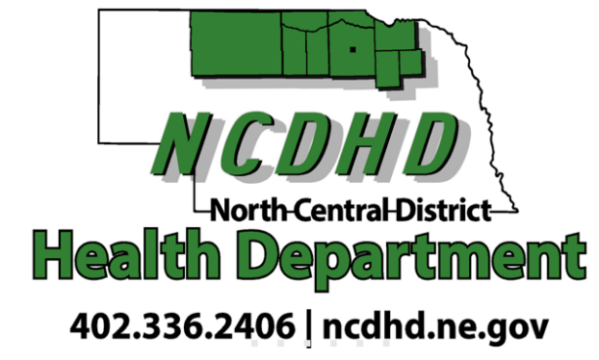
Table of Contents
Overview of the Comprehensive Community Health Needs Assessment 4
Executive Summary 4
Purpose 4
Highlights 5
Recommendations for future CHNAs 7
Community Health Needs Assessment Process 8
Community Partners Involved in the Community Health Needs Assessment Process 9
The County Health Rankings Model and Report Outline 10
Data Sources 12
NCDHD Demographics - Overall and CHA Participants 14
NCDHD Comprehensive Health Needs Assessment 19
Policies and Programs 19
NCDHD Mobilizing for Action through Planning and Partnerships Initiative 19
NCDHD Community Health Improvement Plan 2019-2021 20
PRIORITIES 20
GOALS 20
SUMMARY 21
Health Factors 21
NCDHD Physical Environment 22
Physical Environment: NCDHD Housing & Transit 22
Physical Environment: NCDHD Air & Water Quality 25
NCDHD Social and Economic Factors 26
Social and Economic Factors: Adult Education Levels & Youth Education Levels 27
Social and Economic Factors: Employment 28
Social and Economic Factors: Income 29
Social and Economic Factors: Family & Social Support 31
Social and Economic Factors: Community Safety 33
NCDHD Clinical Care 37
Clinical Care: Access to Care 38
Clinical Care: Quality of Care 40
NCDHD Health Behaviors 42
Health Behaviors: Tobacco Use 43
Health Behaviors: Diet and Exercise 44
Health Behaviors: Alcohol and Drug Use 45
Health Behaviors: Sexual Activity 47
Health Outcomes 49
Health Outcomes: Length of Life 52
Health Outcomes: Quality of Life 52
COVID-19 54
COVID-19: Morbidity and Mortality 54
COVID-19: Community Attitudes towards COVID-19 Vaccines 55
Special Populations 55
Special Populations: Income 55
Special Populations: native Americans & Hispanics 575
Special Populations: Native Americans and Heart Disease/ Diabetes 59
Special Populations: Elderly Population …………………………………………………………………………………………..75
References 80
Appendix A. NCDHD Community Health Needs Assessment Survey 96
Appendix B. NCDHD NALHD Survey 131
Appendix C. NCDHD Forces of Change Assessment 136
Appendix D. NCDHD Local Public Health System Assessment 146
Appendix E. Visioning Process 136
Appendix F. NCDHD Community Themes and Strengths Assessment 158
Appendix G. Disparities and Contributing Factors……………………………………………………..……………………….162

Overview of the Comprehensive Community Health Needs Assessment

Executive Summary
Under the direction of the North Central District Health Department (NCDHD), the 2022-2024 Community Health Needs Assessment (CHNA) provides an overview of population health issues and outcomes facing communities in the NCDHD service area. Along with previous assessments, this 2022-2024 assessment will serve as a reference document for health care providers and community partners to continue working on the Community Health Improvement Plan (CHIP). This assessment will be updated and revised every three years, providing communities with up-to-date data to evaluate progress made towards identified health priorities, and for the selection of new ones.

Purpose
The purpose of this assessment is to provide an overview of the health status of residents in the service area and identify factors affecting health. The data presented in this assessment should be used to educate and mobilize the community and its resources to improve the health of the population. The CHNA process is collaborative and is intended to serve as a resource for multiple coalitions, organizations, and health care providers in the NCDHD service area. This assessment report can be used to:
- Educate community members and leaders about overall community health within the NCDHD service area.
- Inform healthcare providers and professionals about particular issues of concern facing residents of the area.
- Provide a cohesive, easy-to-understand, and evidence-based framework for understanding the linkages between health factors and outcomes, and data points used to measure key indicators using the County Health Rankings model.
- Serve as a foundation for community-wide discussion; identification of public health needs, available existing data, and gaps in data; and development of strategies to address priority concerns.

Highlights
- NCDHD population. The overall population of the NCDHD service area has decreased 13.2% over the last 20 years. The population is majority white and elderly, with growing numbers of racial/ethnic minorities.
- Community concerns. Community member’s health concerns include cancer, heart disease, mental and behavioral health resources, poverty, and quality of life – all issues which have been previously identified as major public health issues.
- Housing quality and safety. Community members are experience severe housing problems in all parts of the NCDHD, though they fall below average reported housing problems across the state.
- Long commutes. A higher percentage of residents in Keya Paha, Boyd, and Pierce counties have work commutes longer than 30 minutes compared to the average in NCDHD and statewide.
- Appropriately educated. Adult residents of the area are more likely to have attained at least some college education compared to other residents of the state, and educational outcomes among youth align with or slightly exceed those of the state.
- Resident incomes. The average NCDHD unemployment rate is below the national average and in line with the state average. However, estimated child poverty rates in the service area are significantly higher than the state average, but similar to the national average.
- Mortality rates. Reported violent crimes in NCDHD are significantly lower than the state and national averages, however injury-related deaths are similar to nationwide averages, but higher in NCDHD than state averages.
- Motor vehicle safety may be an area of interest to NCDHD, as only about half of it’s residents report wearing a seatbelt all of the time, nearly a third reported talking on their cellphone while driving, and just under a quarter reporting texting while driving.
- Emergency planning. Though the majority of residents reported having emergency action plans at work or school, very few reported training on how to use them within the past year.
- Healthy communities. NCDHD residents provided their perspectives on how to make their communities healthier, specifically discussing wanting increased access to health options, increased health education and prevention efforts, and improvement to community spaces.
- Barriers to healthcare. NCDHD residents reported several barriers to healthcare access, including high costs, not knowing when and what kind of services to obtain, not receiving recommended screening services from their provider, and specialty services requiring excessive travel time.
- Accessing medical services. The rate of flu vaccines and mammography screenings for Medicare patients are lower in NCDHD than statewide rates, and only about half of NCDHD residents find it easy to understand written medical information or information from medical professionals.
- Health behaviors. Roughly one quarter of residents report using some form of tobacco, two-thirds report being overweight or obese, with many reporting not eating enough fruits or vegetables, or having enough time for leisure physical activity.
- Health outcomes. The top three causes of death in NCDHD and statewide are heart disease, cancerous tumors, and chronic lower respiratory disease.
- Length of life. The life expectancy of residents of NCDHD is roughly 80 years, which is similar to the statewide average.
- COVID-19. Slightly less than half of the residents of NCDHD have received two doses of a COVID-19 vaccine, with only roughly one-half saying they would recommend the vaccine to others.
- Racial and ethnic disparities. Little data was available regarding health disparities based on race or ethnicity, which highlights the need for targeted data collection in the future.
- Residents aged 65 or older. NCDHD has a higher number of elderly residents than the rest of the state, and although the majority of them report being in good health, only one-fifth reported having firm plans for long-term care, and almost a third reported feeling lonely or disconnected from others.

Recommendations for future CHNAs
- Assessment of data collection tools. Data collected from community members can provide a wealth of rich data on the health of a community. Assessing the number and quality of items as well as how each one is presented to participants will allow NCDHD to focus on the types of items that are important to the community, ensure the items measure the constructs appropriately, and can cut down on participant time commitments.
- Consideration of participant sampling methods. Using stratified sampling methods, or sampling specific subgroups of community members based on selected demographics will increase the validity of community results and efficiency of data collection.
- Additional types of community data. If possible, healthcare systems within NCDHD may be able to provide aggregated information that can help to create a more comprehensive understanding of community health.

The University of Nebraska Public Policy Center (NUPPC) assembled this data, working with the NCDHD. Much of the public health and community well-being data was collected by the North Central District Health Department, through Mobilizing for Action through Planning and Partnerships (MAPP) process, as well as other sources of behavioral health and health data, and U.S. Census data.

Community Health Needs Assessment Process
Table 1 summarizes the overall timeline of the CHNA for the NCDHD.
Table 1. Community Health Needs Assessment Process Timeline
August 30, 2021 | Internal NCDHD meetings to organize, coordinate participants, identify key stakeholders, & prepare for Mobilizing for Action through Planning and Partnership (MAPP) process. NCDHD personnel designated to work on the CHA was NCDHD executive director, the Accreditation Coordinator, and the Minority Health Coordinator. Key stakeholders from previous years were determined to be applicable for this year’s CHA process. In the 2019-2021 CHA, Native Americans, Hispanics, the elderly, and those living in poverty were identified as populations that are disproportionately affected by health risks or poorer health outcomes. NCDHD ensured these populations were represented in the health assessment efforts and made a special effort to invited them to the meetings. Partners were primarily contacted through e-mail and phone calls.
September 7, 2021 | Internal NCDHD meetings to organize, coordinate participants, & prepare for MAPP process.
September 7, 2021 | Internal NCDHD meetings to organize, coordinate participants, & prepare for MAPP process
October 12, 2021 | CHA Partner Meeting was held to determine the vision, identify which questions will be included in the Community Health Status Assessment, outline focus group questions. The CHA contact list was shared with the partners for review, and editing. Partners then sent additional contacts to the NCDHD CHA coordination team.
November 12, 2021 | CHA Partner meeting was scheduled, but due to weather was moved to on online survey format to gather CHA Partner feedback for the Forces of Change Assessment, Community Themes and Strengths Assessment, and the Local Public Health System Assessment (Results in Appendix). This meeting was advertised to the NCDHD Partners via e-mail and to the NCDHD residents via Facebook, radio, and newspaper outlets.
November 15, 2021 | The Community Health Status Assessment was released to NCDHD partners and residents (Results in Appendix). The survey was sent to partners to distribute as they saw fit (many placed them on their websites and distributed them internally). The survey linked was distributed by NCDHD to residents via Facebook, radio, newspapers, and on the NCDHD website.
February 2022 | The draft CHA document was released to partners and the community for review and suggest alterations.
March 15, 2022 | CHA partner meeting to share CHA data and select Community Health Improvement Plan (CHIP) priorities. NCDHD residents were also invited via Facebook, radio, newspapers, and the NCDHD website.

Community Partners Involved in
the Community Health Needs Assessment Process

Table 2 presents community partners involved in the CHNA process.

Table 2. Community Health Needs Assessment Partners
North Central District Health Department | Niobrara Valley Hospital
NCDHD Board of Health | Osmond General Hospital
Antelope Memorial Hospital | Rock County Hospital
Avera Creighton Hospital | West Holt Memorial Hospital
Avera St. Anthony’s Hospital-O’Neill | Indian Health Services***
Brown County Hospital | The Evergreen Assisted Living Facility ***
Cherry County Hospital*** | Cottonwood Villa Assisted Living Facility**
CHI Health Plainview Hospital | Calvary Bible Church
Counseling & Enrichment Center | Brown-Rock-Keya Paha County
Building Blocks | O’Neill Public School Board
Region 4 Behavioral Health System | O’Neill Ministerial Association
Central Nebraska Community Action Partnership*** | West Holt Health Ministries
Northeast Nebraska Community Action Partnership | Legal Aid of Nebraska***
Valentine Community School | O’Neill Public Schools
NorthStar Services*** | Santee Sioux Nation***
North Central Community Care Partnership- | University of Nebraska Public Policy Center
Area Substance Abuse Prevention Coalition | O’Neill Chamber of Commerce
Proteus*** | ESU 17/ Ainsworth Schools
Central Nebraska Economic Development | Holt County Economic Development
Good Samaritan Society – Atkinson | Northwest Nebraska Community Action Partnership
***in the 2019-2021 Community Health Assessment, Native Americans, Hispanics, the elderly, and those living in poverty were identified as populations that are disproportionately affected by health risks or poorer health outcomes. NCDHD ensured these populations were represented in the health assessment efforts.

The County Health Rankings Model and Report Outline

This NCDHD CHNA employs the County Health Rankings model (CHR) as a conceptual and organizational structure (County Health Rankings, 2021). The CHR model is produced and supported by the University of Wisconsin Population Health Institute in partnership with the Robert Wood Johnson Foundation. The CHR has been produced annually since 2010 and contains available county-level data from over 30 national sources (Remington, Catlin & Gennuso, 2015).
The CHR model is composed of three main components: Policies and programs, health factors and health outcomes. Policies and programs will be developed by NCDHD while crafting the CHIP. Health factors are composed of four different sub-components: 1) the physical environment, 2) social and economic factors, 3) clinical care, and 4) health behaviors. Each of these health factor sub-components are further divided into separate categories. Health outcomes are composed of two sub-components: 1) length of life, and 2) quality of life. Also included in the CHR model are policies and programs – those initiatives and interventions that can impact or influence the health factors that drive health outcomes.
The CHR model aligns with a core value of the public health profession – identifying the root causes and structures that impact community health and well-being. By providing an easy-to-understand conceptual structure that identifies and links health factors to resulting outcomes, the CHR model provides public health professionals and community members with data and evidence to enact suitable interventions to improve health. Figure 1 depicts the CHR model and its components.

Figure 1. The Community Health Rankings Model
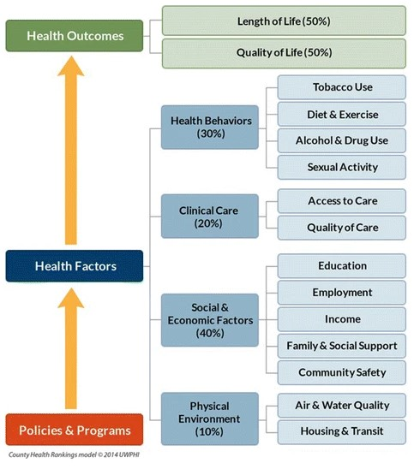
This CHNA report provides an overview of the CHR health factors and health outcomes for the NCDHD – whether available on a county level or health district level. The policies and programs section describes current community health initiatives that the NCDHD and its stakeholders have developed.
There are two sections of this CHNA report that fall outside of the CHR model. First, data related to the COVID-19 pandemic and community perceptions towards COVID-19 vaccines are included for the NCDHD. Secondly, a section featuring relevant data on special populations – racial and ethnic minorities and the elderly – is provided to inform considerations of the health status and needs of these subpopulations. Both these sections are provided near the end of this report.
Select tables and graphics are provided throughout the body of this report to present relevant data. Additional tables and detailed results from data sources are provided in the Appendices to this report. It should be noted that two of the primary data sources used in this report were the Nebraska Behavioral Risk Factor Surveillance System (NBRFSS) and the Nebraska Risk and Protective Factor Student Survey (NPRFSS). The NBRFSS is managed by the Nebraska Department of Health and Human Services and the University of Nebraska-Lincoln Bureau of Sociological Research. Both of those entities have published health district or county level data reports for the NCDHD. Thus, detailed data from those sources for the NCDHD are not included in the Appendices for this report as they are available at those entities’ respective webpages.

Data Sources
Table 3 provides a summary description of data sources used in this CHNA. Data was synthesized across sources where available, but several data limitations are worth noting. The CHA represents the most local, direct source of information about the community members, however, as seen in Table 6, the sample of participants is not necessarily representative of the population of NCDHD. The FoC, CTSA, and LPHSA did not collect demographic information, and the NALHD had missing data for health concerns and demographic items for over half of the participants (65.9%), so the participant demographics were not complete, and therefore not presented in this report. CHR data was only available in aggregate, which prevented detailed statistical analyses, but did allow for basic analyses by county where applicable, as some items were missing information for one or more counties within NCDHD. The NBRFSS data was obtained in aggregate for NCDHD as well and presented in this report as percentages of responses. Additional data limitations are noted where appropriate.

Table 3. CHNA Data Sources
Data Source | Description
NCDHD Community Health Needs Assessments and Surveys (CHA) | Community survey conducted by the North Central District Health Department (NCDHD) in 2021 around issues of community well-being and quality of life. Frequency tables for all items and raw responses for open-ended items are presented in Appendix A.
Nebraska Association of Local Health Directors Survey (NALHD) | This short survey was administered during COVID-19 vaccination clinics and focuses on top health concerns among community members. Frequencies tables and raw responses to open-ended items are presented in Appendix B.
Forces of Change Assessment (FoC) | This assessment focuses on identifying important community characteristics and factors identified by community members. Traditionally conducted as focus group, the FoC was administered as a survey focusing on open-ended responses due to COVID-19. Frequency tables for all items and raw responses for open-ended items are presented in Appendix C.
Community Themes and Strengths Assessment (CTSA) | Provides a better understanding of health and quality of life issues that community members feel are important in their communities within the district. This assessment was administered in conjunction with the FoC, and all responses are presented in Appendix C.
Local Public Health Systems Assessment survey (LPHSA) | Supplemental community survey that focuses on community health concerns. This assessment was administered in conjunction with the FoC, and all responses are presented in Appendix D.
Community Health Rankings (CHR) | The County Health Rankings provide a snapshot of a community’s health and a starting point for investigating and discussing ways to improve health. Information from CHR originates from many sources but are cited from their original source in this report.
Nebraska Behavioral Risk Factor Surveillance System (NBRFSS) | A comprehensive, annual health survey of adults aged 18 and older on risk factors for many areas impacting public health. This survey was most recently conducted in 2020, though some items are not asked every year. Items from previous years are cited with the latest year for which data is available.
Nebraska Department of Education (NDE) | Data contained in Nebraska's annual State of the Schools Report, including graduation and dropout rates, student characteristics, and student achievement scores.
Nebraska Risk and Protective Factor Student Survey (NRPFSS) | A survey of Nebraska youth in grades 8, 10, and 12 on risk and protective factors regarding alcohol, tobacco, and drug use, and bullying, most recently published in 2018.
U.S. Census Bureau - American Community Survey (ACS) | U.S. Census Bureau estimates on demographic elements such as population, age, race/ethnicity, household income, poverty, health insurance, and educational attainment. Annual estimates available through the ACS (2015-2019) were used for this report.
U.S. Centers for Disease Control and Prevention Web-based Injury Statistics Query and Reporting System (CDC) | CDC’s WISQARS is an interactive, online database that provides fatal and nonfatal injury, violent death, and cost of injury data.

NCDHD Demographics - Overall and CHA Participants
The overall population of NCDHD has decreased by 13.2% over the past twenty years. As seen in Table 4, community members who identify as white have decreased by 8.5% from 2010 to 2020, while the number of community members who identify as any other racial category have increased since 2010. Additionally, community members who identify as Hispanic or Latino have also increased by 86.0% since 2010. Table 5 presents the percentages of race/ethnicity of community members per NCDHD county. These demographic changes in NCDHD indicate a growing need for public health policies and programs to be centered around the specific needs of their communities to promote health equity. Health equity refers to a condition where all members of the community enjoy fair and just opportunities to be as healthy as possible (CDC, 2022). Negative mental health outcomes and health-related behaviors are the strongest and most consistent health outcomes associated with racial and ethnic minority status (Paradies, 2006). An in-depth analysis of health disparities for NCDHD can be located in the Special Populations section.

Table 4. NCDHD Demographics
 | 2000 |  | 2010 |  |  | 2020
 | Pop. | % | Pop. | % | % Changeª | Pop. | % | % Change^{b}
NCDHD Total | 51,084 | 100.0% | 46,764 | 100.0% | -8.5% | 44,329 | 100.0% | -5.2%
Gender
Female | 25,894 | 50.7% | 23,660 | 50.6% | -8.6% | 22,150 | 50.0% | -6.4%
Male | 25,190 | 49.3% | 23,104 | 49.4% | -8.3% | 22,178 | 50.0% | -4.0%
Age
Under 5 years | 2,977 | 5.8% | 2,766 | 5.9% | -7.1% | 2,782 | 6.3% | 0.6%
5 ‐14 years | 7,824 | 15.3% | 6,226 | 13.3% | -20.4% | 5,850 | 13.2% | -6.0%
15 ‐24 years | 5,916 | 11.6% | 4,876 | 10.4% | -17.6% | 4,802 | 10.8% | -1.5%
25 ‐44 years | 12,198 | 23.9% | 9,372 | 20.0% | -23.2% | 8,916 | 20.1% | -4.9%
45 ‐64 years | 11,840 | 23.2% | 13,663 | 29.2% | 15.4% | 11,938 | 26.9% | -12.6%
65 ‐84 years | 8,640 | 16.9% | 8,192 | 17.5% | -5.2% | 8,403 | 19.0% | 2.6%
85 and older | 1,689 | 3.3% | 1,677 | 3.6% | -0.7% | 1,636 | 3.7% | -2.4%
Race/Ethnicity
White | 49,518 | 96.4% | 44,369 | 94.3% | -10.4% | 40,586 | 91.6% | -8.5%
African American | 27 | 0.1% | 120 | 0.3% | 344.4% | 128 | 0.3% | 6.7%
Native American | 982 | 1.9% | 1,074 | 2.3% | 9.4% | 1,377 | 3.1% | 28.2%
Asian/Pacific Islander | 98 | 0.2% | 24 | 0.1% | -75.5% | 142 | 0.3% | 491.7%
Other | 14 | 0.0% | 309 | 0.7% | 2107.1% | 643 | 1.5% | 108.1%
2+ Races | 318 | 0.6% | 388 | 0.8% | 22.0% | 1,453 | 3.3% | 274.5%
Hispanic/Latino | 410 | 0.8% | 788 | 1.7% | 92.2% | 1,466 | 3.3% | 86.0%
Note. The counts for racial categories are considered Non-Hispanic, those who identify as Hispanic/Latino are accounted for in the ethnic category of Hispanic/Latino.
ª Change in population from 2000 to 2010
^{b} Change in population from 2010 to 2020
Table 5. Race & Ethnicity Percentages per NCDHD County 2020
 | Antelope | Boyd | Brown | Cherry | Holt | Keya Paha | Knox | Pierce | Rock
White | 91.1% | 93.5% | 86.5% | 86.2% | 88.8% | 93.4% | 81.8% | 93.8% | 95.4%
African American | 0.3% | 0.0% | 0.1% | 0.2% | 0.4% | 0.0% | 0.2% | 0.4% | 0.2%
Native American | 0.2% | 1.0% | 0.4% | 5.2% | 0.5% | 0.3% | 11.2% | 0.3% | 0.1%
Asian/Pacific Islander | 0.4% | 0.0% | 0.3% | 0.1% | 0.5% | 0.1% | 0.4% | 0.2% | 0.0%
Other | 1.4% | 0.7% | 3.4% | 0.6% | 2.2% | 0.8% | 1.1% | 0.7% | 0.7%
2+ Races | 3.1% | 3.0% | 3.7% | 5.0% | 2.6% | 2.9% | 3.2% | 2.7% | 2.0%
Hispanic | 3.4% | 1.8% | 5.7% | 2.6% | 4.9% | 2.5% | 2.2% | 1.9% | 1.6%
Note. Percents for racial categories are considered Non-Hispanic, those who identify as Hispanic/Latino are accounted for in the ethnic category of Hispanic/Latino.

Table 6. Languages Spoken per NCDHD County 2020

 | Antelope | Boyd | Brown | Cherry | Holt | Keya Paha | Knox | Pierce | Rock
 | Total | Total | Total | Total | Total | Total | Total | Total | Total
Population 5 years and over | 5,896 | 1,832 | 2,716 | 5,401 | 9,470 | 836 | 7,868 | 6,664 | 1,305
Speak only English | 5,604 | 1,745 | 2,594 | 5,300 | 9,119 | 827 | 7,520 | 6,510 | 1,283
Speak a language other than English | 292 | 87 | 122 | 101 | 351 | 9 | 348 | 154 | 22
SPEAK A LANGUAGE OTHER THAN ENGLISH
Spanish | 193 | 59 | 42 | 27 | 256 | 9 | 181 | 138 | 19
5-17 yr | 51 | 0 | 0 | 24 | 24 | 0 | 23 | 15 | 0
18 - 64 years | 131 | 30 | 40 | 3 | 193 | 9 | 143 | 112 | 14
65 years old + | 11 | 29 | 2 | 0 | 39 | 0 | 15 | 11 | 5
Other Indo-European languages | 75 | 11 | 57 | 23 | 71 | 0 | 84 | 15 | 3
5-17 yrs | 22 | 0 | 0 | 0 | 3 | 0 | 36 | 0 | 0
18 - 64 years | 48 | 0 | 5 | 16 | 29 | 0 | 7 | 12 | 1
65 years old + | 5 | 11 | 52 | 7 | 39 | 0 | 41 | 3 | 2
Asian and Pacific Island languages | 21 | 12 | 23 | 39 | 8 | 0 | 33 | 0 | 0
5-17 yrs | 0 | 8 | 10 | 0 | 0 | 0 | 5 | 0 | 0
18 - 64 years | 16 | 2 | 7 | 39 | 4 | 0 | 28 | 0 | 0
65 years old + | 5 | 2 | 6 | 0 | 4 | 0 | 0 | 0 | 0
Other languages | 3 | 5 | 0 | 12 | 16 | 0 | 50 | 1 | 0
5-17 yrs | 0 | 0 | 0 | 0 | 0 | 0 | 11 | 0 | 0
18 - 64 years | 3 | 0 | 0 | 10 | 16 | 0 | 35 | 1 | 0
65 years old + | 0 | 5 | 0 | 2 | 0 | 0 | 4 | 0 | 0
CITIZENS 18 YEARS AND OVER
All citizens 18 years old and + | 4,737 | 1,523 | 2,205 | 4,442 | 7,523 | 668 | 6,325 | 5,358 | 1,120
Speak only English | 4,594 | 1,465 | 2,117 | 4,371 | 7,307 | 659 | 6,086 | 5,242 | 1,098
Speak a language other than English | 143 | 58 | 88 | 71 | 216 | 9 | 239 | 116 | 22
Spanish | 78 | 39 | 18 | 3 | 151 | 9 | 135 | 103 | 19
Other languages | 65 | 19 | 70 | 68 | 65 | 0 | 104 | 13 | 3
Source.ACS

The community members of NCDHD who participated in the CHA were overwhelmingly white (95.6%), non-Hispanic (97.5%), 45 years of age or older (65.6%), primarily spoke English (100%), married (80.4%), and resided in Holt County (40.7%). It is recommended that in future years that the CHA utilizes a stratified sampling method of community members in order to capture responses that are more representative of the community.
Table 6. CHA Participant Demographics
Demographic Item | n | %
Selected race (n = 204)
African American/Black | 0 | 0.0
American Indian/Alaskan Native | 4 | 2.0
Asian | 0 | 0.0
Hawaiian/Other | 0 | 0.0
White | 195 | 95.6
2 or more races | 4 | 2.0
Other | 1 | 0.4
Selected ethnicity (n = 204)
Not Hispanic or Latino | 196 | 97.5
Hispanic or Latino | 5 | 2.5
Age group (n = 201)
Under 18 | 0.0 | 0.0
18 to 24 | 4 | 2.0
25 to 44 | 65 | 32.3
45 to 64 | 105 | 52.2
65 & over | 27 | 13.4
Primary Language (n = 204)
English | 204 | 100.0
Refugee Status (n = 202)
No | 194 | 96.0
Yes | 8 | 4.0
From Where? (n = 8)
No Response | 8 | 100.0
Marital Status (n = 204)
Married | 164 | 80.4
Widowed | 10 | 4.9
Single | 15 | 7.4
Divorced | 9 | 4.4
Separated | 1 | 0.5
Unmarried and live with a partner | 5 | 2.5
County Lived (n = 204)
Holt | 83 | 40.7
Boyd | 12 | 5.9
Cherry | 6 | 2.9
Rock | 4 | 2.0
Brown | 11 | 5.4
Keya Paha | 3 | 1.5
Knox | 44 | 21.6
Antelope | 9 | 4.4
Pierce | 29 | 14.2
Other (Please specify)* | 3 | 1.5
Cedar | 1 | 0.4
Wheeler | 2 | 0.8
*Responses from participants were included in analyses as they worked or went to school
within NCDHD.

NCDHD Comprehensive Health Needs Assessment

Policies and Programs

NCDHD Mobilizing for Action through Planning and Partnerships Initiative
The NCDHD employed the Mobilizing for Action through Planning Partnerships (MAPP) framework to identify priorities and strategies to address community health issues. MAPP is an established framework developed by the National Association of County and City Health Officials and has been used by numerous communities since its inception in 2001. Foundationally, the MAPP approach engages community members, stakeholders, and healthcare professionals in assessing the overall health status of the community, prioritizing health concerns, and identifying strengths and gaps salient to community health (NACCHO, 2020). The MAPP approach used by the NCDHD composed four different but interrelated processes to assess overall health status, systems, and priorities within the community – defined as the coverage area for the NCDHD:
- An NCDHD CHNA: A comprehensive overview of data that provides a snapshot of the community’s health status. The majority of this report serves as the CHNA. As noted above, the conceptual and organizational structure of the NCDHD’s CHNA follows the CHR model and includes multiple data sources used by the CHR. Additionally, the NCDHD created and administered an online CHNA Survey that was made available to residents of the service area to gauge specific items of interest. Detailed data points from the CHNA Survey are provided in Appendix A. To complement the CHNA Survey, a smaller scale survey was also developed by the NCDHD and administered to individuals who attended COVID-19 vaccine clinics. This survey was based on items developed in partnership with the Nebraska Association of Local Health Directors and is referred to as the NCDHD NALHD Survey. Detailed data points from the NCDHD NALHD Survey are provided in Appendix B.
- NCDHD Forces of Change Assessment – a comprehensive assessment of factors within the community that affect health status. The Forces of Change Assessment process evolved from a survey and interviews with community members and stakeholders from the NCDHD service area. Through the survey portion of the Forces of Change Assessment, community members identified A) events, factors and trends within the NCDHD service area relevant to community health; B) threats and opportunities to improve community health; and C) important priorities and strengths within NCDHD communities salient to improving population health. Through a series of interviews, stakeholders and residents of the NCDHD service area provided more in-depth insight into seeking health information and identifying priorities and barriers for community health. Data and themes from the Forces of Change Assessment results are provided in Appendix C.
- NCDHD Local Public Health System Assessment – an overview of community perceptions and experiences with the local public health system in the NCDHD service area. This assessment was composed largely of survey questions asking respondents to indicate their opinions of how well the Ten Essential Public Health Services are provided. Data points from the Local Public Health System Assessment are provided in Appendix D.

NCDHD Community Health Improvement Plan 2019-2021

PRIORITIES
1. CHRONIC DISEASE DETECTION & MANAGEMENT
2. MENTAL WELLNESS

GOALS
1. Effectively screen and manage chronic disease throughout the district.
2. Mental Health will be promoted throughout the district as an integral part of overall well-being.

SUMMARY
The 2019-2021 Community Health Improvement Plan, goals, and priorities were sidelined by NCDHD and partners due to the COVID-19 pandemic.

Health Factors
The County Health Rankings Model provides a holistic structure that identifies factors impacting public health into four categories: Physical Environment, Social and Economic Factors, Clinical Care, and Health Behaviors (CHR, 2021). Studies have previously examined associations between health outcomes and CHR health factor measures and found strong support for the structure and categorizations used in the CHR (Hood et al., 2016; Krause et al., 2021).
Public health professionals have known for some time that the determinants of health are broad, complex, and interact in multiple ways to increase risk and cause illness. An abundance of research indicates that multiple causal connections impact health outcomes (Braveman & Gottlieb, 2014; LaVeist & Pierre, 2014; Viner et al., 2012; Xanthos et al., 2010). In addition to the measures employed by the CHR, the NCDHD CHNA Survey queried residents about their subjective perceptions of health concerns (see Table 7; see Tables A1 and A2 for additional health concern data and qualitative responses for ‘Other’ or ‘Something else’). The top concerns identified by respondents (n = 242) included cancer (65.2%), heart disease (59.5%), mental health (58.7%), lack of exercise (36.7%), and diabetes (36.4%) – all of which are health outcomes driven by multiple factors.
Table 7. Top Health Concerns of NCDHD CHA Respondents
 | Count | %
Cancer | 158 | 65.2
Heart disease | 144 | 59.5
Mental health | 142 | 58.7
Getting enough exercise | 89 | 36.7
Diabetes | 88 | 36.4
Alcohol, Drugs and Tobacco use | 65 | 26.8
Challenges getting healthy and affordable food | 61 | 25.3
Chronic lung disease | 46 | 18.9
Getting around town safely (driving, walking, and riding) | 35 | 14.5
Asthma | 34 | 14.4
Something else | 24 | 9.9

NCDHD Physical Environment
A community’s physical environment refers to where people live, work, learn, and play. Individuals interact with their physical environment through the dwellings in which they live, their means of transportation, the air they breathe, and the water they drink. The quality of these aspects of people’s lives can affect their ability to live healthy and productive lives. The main areas of concern regarding the physical environment within the NCDHD service area relate to housing problems and long commutes. Additionally, 69.6% (n = 433) of NCDHD residents reported having access to safe places to walk in their neighborhood in 2017, down from the 80.4% (n = 518) reported in 2015 (NBRFSS, 2020). However, counties within NCDHD have reported overall good air and drinking water quality.

Physical Environment: NCDHD Housing & Transit
The housing options and transportation systems that shape a community-built environment affect where its residents live and how they get from place to place. Choices made regarding housing and transportation, as well as underlying opportunities that lead to these choices, also impact community health (CHR, 2021).

Physical Environment: Housing
Housing has been associated with health via several pathways: home quality and safety, housing affordability and stability, and community resource availability and accessibility. Adequate housing can contribute to good health by protecting individuals and families from harmful exposures as well as by providing them with a sense of privacy, security, stability, and control. In contrast, poor quality and inadequate housing contributes to health problems such as infectious and chronic diseases, injuries, and poor childhood development. Housing measures can also be considered proxy indicators of more general socioeconomic circumstances (Shaw, 2004). Households experiencing severe cost burdens face difficult trade-offs to meet other basic needs, such as health care costs, healthy food, utility bills, or reliable transportation to work or school (Kushel et al., 2006; Long, 2003; Levy & DeLeire, 2003; Ma et.al, 2008). This can then lead to increased emotional strain and stress levels (Hiscock et al., 2001; Dunn, 2000).
As of July 2019, a total of 24,828 housing units were reported within the NCDHD, 74.3% of which are reported as owner-occupied, with a median value of $95,900.00, in which occupants paid a median monthly cost of $1,055.00 (US Census, 2019). Households who reported renting within the NCDHD paid a median gross cost of $630.00 a month. NCDHD residents reported an average of 2.3 persons per household (US Census, 2019). Among the households within NCDHD, 9.0% have reported having severe housing problems such as high housing costs (7.3%), overcrowding (1.2%), or lacking a complete kitchen or plumbing facilities (1.3%; CHR, 2017; Figure 2). Overall, NCDHD (9.0%) reported lower severe housing problems than the U.S. rate (17.5%; t(8) = -12.915, p < .05) and the Nebraska rate (12.6%; t(8) = -5.476, p < .05). Brown County (11.2%) reported a significantly higher percentage of severe housing problems than the NCDHD total (9.0%; t(8) = 3.351, p < .05), and Rock County (4.6%) reported a significantly lower percentage of severe housing problems than the NCDHD total (9.0%; t(8) = -6.669, p < .05), with all other counties reporting statistically similar percentages to the NCDHD average.

Figure 2. Percentage of Reported Severe Housing Problems in US, NE, & NCDHD.
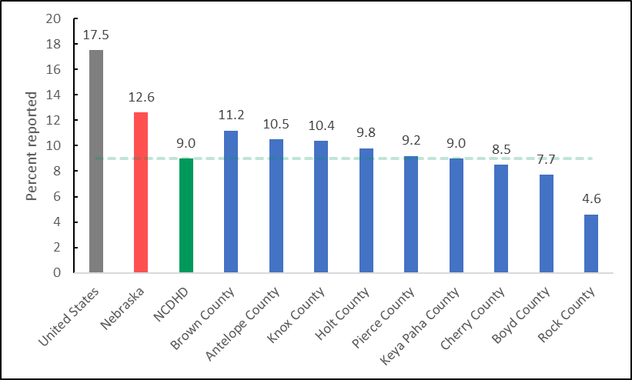
Note. NCDHD average line is calculated at 9.0% using CHAS 2013-2017 data.
Access to reliable, high-speed broadband internet can improve access to education, employment, and health care opportunities and is associated with increased economic development (Conroy et al., 2021). Within the NCDHD, 84.5% of households reported having access to a computer, and 76.3% reported having access to a broadband internet connection (U.S. Census, 2019; ACS, 2019).

Physical Environment: Public Transit
Public systems such as city buses, sidewalks, bike paths, and highways, as well as cars and bicycles, are included within public transit. However, heavy dependence on individual motorized transit can lead to increased traffic-related accidents and death, air pollution, and physical inactivity and obesity (Robert Wood Johnson Foundation, 2021). Additionally, driving long commutes alone have been associated with poorer mental health outcomes (Künn-Nelen, 2016; Hilbrecht et al., 2014).
According to the American Community Survey (2019), 73.0% of NCDHD residents reported that they drive alone to work, with 19.3% of those residents reporting that their commute is longer than 30 minutes (Figure 3). The average travel time to work in NCDHD is 16.1 minutes (ACS, 2019). The total percentage of NCDHD residents with long commutes is significantly lower than the U.S.’s (36.6%; t(8) = -8.012, p < .05) but similar to Nebraska’s total percentage (18.8%; t(8) = 0.247, p > .05). Three counties reported significantly higher percentages of residents who have long commutes: Keya Paha (28.1%; t(8) = 4.068, p < .05), Boyd (26.4%; t(8) = 3.279, p < .05), and Pierce (25.0; t(8) = 2.629, p < .05).
Figure 3. Percentage of Residents with Long Commutes to Work in U.S., NE, & NCDHD
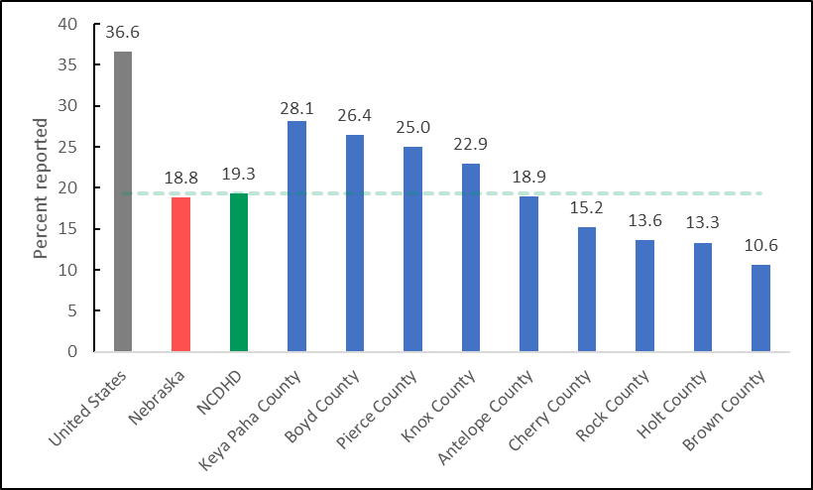
Note. NCDHD average line is calculated at 19.3% using ACS 2015-2019 data.

Physical Environment: NCDHD Air & Water Quality
Clean air and safe drinking water are essential to community health, as they both support brain health and bodily functions throughout development. The U.S. Environmental Protection Agency (EPA) provides thresholds for six principal pollutants in the National Ambient Air Quality Standards, including particle pollution (PM). Counties within NCDHD appear to enjoy relatively clean air and have had no reported drinking water violations.

Physical Environment: Air Quality
Air quality is an important factor to community health, as ambient air pollution has been correlated with decreased lung function, asthma, chronic bronchitis, and other negative pulmonary effects, and long-term exposure to fine particulate matter specifically is linked with premature death risk among those 65 and older (Di et al., 2017; Pope et al., 1995). Air quality is modeled at a county-level through measurement of fine particulate matter (PM_{2.5}) 2.5 microns or less in width per cubic meter (µg/m³) and number of days with ground-level ozone, as reported by the CDC's National Environmental Public Health Tracking Program from 2016. PM_{2.5} thresholds are reported as a three-year average, in which the primary standard of PM_{2.5} under 12 µg/m³ are considered safe for public health protection, including sensitive populations such as children, the elderly, and people with asthma, while the secondary standard PM_{2.5} under 15 µg/m³ protects against decreased visibility and damage to animals, crops, vegetation, and buildings. Counties within NCDHD reported average levels of PM_{2.5} (5.2) that were well below the national threshold of 12, significantly below the national average (7.2; t(8) = -7.747, p < .05), and similar to the Nebraska average (5.7; t(8) = -2.032, p > .05). The standard for ozone pollution, otherwise known as “smog”, is 0.08 parts per million. However, within the NCDHD service area, only Holt County reported exposure to unhealthy ozone levels in 2016.

Physical Environment: Water Quality
Poor drinking water has been associated with illnesses such as nausea; lung and skin irritation; cancer; and kidney, liver, and nervous system damage, as well as birth defects and death (Centers for Disease Control and Prevention, 2019; Craun et al., 2010). Water quality is measured by the reported number of drinking water violations per county to the EPA’s Safe Drinking Water Information System (SDWIS) from 2019, which include maximum contaminant level, maximum residual disinfectant level, and treatment technique violations. While Nebraska as a whole has reported drinking water violations in some counties, no counties within NCDHD had any drinking water violations reported in 2019.

NCDHD Social and Economic Factors
Social and economic factors affect one’s ability to afford housing and medical care, make healthy choices, manage stress, and provide support to others (CHR, 2021) and should be considered when making decisions about how to appropriate resources within communities. These factors include education, employment, income, family and social supports, and community safety. Residents within NCDHD appear to be appropriately educated, be predominately employed, have relatively secure social supports, and enjoy relatively low crime rates. However, household income measures indicate a higher rate of child poverty than the state average, and nearly a third of those surveyed reported making less than a living wage last year (CHA, 2021; Glasmeier, 2020). Additionally, accidental injury rates are higher than national and state averages and self-reported safety behaviors are fairly inconsistent.
NCDHD residents also provided some feedback on several areas that they feel are important to their communities. When asked about what they thought was important to their community, residents touched on community connections, support, and equality; access to high quality physical and mental healthcare; good school systems; agriculture; supporting community businesses; and retaining the youth in their communities. When asked what made them proud of their community, comments centered around pride in community connection and collaboration. See Tables C1 to C28 for detailed data points on these themes.

Social and Economic Factors: Adult Education Levels & Youth Education Levels
Higher levels of education are associated with better employment opportunities, higher incomes, greater sense of control in one’s life, and increased social supports, all of which encourage opportunities for healthy decision-making (Egerter, Braveman, Sadegh-Nobari, & Grossman-Kahn, 2011). Available measures of community education include survey items asking for self-reported highest completed educational level and student perspectives of their school, as well as school district-level language arts and math proficiencies. Overall, the residents of NCDHD appear to be appropriately educated, as the majority of adults who live in NCDHD have reported completing high school and some college; third graders are slightly ahead of their grade levels in reading and math; and the majority of eighth, 10th, and 12th graders report having good grades (mostly A’s and B’s). See Table A3 for NCDHD client reported highest degree of education.

Social and Economic Factors: Adult Education Levels
The overall reported percentage of adults (25 years or older) who have graduated high school in NCDHD (94.7%) is significantly higher than the United States (88.0%; t(8) = 13.519, p < .05) and Nebraska (91.4%; t(8) = 6.607, p < .05) average rates (ACS, 2019). Additionally, the rate of adults (25-44 years old) living in NCDHD who reported having completed some college (75.7%) is significantly higher than the United States (66.0%; t(8) = 3.458, p < .05) rates but similar to the overall Nebraska (72.0%; t(8) = 1.314, p > .05) rates (ACS, 2019). The reported percentage of adults in NCDHD who report having completed a bachelor’s degree or higher (21.6%), however, is significantly lower than the national (32.1%; t(8) = -12.156, p < .05) and Nebraska (31.9%; t(8) = -11.926, p < .05) average rates (ACS, 2019).

Social and Economic Factors: Youth Education Levels
Student-level data provides another way to assess community education. The average grade level performance for third grade NCDHD students is 3.2 for reading and 3.2 for mathematics (Stanford Education Data Archive, 2018). This indicates that on average, third graders in the NCDHD service area are testing slightly above their grade level in reading and math. The majority of eighth, 10th, and 12th grade students in NCDHD reported receiving mostly A’s or B’s (79.0%), feeling safe at their school (90.8%), and having an adult at school that listens to them (87.7%; NRPFSS, 2018). Graduation rates from school districts within NCDHD (92.3%) are significantly higher than the statewide (88.0%; t(13) = 4.142, p < .05) student population (NDE, 2021).

Social and Economic Factors: Employment
Gainful employment can provide income and a sense of purpose and belonging. Employment may often include provision of health care insurance, paid sick leave, and wellness programs that can encourage healthy choices. Employment can have profoundly positive effects on social and emotional well-being and self-efficacy. Unfortunately, those who are unable to find and maintain gainful employment often are more likely to suffer increased stress, high blood pressure, and greater prevalence of heart disease and depression than those with gainful employment (Braveman, Dekker, et al., 2011; RWJF, 2013).
The unemployment rate in NCDHD (2.9%) is significantly below that of the national average (3.7%; t(8) = 6.395, p < .05) but similar to Nebraska’s (3.0%; t(8) = 1.071, p > .05) overall rate (Figure 4). When comparing individual counties within NCDHD, Brown (3.5; t(8) = -4.874, p < .05) and Boyd (3.3; t(8) = -3.353, p < .05) counties have higher unemployment rates, while Keya Paha (2.5; t(8) = 2.733, p < .05) and Cherry (2.4; t(8) = 3.493, p < .05) counties have lower unemployment rates than the average rate for NCDHD (2.9%; Bureau of Labor Statistics, 2019). See Table A4 for additional data on reported employment status.
Figure 4. Unemployment Rates in U.S., Nebraska, & NCDHD
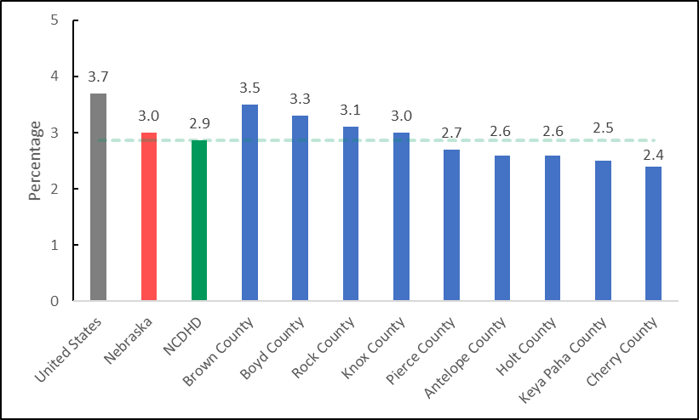
Note. NCDHD average line is calculated at 2.9% using BLS 2019 data.

Social and Economic Factors: Income
A household’s income level determines what types of health-related choices are available. Those with lower levels of income often have lower access to healthy foods, preventative health care, and educational opportunities and are also associated with poorer physical and mental health outcomes (Braveman, Egerter, & Barclay, 2011). Community income levels can be assessed in terms of percentage of children and households in poverty, income inequality and reported household incomes.
The reported five-year median estimate of NCDHD residents’ household income is $56,250, while their per capita average income is $30,412 (US Census Bureau, 2019). When surveyed about their household income, 31.9% of NCDHD residents (n = 185) reported an annual household income at or below a calculated Nebraska average for a living wage (CHA, 2021; Glasmeier, 2020). See Tables A5 and A6, respectively, for data on reported household income and NCDHD client-reported assistance program participation. Income inequality, which is reported as the ratio of household incomes at the 80th and 20th percentiles, where a higher ratio indicates greater division between the top and bottom ends of the income spectrum (CHR, 2021). NCDHD’s average Income inequality ratio (3.9) is significantly smaller than the national ratio (4.9; t(8) = -7.909, p < .05) and the Nebraska ratio (4.2; t(8), -2.621, p < .05).
According to the US Census Bureau (2019), 12.1% of NCDHD residents and 17.7% of children are estimated to live in households with poverty-level incomes. As seen in Figure 5, the NCDHD estimated percentage of children living in poverty is similar to the national rate (16.8%; t(8) = 0.688, p > .05) but higher than the Nebraska rate (11.5%; t(8) = 4.593, p < .05). Estimates of children in poverty for Keya Paha (24.1%; t(8) = -4.691, p < .05), Boyd (21.9 %; t(8) = -3.070, p < .05), and Rock (21.1%; t(8) = -2.480, p < .05) counties are significantly higher than the NCDHD average rate, while Pierce County (10.7%; t(8) = 5.182, p < .05) is significantly lower. Table A7 provides additional data on reported household size by CHA survey respondents.

Figure 5. Estimated Children in Poverty Rates for the U.S., NE, & NCDHD
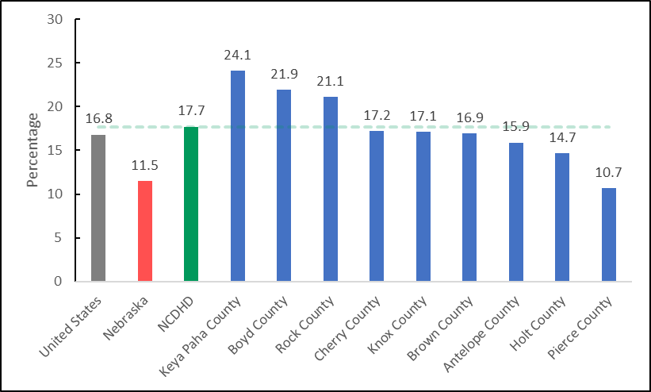
Note. NCDHD average line is calculated at 17.7% using US Census Bureau 2019 data.
Children within NCDHD (46.3%) who are eligible for free or reduced lunch rates (National Center for Education Statistics, 2019) are on average similar to national (52.0%; t(8) = -2.160, p > .05) and Nebraska (45.0%; t(8) = 0.595, p > .05) rates. Boyd (60.0%; t(8) = 5.309, p < .05) is the only county that has significantly higher rates of free/reduced lunch eligible students than the NCDHD average.

Social and Economic Factors: Family & Social Support
Strong social support systems made up of family, friends, colleagues, and acquaintances provide protective factors for physical and mental health and help to facilitate healthy choices (Kawachi et al., 1999). Individuals who lack adequate social support can be especially susceptible to stress or depression. Social and emotional wellbeing is also associated with increased cardiovascular issues and behavioral choices such as overeating and smoking (Egerter, Braveman, & Barclay, 2011).
According to the results of the American Community Survey (2019), 15% of children within the NCDHD live in single-parent households, which is associated with adverse mental health outcomes and unhealthy behaviors for children and adults (Balistreri, 2018; Manning, 2015). However, the percentage of children in single-family households in the NCDHD (15.0%) is significantly lower than the US average (25.5%; t(8) = -5.349, p < .05) and the Nebraska average (21.0%; t(8) = -3.111, p < .05). This result is supported by NCDHD student self-reports, with 14% saying they lived with one parent (NRPFSS, 2018). Students living in the NCDHD also largely agreed that they could ask their parents for help with personal problems (85.4%) and that they had an adult who listens to them at home (86.9%).
The rate of community social associations, as measured by a proxy of county businesses self-reporting the number of membership associations per 10,000 population (County Business Patterns, 2018), in the NCDHD (16.7%) is significantly higher than the national rate (9.3%; t(8) = 2.959, p < .05) and similar to the Nebraska rate (14.0%; t(8) = 1.091, p > .05). Additionally, 75% (n = 12) of NCDHD residents responded affirmatively when asked if there were networks of support for individuals and families during times of stress and need (FoC, 2021). In response to that question in the FoC (2021) survey, one respondent commented:
“I believe we could do more to help those that are dealing with behavioral health issues such as depression, grieving, and drug addiction.”
Residential segregation is defined as the degree to which two or more groups live separately from one another within a geographic area (ACS, 2019). Residential segregation within a community remains prevalent in many areas within the country and is associated with poor health outcomes in areas such as reproductive health, infectious and chronic disease, and increased rates of mortality (Bailey et al., 2017; Kramer & Hogue, 2009). As seen in Figure 6, the average index of racial segregation in the NCDHD service area (27.0) appears lower than the national (46.6) and Nebraska (44.9) indices, but due to a lack of county-level data from several counties, a valid analysis is not available. It should be noted that the Santee Sioux Reservation of the Santee Sioux is located in Knox county, which would explain why it has a high racial segregation index.

Figure 6. Racial Segregation Index for U.S., NE, and NCDHD.
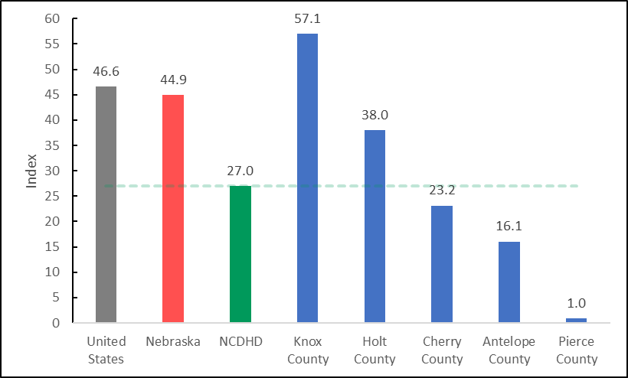
Note. NCDHD average line is calculated at 27.0 using ACS 2019 data. No data was available for
Boyd, Brown, Keya Paha, & Rock counties.

Social and Economic Factors: Community Safety
Community safety, which encompasses violent crime, unintentional injuries, and community-level safety behaviors, affects the quality of life for all community members. Community members provided feedback on several key themes for a healthier community. See Tables A8 to A9 for safety-related behaviors among CHA survey respondents, and concerns about overall health.
The violent crime rate within NCDHD, which is measured as the number of violent crimes reported per 100,000 population, is relatively low (88.2) compared to the national (386.5; t(7) = -11.299, p < .05) and Nebraska (285.7; t(7) = -7.729, p < .05) rates (Uniform Crime Reporting, 2016). As seen in Figure 7, Cherry County’s (239.7) violent crime rate appears higher than NCDHD’s rate, although due to the lack of data from all counties, these results should be interpreted with caution. No homicides were reported within the NCDHD service area between 2015 and 2019 (National Center for Health Statistics, 2019).

Figure 7. Violent Crime Rates for U.S., NE, and NCDHD
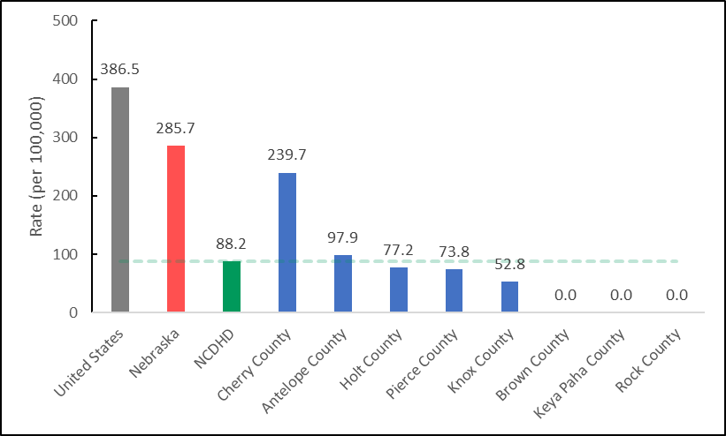
Note. NCDHD rate calculated at 88.2 using FBI 2014 & 2016 data. No data was available for
Boyd County.
Unintentional injury-related deaths are the third leading cause of death in the U.S., the fourth leading cause of death in Nebraska, and the sixth leading cause of death in the NCDHD service area (CDC, 2020). As seen in Figure 8, the rate of injury-related deaths in the NCDHD service area is 89.9 per 100,000 residents, which is similar to the nationwide rate (72.3; t(6) = 1.514, p > .05), but significantly higher than the state rate (60.0; t(6) = 2.576, p < .05), though no data was available for Keya Paha and Boyd counties (NCHS, 2019). No firearm fatalities were reported within the NCDHD service area between 2015 and 2019 (NCHS, 2019).

Figure 8. Injury-Related Deaths Rates in U.S., NE, and NCDHD
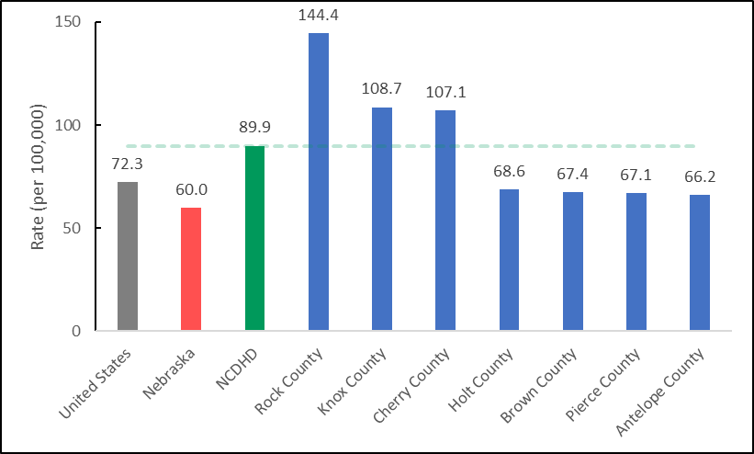
Note. NCDHD rate calculated at 89.9 using NCHS 2019 data. No data was available for Boyd and
Keya Paha counties.

Social and Economic Factors: Motor Vehicle Safety
Individual-level safety behaviors also contribute to the overall health and sense of well-being within a community. Vehicular safety plays a large role in preventing accidental injuries, which in turn promotes feelings of safety among residents. The NCDHD service area has a rate of 20.0 motor vehicle crash deaths per 100,000 residents, although data is only available for Holt, Knox, and Pierce counties (NCHS, 2019). When asked about vehicle safety, only 52.5% (n = 727) of NCDHD residents said they always wear a seatbelt while driving or riding in a car, 63.8% (n = 379) reported talking on a cell phone while driving in the past 30 days, and 22.9% (n = 380) said they had texted while driving in the past 30 days (NBRFSS, 2020; NBRFSS, 2017). Teenagers also reported talking on their cell phone (n = 349; 42.3%) and texting or using an app (n = 389; 48.7%) while driving in the past 30 days (NRPFSS, 2018).

Social and Economic Factors: Student Safety
NCDHD service area students were asked to self-report on several aspects of safety. The majority of students agreed that they felt safe at their school (n = 1001, 90.8%). However, when asked about being bullied, some students reported being bullied physically (n = 991; 5.0%), verbally (n = 990; 21.9%), socially (n = 989; 21.0%), and electronically (n = 990; 7.3%) at least once a month in the past year. Additionally, some students also reported being physically hurt on purpose by someone they were dating (n = 1001; 5.4%) within the past year.

Social and Economic Factors: Safety Planning
Safety planning at work and home can help increase preparedness for emergencies, reduce injuries during emergencies, and contribute to an increased sense of safety during non-emergencies. NCDHD residents were asked several questions related to safety planning, and 65% (n = 200) reported having a family plan for emergencies, 44.1% (n = 213) reported maintaining an emergency preparedness kit at home, 92.0% (n = 176) reported having a written emergency action plan at work or school, and 6.1% (n = 49) reported that employees or students received training for their emergency action plan within the last year (CHA, 2021).

Social and Economic Factors: Community Perspectives
NCDHD community members were asked to provide some insight on topics such as what they thought would make their neighborhoods healthier places for them and their families. A wide range of responses (194) were given that were categorized into several themes: increased access to healthy options, increased health education and prevention, and improvements to community spaces. See Tables A6 and C19 for community insight into these themes.
Increased access to healthy options. Many responses focused on increased access to fresh, healthy food options within their communities. This includes better access to grocery stores with fresh food options and more healthy options in their schools, as well as access to better drinking water. This concern is supported by data indicating that 15.3% of NCDHD residents suffer from food insecurity (NBRFSS, 2015). Additionally, free or low-cost education and training opportunities were discussed as ways to increase the communities’ healthy options, including training on healthy food options and cooking classes and general community education on health topics. Additionally, respondents noted some community assistance needs, such as help covering costs of necessary home repairs and affordable health insurance.
Increased health education and prevention. Several responses espoused a need for increased mental health education regarding resources, stigma, prevention efforts, and better access to resources throughout their community, especially in schools. One participant specified:
“Recognition that mental health is an integral part of your overall health and needs checked just like your lipids”
Several other target areas for health education include the negative effects of tobacco, drugs, alcohol use/abuse, and vehicular safety, such as distracted driving, speeding, and traffic sign adherence. Several people commented on the need for increased attention to maintaining healthcare facilities as well as needing more healthcare providers in the area. One respondent also mentioned the need for a decrease in pesticide use throughout the area. Detailed qualitative responses on these items are featured in Appendix B and Table C19.
Improvement of community spaces. Several types of community area improvements were suggested, including increased spaces for children to play, increased and improved access to sidewalks and general attention to walkability, expansion of walking and biking trails, and better traffic lights. Respondents also mentioned that affordable exercise programs and access to indoor swimming would make their neighborhoods healthier places to live.

NCDHD Clinical Care
Although advances in medicine and science continue to offer great promise, lack of access to clinical care, and disparities in quality of care continue to serve as critical differentiators that affect outcomes across population groups. Numerous studies indicate that clinical care access and experiences align with health outcome disparities, particularly at the level of socio-economic (Lazar & Davenport, 2018; Riley, 2012) and racial/ethnic group (Cook et al., 2017; Mayberry et al., 2000) differences. In addition to these broad social inequities, systems for healthcare payment also drive access to and quality of clinical care for a wide variety of physical and mental health issues (Fry & Sommers, 2018; Loehrer et al., 2018; Zhao et al., 2018). The CHR model bifurcates clinical care measures into two categories - quality of care and access to care.

Clinical Care: Access to Care
Regular access to clinical care is critical for illness or disease prevention, management and treatment. Access to care is essential to achieving health equity, but profound barriers exist for many populations (AHRQ, 2021). The CHR employs several broad indicators for access to care. Lack of health insurance coverage prevents many people from obtaining preventative care, and can also be a source of major financial instability. In 2018, an estimated 12% of the NCDHD’s population under age 65 was uninsured, compared to an overall average of 9% for Nebraska. When looking specifically at adults aged 18-64 in the NCDHD area, 13.2% reported not having health insurance, compared to the Nebraska average of 11%. For children under 19 in the NCDHD area, 8.8% are estimated to not have health insurance, compared to a statewide average of 5%. This data suggests that both adult and child residents of the NCDHD area have a lower rate of insurance coverage relative to the rest of Nebraska. Tables A10 to A12 present CHA survey responses related to health insurance coverage and barriers to healthcare.
The Community Health Rankings model also contains measures identifying the ratio of health care providers to the overall population. The ratio of the population to number of primary care physicians averaged across counties in the NCDHD was 1,366 persons per primary care provider, compared to an overall statewide average of 1,310 persons per primary care provider. The NCDHD ratio of the population to dentists was 555 to one dentist, compared to an average of 1,270 persons per dentist in Nebraska. Finally, averaged across NCDHD counties, the ratio of the population to mental health providers was 1,903 persons per mental health provider, compared to an overall average of 360 people per mental health provider statewide. It should be noted that all counties which compose the NCDHD are designated as health professional shortage areas by the State of Nebraska for at least one if not all primary medical professions; as well as dentistry, pharmacy, and allied health professions (Wehbi et al., 2020). Additionally, every NCDHD county is also a HRSA-designated mental health professional shortage area (HRSA, 2021).
The NBRFSS asks several questions centering on access to care. According to the NBRFSS 2020 survey results for the NCDHD area, 10% of adults aged 18-64 reported having no health care coverage, whereas 89.9% did. The overall Nebraska average for these survey items were 15.1% and 79.5%. Similarly, 7.8% of NCDHD adults aged 18-64 years old indicated that they needed to see a doctor but could not due to cost in the past year. The Nebraska average was higher, with 9.3% of adults reporting needing to see a doctor but, not being able to due to costs. In terms of having a primary care doctor, 14.3% of adults 18-64 years old indicated they had no personal doctor or health care provider, but 85.7% did. This compares to an overall Nebraska average of 20.5% not having a personal doctor, and 79.5% having a doctor. Among adults within the NCDHD aged 65 or above, 95% had a personal health care provider, or more than one, which is similar to the statewide average of 95%.
Finally, the NCDHD CHA survey, although not representative of the larger population, provides some insight into barriers to accessing clinical care. When asked what problems prevented people from access health screening or services, 49.6% of respondents said there were no barriers. Among those reporting barriers, the top associated problems to accessing care were high costs (15.4%), followed by not knowing when and what kind of services to obtain (11.4%), and not receiving a recommendation from a provider for any screening services (also 11.4%). A major barrier to accessing clinical care is transportation. When it comes to distance needed to travel for clinical care, CHA respondents indicated that distance varied by type of profession or service (Table 8; See Table A13 for detailed data on travel time to clinical care). Distance traveled was less for more common health professionals. For example, 83.3% and 81.4% of NCDHD CHA respondents indicated they lived within 0-30 miles of a primary care provider or pharmacist, respectively. For specialty providers, distances traveled could be much further. Over 33% of respondents indicated they had to travel 75 or more miles to access an oncologist. The availability of specialty care providers in the NCDHD thus remains a significant barrier to some residents. Tables A14 to A18 provide information on healthcare utilization and satisfaction with NCDHD providers.
Table 8. Distance in Miles to meet Health Professionals for NCDHD CHA Respondents
 | n | 0-30 miles | 31-45 miles | 46-75 miles | 75+ miles
Primary Care Professional | 192 | 83.3% | 10.4% | 4.2% | 2.1%
Cardiology | 118 | 55.9% | 13.6% | 11% | 19.5%
Orthopedic | 111 | 41.4% | 17.1% | 11.7% | 29.7%
Urology | 91 | 45.1% | 16.5% | 14.3% | 24.2%
Obstetrics/Gynecology | 92 | 39.1% | 20.7% | 17.4% | 22.8%
Pediatrician | 74 | 33.8% | 23.0% | 14.9% | 28.4%
General surgery | 93 | 49.5% | 17.2% | 15.1% | 18.3%
Oncology | 80 | 27.5% | 22.5% | 16.3% | 33.8%
Mental Health | 77 | 50.6% | 16.9% | 11.7% | 20.8%
Dental Health | 159 | 40.5% | 19.5% | 8.8% | 5.7%
Prescriptions/Pharmacy | 156 | 81.4% | 11.5% | 3.8% | 3.2%
Other | 38 | 52.6% | 7.9% | 5.3% | 34.2%

Clinical Care: Quality of Care
Quality of care generally refers to quality screening activities, preventative care, and treatment of acute or chronic conditions to maintain or increase overall wellness and improve health outcomes. Care quality is a broad concept and implicates not only delivery of services to individual consumers, but availability of community health resources and quality and accessibility to health care systems. The CHR model focuses on measures that indicate receipt of timely, preventative services that can decrease health risks and preventable health issues.
The rate of flu vaccinations refers to the percentage of Medicare enrollees that received an annual flu vaccination, based on Medicare reimbursements. Influenza is a common virus that can cause serious illness and death, particularly among medically vulnerable populations. The percentage of fee-for-service Medicare enrollees who received a reimbursed flu vaccine averaged across counties within the NCDHD was 23.1%, significantly lower than the statewide average of 50% (MMD, 2018). This difference speaks to the importance of expanding education about the value and safety of vaccines and identifying opportunities to integrate and provide influenza vaccinations to community members in affordable and accessible ways.
Mammography screenings measure the percentage of female Medicare enrollees that receive an annual mammography. Regular screenings can reduce breast cancer deaths and increase the survival rate among patients and is particularly recommended for females over the age of 45. The percentage of female fee-for-service Medicare enrollees who received a mammogram averaged across counties within the NCDHD was 43.9%, compared to an overall Nebraska average of 48% (MMD, 2018).
Preventable hospital stays are the rate of hospitalizations per 100,000 Medicare enrollees that are identified as ambulatory-care sensitive conditions (ACSC). These ACSC hospitalizations fall under a wide category of conditions that are generally considered to not require hospitalizations, such as acute diabetes, dehydration, or asthma-related issues (Ansari et al., 2006; Hodgson et al., 2019). Conceptually, researchers have examined and presented elevated rates of preventable hospital stays as an indicator of inadequate access to or low quality or quantity of primary care resources in the community (Freund et al., 2013). In 2018, the number of ACSC hospitalizations per 100,000 Medicare enrollees in the NCDHD was 3242, lower than the overall average rate for Nebraska of 3,475 (MMD, 2018).
The NBRFSS responses provide some insight into how NCDHD residents experience and perceive information about health or medical issues. When asked how difficult it was for people to get needed advice or information about health or medical topics, 68% of respondents (n = 642) thought it was very easy. Additionally, 51% and 52%, respectively, thought it was very easy to understand information from medical professionals, and understand written health information. Ideally, increasing the percentage of people who find it very easy to find, consume and understand health information should remain a priority public health strategy for the foreseeable future.
Functional health literacy, or the ability to read, understand, and act on health information is a crucial skill so individuals understand their options and diagnoses, directions for medication, and self-care instructions (Andrus & Roth, 2002). When asked if they had trouble reading and understanding health information, 14.4% of NCDHD residents (n = 235) reported sometimes or often having trouble. Health literacy also includes basic knowledge about the health services provided in the area, or by the NCDHD itself. See Table A19 for information on respondent knowledge and awareness of the health services offered by the NCDHD.

NCDHD Health Behaviors
An abundance of research shows that personal health behaviors are strongly linked to chronic disease, mortality, or other outcomes that affect well-being (Berrigan et al., 2003; Hanson & Chen, 2007; Schwarzer, 2008). Cancer, heart disease, diabetes, and other leading causes of death in the United States are strongly associated with unhealthy behaviors that may evolve over a lifetime (Colditz et al., 1992; Keys, 1957; Sasco et al., 2004; Walker et al., 2010). Health professionals play a critical role highlighting behavioral health risks and promoting interventions that encourage communities and individuals to adopt and maintain healthy behaviors across their lifespans. According to NBRFSS data (2020), 70.5% (n = 749) of NCDHD respondents had a routine checkup in the past year with a healthcare provider, 89.7% (n = 436) had their blood pressure checked in the past year, 61.5% of female respondents aged 21-65 (n = 150) reported up-to-date cervical cancer screenings, and 69.0% of females aged 50-74 (n = 230) reported up-to-date breast cancer screenings. Among CHA (2021) survey respondents, 92.7% (n = 234) indicated that they had seen a primary care provider once within the previous one to two years, 85.7% (n = 231) had seen a dentist, and 83.9% (n = 229) had seen an eye doctor. Regularly seeing a healthcare provider and screening for common conditions is an important preventative measure. Tables A20 and A21 provides detailed information on use of preventative health services. Particular areas of interest in behavioral health include data on sexual activity, alcohol and drug use, diet and exercise, and tobacco product use.

Health Behaviors: Tobacco Use
Tobacco use has historically been one of the top preventable causes of morbidity and death in the United States (CDC, 2012; King et al., 2012). Approximately 480,000 deaths a year are caused by cigarette smoking and secondhand exposure (Gallaway et al., 2018). In the United States, cigarette smoking has become less prevalent from what it was previously. In the 1970s, over 35% of college-educated adults smoked cigarettes, whereas in 2010 that number had declined to less than 10% (Drope et al., 2018). Changes in access and price due to tobacco control policies and the popularity of e-cigarette vaping has considerably altered patterns of tobacco use. Increased vaping among adolescents, and particularly those from low-income or disadvantaged populations, has become a major concern (Dai and Leventhal, 2019; Obisesan et al., 2020).
The NBRFSS data for 2020 indicates that 13.5% of adults in the NCDHD currently smoke cigarettes, and 8.7% use smokeless tobacco. Additionally, 2.3% of adults reported current tobacco vaping, and 14.4% reported vaping tobacco in their lifetimes. Youth responses to the NRPFSS (2018) showed tobacco use that was slightly higher than state averages. For example, among 12th grade respondents 19.6% reported current cigarette or smokeless tobacco use (compared to 15.3% statewide), and 38.9% reported vaping once or more in the past 30 days (compared to 37.3% statewide). Because of the discreet nature of vaping, lower cost compared to cigarettes, and perception that vaping is a “safe” form of tobacco consumption, the illegal use of e-cigarettes has become more prevalent with minors. Among 10th graders, 23.7% of NRPFSS respondents in the NCDHD reported vaping once or more in the past 30 days (compared to 24.7% statewide), and with 8th graders, 8.6% reported vaping in the past 30 days (compared to 10.4% statewide). The continuing prevalence of tobacco consumption – particularly the popularity of vaping products among youth – suggests the need to increase school-based preventive education, tobacco use cessation programming, and other policies to restrict tobacco use and the effects of secondhand smoke. Tables A23 to A25 include further information on tobacco/nicotine use.

Health Behaviors: Diet and Exercise
Maintaining a healthy diet and regular exercise are key predictors of positive health outcomes. An abundance of evidence links obesity with a wide variety of chronic health conditions, including diabetes, heart disease, stroke, hypertension, cancers, and other illnesses (Hu, 2003; Hubbard, 2000; Kelly et al., 2013; Nejat et al., 2010). Obesity and poor exercise habits are major factors causing preventable chronic diseases and deaths among Americans, resulting in substantially increased individual health care costs and social-economic losses. It should be noted that both obesity and lack of exercise are also impacted by environmental conditions (e.g., costs and availability of healthy food) (Cooksey-Stowers et al., 2017; Walker, Keane & Burke, 2010) and workplace or social and community contexts that promote sedentary lifestyles (Bassett et al., 2015; Gaziano, 2010). It is worth highlighting that the prevalence of obesity and its health impacts in the United States is among the highest in the world, and research indicates strong associations between obesity and race, ethnicity, income, and educational status (Kirby et al., 2012; Lee, 2011; Rossen, 2014).
CHA survey results suggest that residents may feel that they are in overall good health (Table A26). However, NBRFSS (2020) data for the NCDHD indicate that 66.1% (n = 702) of respondents reported being either overweight (Body Mass Index > 25) or obese, and 32.2% (n = 702) indicated they were obese (Body Mass Index > 30). Forty percent (n = 318) of NBRFSS respondents eat less than one piece of fruit a day, and 19.4% (n = 774) consumed vegetables less than one time a day. Additionally, 29.3% (n = 757) of adult respondents indicated that they had no leisure-time activity in the past 30 days. Again, considerations of poverty and barriers to obtaining healthy food are issues of note. The Community Health Rankings data indicate that an average of 11.9% of respondents across the NCDHD reported not having access to a reliable source of food the previous year, and 16.5% of the low-income population does not live close to a grocery store. Opportunities to exercise or engage in physical activities are also important. Tables A 27 to A 30 provide additional information from CHA survey respondents on physical activity and status.

Health Behaviors: Alcohol and Drug Use
Alcohol sale and consumption is a widespread fixture of American life. However, excessive use has been linked to a wide range of preventable chronic conditions and acute issues, including a variety of cancers, cardiovascular disorders, and gastrointestinal conditions (Room et al., 2005). Excessive alcohol use is also associated with unintentional and intentional injuries (Chikritzhs & Livingston, 2021; Shield et al., 2012), co-morbidities in mental health (Tembo et al., 2017; Weitzman, 2004), and domestic or relationship aggression and violence (Foran & O’Leary, 2008; Leonard, 2005). Similarly, illegal drug use and addiction is linked to a variety of physical and mental health co-morbidities (Fenton et al., 2012; Jones & McCance-Katz, 2019) and drug overdose related deaths (Lim et al., 2021; Lippold et al., 2019). Studies have indicated that patterns of substance use and associated risk behavior vary by age and geography. For example, alcohol and methamphetamine use is generally higher among rural youth than urban youth (Lambert et al., 2008). Among people aged 12 or older in 2020, marijuana remains the most widely used substance that remains illegal under federal law (49.6 million used in the past year) followed by abuse of prescription drugs (9.3 million used in the past year) (SAMHSA, 2021). SAMHSA estimates that 2.5% of individuals older than 12 years abuse/misuse prescription drugs in Nebraska compared to a national average of 3.7% (SAMHSA, 2020).
According to NBRFSS data for 2020, 55.5% of adult respondents reported having consumed alcohol in the past 30 days, 20.8% reported binge drinking (4/5 or more drinks on a single occasion for females/males) within the past 30 days, 6.3% reported heavy drinking (8/15 or more drinks in a week for females/males), and 1.5% reported driving under the influence of alcohol. The NCDHD CHA survey indicated that 13.5% (n = 193) of respondents reported consuming alcohol more than three times a week, and 11.2% (n = 187) reported binge drinking in the past month.
The NRPFSS provides a wider range of data about alcohol and substance use among youth by sampling students from participating public and private school in Grades 8, 10, and 12 from across the state. Among NCDHD youth respondents, 7.2% (n = 996) indicated they had consumed alcohol three or more times in the previous month (6.1% statewide), and 26.7% (n = 997) indicated it was a little or not wrong to drink alcohol frequently (25.3% statewide). Additionally, 12.0% (n = 998) of youth respondents reported that half or more of their peers drank alcohol within the past 30 days (30.7% statewide). Indicators regarding marijuana use suggest a significant prevalence of use among youth. Among youth respondents who reported use of marijuana, 24.6% (n = 114) of respondents indicated first use at a mode of 15 years of age. Five percent (n = 997) indicated a lifetime use of marijuana of 10 or more times, and 2.9% (n = 993) reported using marijuana 3 or more times a week. Among respondents in the NCDHD service area, 2.9% (n = 993) indicated current use of marijuana within the past 30 days compared to a statewide average of 3.9% (NRPFSS, 2018). Additionally, 49.8% (n = 987) of youth respondents also indicated that it was easy to obtain alcohol, and 21.1% (n = 986) stated it was easy to obtain marijuana. Among those who reported drinking alcohol in the past 30 days, 45.0% (n = 211) indicated they accessed alcohol at a party, 25.9% (n = 201) indicated they had someone buy it for them, and 22.3% (n = 211) got it from home without permission. The prevalence of alcohol and drug use among both adults and youth suggests several possible community strategies, including community education directed to both youth and adults, continued screening and brief intervention processes, and more robust enforcement of laws pertaining to illegal sale or provision of alcohol to minors, such as increased compliance checks and expanded liability for alcohol providers (CHR, 2021). Additional information on alcohol use among CHA survey respondents is provided in Tables A31 and A32.

Health Behaviors: Sexual Activity
Research studies indicate disproportionately higher rates of Human Immunodeficiency Virus (HIV) and other sexually transmitted diseases among men who have sex with men (Oster et al., 2011; Prejean et al., 2011), younger people (Rangel et al., 2006), and racial minorities (Maulsby et al., 2014; Wohl et al., 2013). Sexually transmitted infections are associated with reproductive health and other acute and chronic conditions (Owusu-Edusei, 2013). Community Health Rankings data derived from the National Center for HIV/AIDS, Viral Hepatitis, STD, and TB Prevention, indicate that the number of newly diagnosed chlamydia cases per 100,000 population in the NCDHD averaged across counties is 157.9, which, as seen in Figure 9, appears lower than the national (539.9; t(5) = -21.313, p < .05) and state (418.0; t(5) = -14.600, p < .05) rates, but due to missing data from several counties, these results should be interpreted with caution (CHR, 2021).
Figure 9. Chlamydia Incidence Rate in U.S., NE, & NCDHD
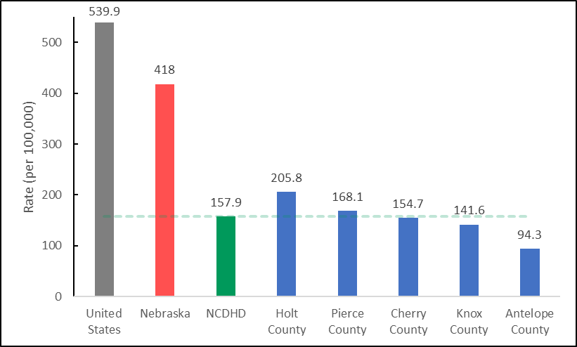
Note. NCDHD rate calculated at 157.9 using National Center for HIV/AIDS, Viral Hepatitis, STD, and
TB Prevention 2018 data. No data was available from Boyd, Brown, Keya Paha, & Rock counties.

Chlamydia incidence is used as a measure of unsafe sexual activity as it is the most common bacterial sexually transmitted infection in the United States (CHR, 2021). Among CHA survey respondents, only 17.1% (n = 193) indicated that they had been tested for a Sexually Transmitted Disease (STD) within the previous one to two years, and 61.7% (n = 193) indicated that they had never been tested for an STD. Likewise, only 11.4% (n = 193) of CHA survey respondents reported receiving an HIV test within the previous one to two years, and 68.9% (n = 193) reported never being tested for HIV. The CHA survey responses reflect NBRFSS data, which indicate that only an estimated 21.1% (n = 396) of adult residents have ever tested for HIV (NBRFSS 2020). NCDHD client-reported number of sexual partners is provided in Table A33.
Teen pregnancy is often associated with unsafe sexual activity, indicative of increased risk of STIs, and can result in a variety of acute and chronic adverse health conditions (Black et al., 2012; Leve, et al., 2013). Unplanned teen pregnancies can result in significant social costs, with teen mothers being less likely to complete high school and obtain meaningful career training opportunities (Card, 1999; Lavin & Cox, 2012), and contributes to unequal achievement gaps and poverty among young mothers and families later in life (Basch, 2011; Johns, et al., 2000; Tortolero et al., 2010). Teen pregnancy is also associated with underweight or premature births, and a variety of birth defect risks that may impact well-being much later in life (Bornstein et al., 2021; Gill et al., 2012). As seen in Figure 10, Community Health Rankings data derived from the National Center for Health Statistics (2019) indicate that the average number of births to females aged 15-19 across NCDHD counties is 17.9 per 1,000 females, which appears similar to the national (20.9; t(5) = -1.093, p > .05) and state (19.7; t(5) = -0.662, p > .05) rates, but due to missing data for several counties, these results should be interpreted with caution.

Figure 10. Reported Teen Births in the U.S., NE, and NCDHD
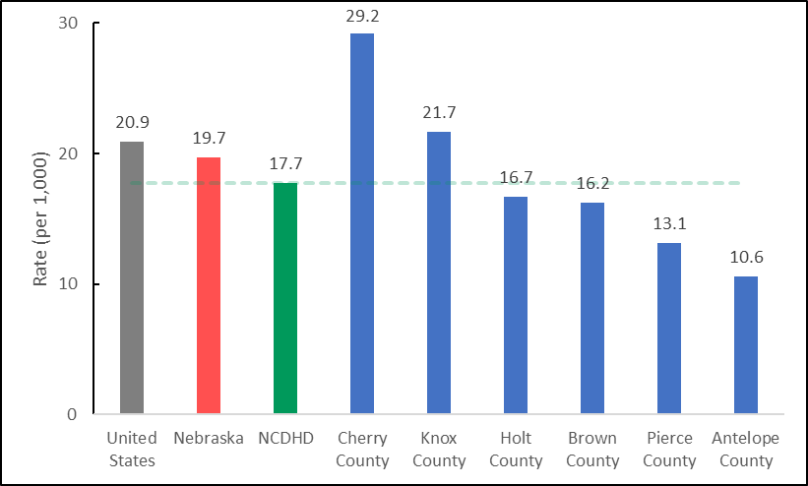
Note. NCDHD rate calculated at 17.7 using National Center for Health Statistics - Natality files
2019 data. No data was available from Boyd, Keya Paha, & Rock counties.
Preventing unplanned teen pregnancies implicate a number of potential interventions and strategies, including access to pre- and post-natal health care for teen mothers and their children in communities and schools, case management services for young families with income and education needs, and sexual education and reproductive health services in general (Alford, 2009; Kirby, 2001).

Health Outcomes
Health outcomes represent the overall current health of the community. Health outcomes are driven and influenced by core structural problems related to place, environment, financial insecurity, and social inequality. All structures and influences identified in the CHR model drive the health factors that impact community health outcomes. The CHR model presents health outcomes as measures of the overall physical and mental well-being of people. Health outcomes fall in two categories of data: 1) length of life measures, which indicate how long people are living, as well as the prevalence of premature deaths; and 2) quality of life measures, which indicate how healthy people are and feel throughout their lives.
Distinctions exist between NCDHD and Nebraska residents when it comes to length of life. There are similarities among top causes of death but differences in rates of death per 100,000 residents among the major causes. As seen in Table 9, though heart disease, cancer and lower respiratory disease were the top three causes of death in NCDHD between 2015-2017 and 2018-2020, different rates for other causes fluctuated over time. The top three causes of death and rates per 100,000 residents between 2018 and 2020 for NCDHD (Table 9) versus Nebraska (Table 10), respectively, were heart disease (292.6; 182.9), cancer (223.9; 181.7), and respiratory diseases (81.4; 57.2; CDC, 2020). These rates may reflect differences between older (NCDHD) and younger populations (Nebraska overall). For example, Alzheimer’s disease was the fourth leading cause of death among residents of the NCDHD (65.7) but the sixth leading cause of death among Nebraska residents overall and at a much lower rate of death (38.9).
Table 9. Top Causes of Death in NCDHD 2015-2017 & 2018-2020
 |  | 2015-2017 |  |  |  | 2018-2020
Rank | Cause of Death | Deaths | Crude Rate | Rank | Cause of Death | Deaths | Crude Rate
1 | Diseases of heart | 447 | 328.8 | 1 | Diseases of heart | 392 | 292.6
2 | Malignant neoplasms | 321 | 236.1 | 2 | Malignant neoplasms | 300 | 223.9
3 | Chronic lower respiratory diseases | 109 | 80.2 | 3 | Chronic lower respiratory diseases | 109 | 81.4
4 | Accidents (unintentional injuries) | 93 | 68.4 | 4 | Alzheimer disease | 88 | 65.7
5 | Cerebrovascular diseases | 92 | 67.7 | 5 | Cerebrovascular diseases | 77 | 57.5
6 | Diabetes mellitus | 64 | 47.1 | 6 | Accidents (unintentional injuries) | 77 | 57.5
7 | Alzheimer disease | 58 | 42.7 | 7 | COVID-19 | 77 | 57.5
8 | Influenza and pneumonia | 52 | 38.3 | 8 | Diabetes mellitus | 66 | 49.3
9 | Nephritis, nephrotic syndrome and nephrosis | 28 | 20.6 | 9 | Influenza & pneumonia | 44 | 32.8
10 | Parkinson disease | 24 | 17.7 | 10 | Nephritis, nephrotic syndrome and nephrosis | 29 | 21.6
11 | Essential hypertension and hypertensive renal disease | 23 | 16.9 | 11 | Parkinson disease | 22 | 16.4
12 | Intentional self-harm (suicide) | 22 | 16.2 | 12 | Intentional self-harm (suicide) | 21 | 15.7
13 | Chronic liver disease and cirrhosis | 16 | UR | 13 | Essential hypertension & hypertensive renal disease | 20 | 14.9
14 | Septicemia | 15 | UR | 14 | In situ, benign, & neoplasms of uncertain/unknown behavior | 13 | UR
15 | Pneumonitis due to solids and liquids | 12 | UR | 15 | Chronic liver disease & cirrhosis | 13 | UR
Note. Crude rate is defined as number of deaths per 100,000 residents. UR = Unreliable crude rate.

Table 10. Top Causes of Death in Nebraska 2018-2020
 | UCD - 15 Leading Causes of Death NE | Deaths | Crude Rate
1 | Diseases of heart | 10611 | 182.9
2 | Malignant neoplasms | 10539 | 181.7
3 | Chronic lower respiratory diseases | 3320 | 57.2
4 | Accidents (unintentional injuries) | 2560 | 44.1
5 | Cerebrovascular diseases | 2406 | 41.5
6 | Alzheimer disease | 2259 | 38.9
7 | COVID-19 | 2043 | 35.2
8 | Diabetes mellitus | 1760 | 30.3
9 | Influenza & pneumonia | 1047 | 18.0
10 | Essential hypertension & hypertensive renal disease | 957 | 16.5
11 | Intentional self-harm (suicide) | 863 | 14.9
12 | Parkinson disease | 785 | 13.5
13 | Chronic liver disease & cirrhosis | 764 | 13.2
14 | In situ, benign, & neoplasms of uncertain/unknown behavior | 746 | 12.9
15 | Septicemia | 506 | 8.7
Note. Crude rate is defined as number of deaths per 100,000 residents.
It should be noted that deaths attributed to COVID-19 in NCDHD and Nebraska were lower than in the U.S. overall. In 2020, COVID-19 was the third leading cause of death in the United States (85; CDC, 2020), after heart disease and cancer. COVID-19 was the seventh leading cause of death in both the NCDHD (57.5) and Nebraska (35.2).

Health Outcomes: Length of Life
Length of life measures indicate overall length of life among community members relative to others. Length of life can be impacted in a number of ways, and measures employed can identify areas of concern and potential areas for preventative interventions. Premature death refers to Years of Potential Life Lost (YPLL), expressed as the number of years of life lost per 100,000 residents due to deaths before the age of 75 over a three-year period (2017-2019). The statewide YPLL for Nebraska is 6,148.5 years, compared to a slightly higher average of 6768.7 YPLL across the counties composing the NCDHD (excluding Keya Paha County, which did not have reported data). Life expectancy – the average number of years a person is estimated to live – is 79.6 years for Nebraska and 80.1 for the NCDHD (excluding Keya Paha and Rock counties), suggesting approximate parity, t(7) = 1.267, p > .05 (Figure 11).
Figure 11. Life Expectancy in U.S., NE, and NCDHD
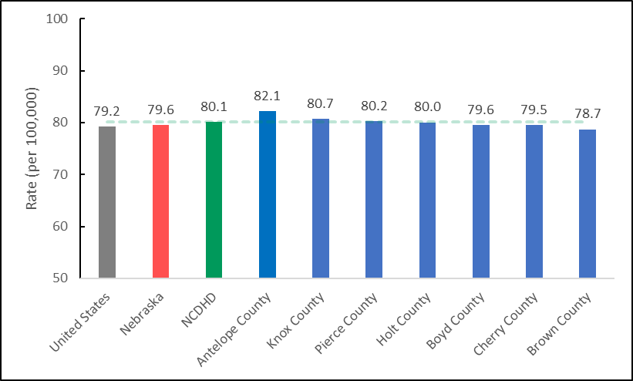
Note. Average line calculated as 80.1 using NCHS 2017-2019 data. No data was available for Keya
Paha and Rock counties.

Health Outcomes: Quality of Life
Quality of life is a broad concept that includes overall wellness, subjective experiences and feelings, and day-to-day functioning. The CHR model presents quality of life as select measures that reflect the overall health and well-being of people while alive, providing more depth than length of life indicators. Self-reported health-related quality of life is a well-accepted subjective measure that aligns with overall mortality risk measures (CHR, 2021). Averaged across counties, the percentage of adults reporting ‘fair’ or ‘poor’ health in the NCDHD was 12.0%, compared to the state average of 10.8% (NBRFSS, 2020). The averaged county values (age-adjusted) in the NCDHD for the number of physically unhealthy days reported in the past 30 days was 2.8 days, compared to the statewide average of 2.6 (NBRFSS, 2020). Similarly, averaged county values in the NCDHD for the reported number of mentally unhealthy days in the past 30 days was 2.3 days, while the Nebraska average number of days was 3.8 (NBRFSS, 2020).
Two additional self-reported quality of life measures include frequent physical distress and frequent mental distress, which are more responsive to individuals with chronic or severe physical or mental health conditions. Frequent physical distress is the percentage of adults reporting 14 or more days of poor physical health in the past 30 days, and frequent mental distress is the percentage reporting 14 or more poor mental health days. The averaged values across NCDHD counties was 8.5% for frequent physical distress, and 6.6% for frequent mental distress, compared to overall Nebraska values of 7.9% and 11.9%, respectively (NBRFSS, 2020). Additionally, the presence of diabetes is another major quality of life indicator. Diabetes is a common condition, and its high prevalence reflects a number of unhealthy factors and behaviors endemic in society. The CDC (2021) estimates that in 2019, 37 million people of all ages had diabetes in the United States. Averaged across counties, the proportion of adults aged 20 or above with diagnosed diabetes was 11.2% in the NCDHD, and 10% overall in Nebraska (t(8) = 2.258, p > .05), reflecting relative parity. Additional data on disabilities and experienced health issues are provided in Tables A34 and A35.

COVID-19

COVID-19: Morbidity and Mortality
The COVID-19 pandemic has brought significant disruptions to the nation’s economy and society, including in Nebraska. The Johns Hopkins University of Medicine Coronavirus Resource Center reports a total of 3,815 deaths and 451,074 confirmed cases of COVID-19 for Nebraska since the pandemic began, and an estimated 63% of the population fully vaccinated (JHU, 2021, Feb. 15). It should be noted that deaths attributed to COVID-19 in both the NCDHD and Nebraska were lower than in the U.S. overall. In 2020, COVID-19 was the third leading cause of death in the United States (85; CDC, 2020), after heart disease and cancer. COVID-19 was the seventh leading cause of death in both the NCDHD (57.5) and Nebraska (35.2).
According to publicly available data compiled by the NCDHD (2022), as of February 2022 there were a total of 9,657 confirmed COVID-19 cases and 122,156 tests across all NCDHD counties (NCDHD, 2022). The highest number of confirmed cases in the NCDHD coverage area occurred in Holt County (2283 cases), and the least in Keya Paha (128 cases). Table 11 shows the number of confirmed cases per county and distribution across the NCDHD coverage area. It should be noted that the Nebraska Department of Health and Human Services also maintains the Nebraska Hospital Capacity and Respiratory Illness Dashboard, which maintains county level data on vaccinations, and cases and reinfections within the previous 14 days.
Table 11: NCDHD COVID-19 Case County by County
County | n | %
Antelope | 1224 | 12.7
Boyd | 447 | 4.6
Brown | 665 | 6.9
Cherry | 986 | 10.2
Holt | 2283 | 23.6
Keya Paha | 128 | 1.3
Knox | 2190 | 22.7
Pierce | 1444 | 14.9
Rock | 290 | 3.0
Total | 9657 | 100.0

COVID-19: Community Attitudes towards COVID-19 Vaccines
COVID-19 vaccination uptake is a critical means to decrease infection rates and prevent the spread of potential variants, but acceptance remains a major challenge (Dai et al., 2021). Self-reported data from the NCDHD CHNA Survey indicate that 80.6% (n = 201) of respondents received a COVID-19 vaccine. However, only 57.5% (n = 191) of respondents said they would recommend getting the COVID-19 to others. Open-ended responses to the questions “Why are you likely, or unlikely, to recommend the COVID-19 vaccine?” and “Where do you get your most trusted information regarding COVID-19?” are provided in Table A 36 and Table A 37, respectively.

Special Populations

Introduction
This document adds to the Community Health Assessment for the North Central District Health Department (NCDHD). The priority populations identified in the NCDHD CHA were low-income residents, Hispanics, Native Americans and the elderly, which this report attempts to provide more helpful information on to guide interventions addressing health disparities in these populations.

Income
A lack of financial resources can make engaging in healthy behaviors difficult, often leading to poor health behaviors and outcomes. Below we see that poor physical health and mental health are all more common among people making less money in their household. A lack of health care coverage for lower income populations, more cancer diagnoses, less up-to-date colon cancer screening and higher depression rates were notable inequities identified for low-income people in NCDHD’s service area.

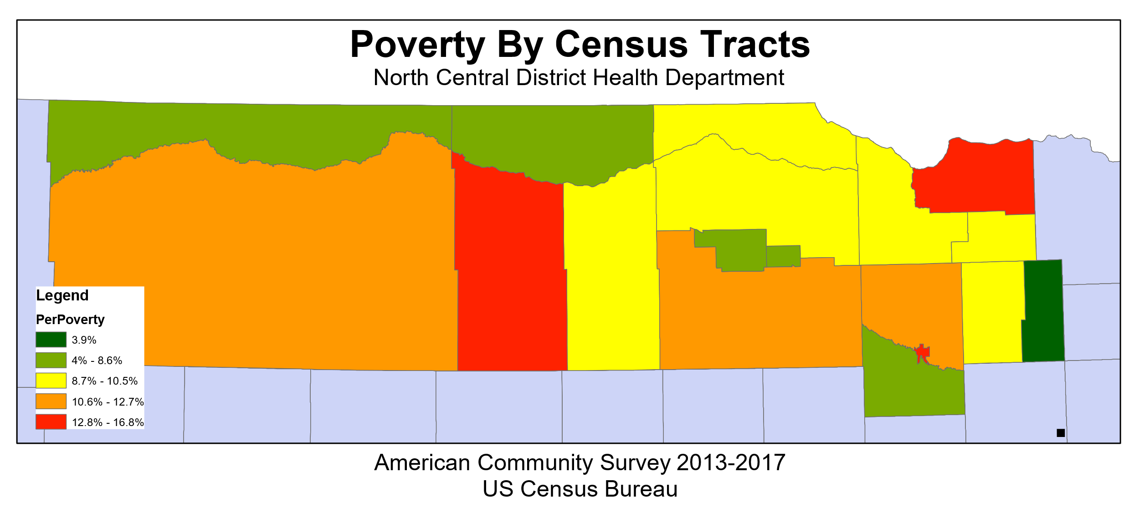

The map shown above helps us understand where possible areas of inequity exist regarding poverty. This map can be used to assist NCDHD and its partners conduct interventions designed to address health inequities associated with poverty.

American Indians and Hispanics:
The two primary minority populations in NCDHD are American Indians and Hispanics. Due to sample size limitations, these charts should be interpreted with caution. General health and physical health is worse for American Indians and Hispanics compared to non-Hispanic Whites, while mental health are better for Hispanics and Whites compared to American Indians. Other notable health disparities are health care coverage, diabetes, cigarette use and depression. Hispanics have higher rates of being uninsured, while American Indians have higher rates of diabetes, tobacco use and depression.

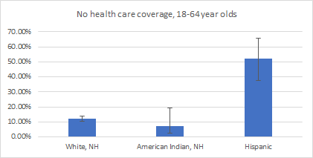 | 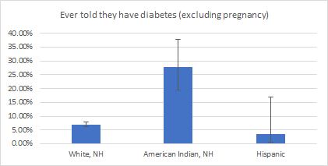

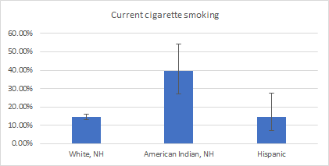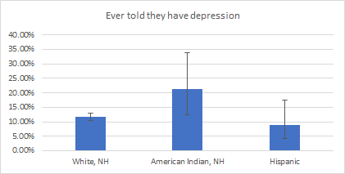
Some notable disparities among American Indians and Hispanics also exist for birth outcomes. These include less frequent prenatal care for American Indians (60.8%) and Hispanics (63.0%) compared to non-Hispanic Whites (76.3%), as well as more frequent preterm births (15.3%) and low birth weight babies (6.8%) for American Indians compared to non-Hispanic Whites (6.8% and 5.2%, respectively). The teen birth rate among Hispanics (37.3) was much higher than those for non-Hispanic Whites (15.0).
Inequities in mortality are most pronounced among American Indians. Specifically, death rates due to heart disease (256.7), cancer (211.8) and unintentional injury (145.9) are much higher than the rates among non-Hispanic Whites (165.2, 141.0, and 44.2, respectively).
The map below shows the distribution of Hispanics in the North Central District Health Department area. Considering that health inequities exist among Hispanics in the NCDHD service area for the indicators of poor health described above, this map should serve as a helpful tool for targeting interventions and reducing the prevalence of poor health outcomes and inequities in our health district.
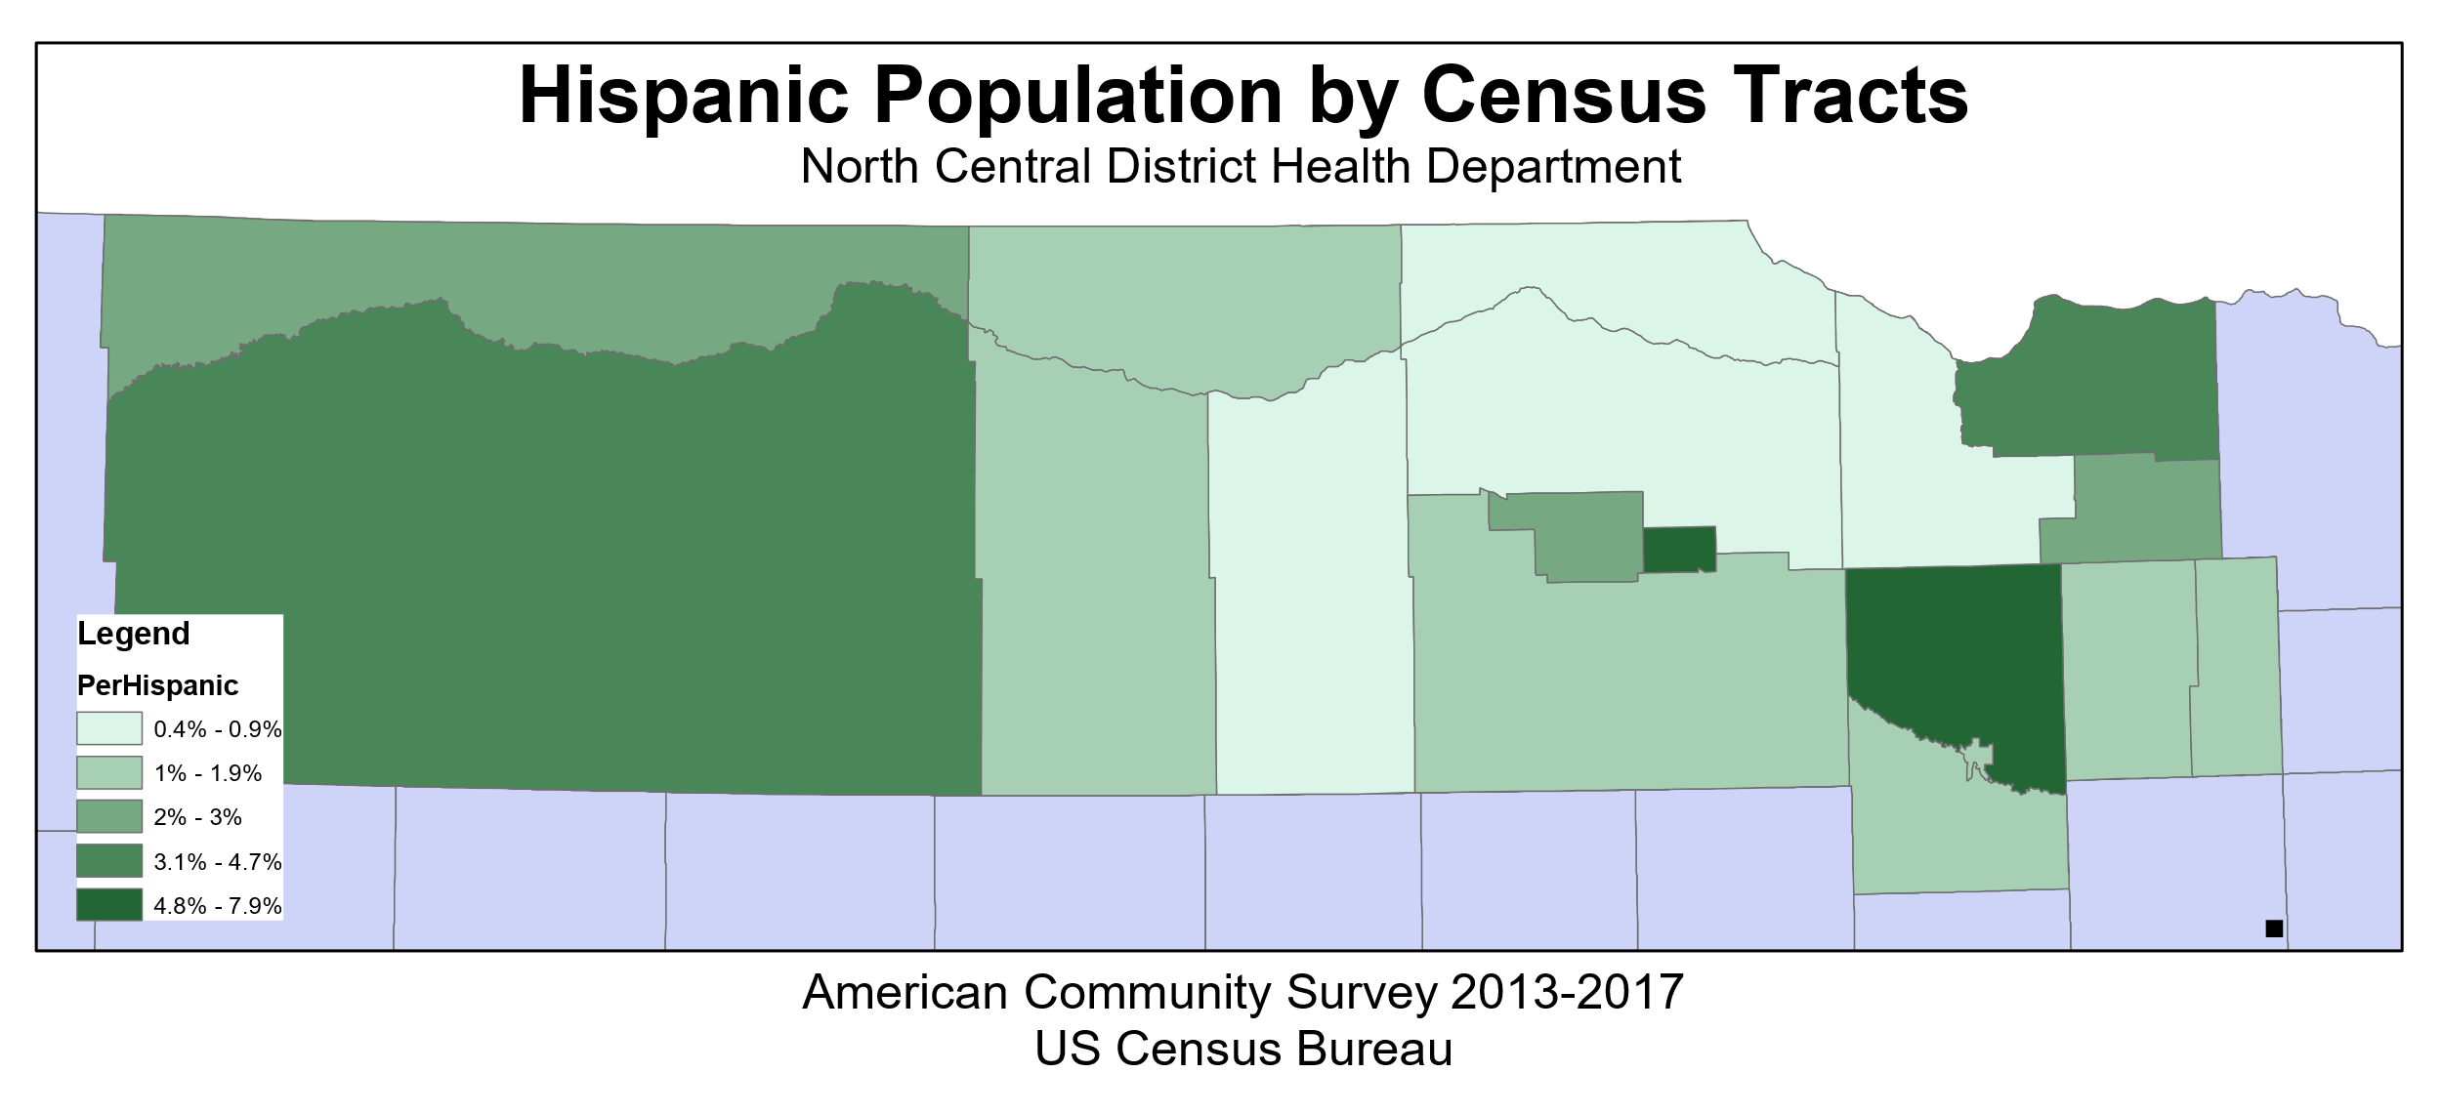
The map below shows the distribution of American Indian and Alaska Natives in the NCDHD service area. This high-risk population also exhibited poor outcomes and health disparities on a variety of indicators and this map should inform NCDHD and its partners interventions.
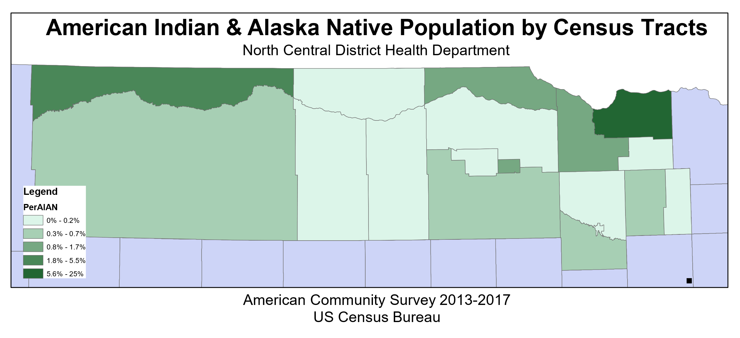
Heart Disease and Diabetes within the Native American
Heart Disease within the Native American Community Background
Per the CDC, heart disease risk factors include high blood pressure, blood cholesterol, diabetes, obesity, lack of exercise, excess alcohol consumption, tobacco use, unhealthy diet, and genetics (Heart Disease Facts, 2021). Per the CDC, diabetes risk factors are family history, age, overweight, lack of physical activity, and history of gestational diabetes.
These risk factors for heart disease and diabetes can be seen in the following information as being present. Where these factors are present, there is also an increased prevalence for heart disease and diabetes within the American Indian population. Where risk factor trends may be similar amongst race groups, mortality rates and access to health differ tremendously. Furthermore, programs preventing or aiding in these diseases vary in counties, further skewing mortality rates and access to healthcare.
Health Disparities
The Nebraska Office of Health Disparities & Health Equity found that 20.9% of Native Americans were unable to see a doctor due to cost (figure 1.1) (Division of Public Health, 2020). The office also found that 26.3% of Native Americans were likely to be considered in fair or poor health (figure 1.2). Between 2013 to 2017, the office found that the top killer of American Indian males was heart disease (15.3%) and the fifth was diabetes (7.3%) out of 300 deaths while for females the second was heart disease (13.2%) and the sixth was diabetes (5.2%) out of 288 deaths (Division of Public Health, 2020). Between these same years, the office found that by the age group of 25-34, both heart disease and diabetes were top causes of deaths for American Indians.
Supplementing the high prevalence of heart disease and diabetes, the Office found that 34.8% American Indians as having high blood pressure (figure 1.3). Figure 1.4 shows that 28.4% of American Indians have high cholesterol (Division of Public Health, 2020). Per 100,000 deaths, it was found that 76.9 American Indian deaths were caused by coronary heart disease, 203.1 were from cardiovascular disease, and 13 were from congestive heart failure (figure 1.5 and 1.6). Of diabetes, it was found that 22.3% of American Indians had diabetes (figure 1.7) (Division of Public Health, 2020). Per 100,000 deaths, it was found that 132.5 were from diabetes and 48.2 were from diabetes as an underlying cause (figure 1.8).
The American College of Cardiology penned an article outlining the problem of cardiovascular disease within the Native American Population (Beck, 2020). In this it was mentioned how the Strong Heart Study showed that American Indians were exposed to toxic metals and air pollution similarly to other rural groups. However, Dr. Eric Brody mentioned that access to health care, poverty, substance abuse, and other socioeconomic issues occurring in rural areas, specifically transportation and insurance. It is also important to note that 26% of American Indians live in poverty (Beck, 2020). Dr. Dena Wilson (cardiology clinical consultant for the IHS) noted that discrimination and microaggressions are an important factor to the health of American Indians in regard to stress. Data shows that about 23% of American Indians have experienced discrimination (Beck 2020).
Insurance
The IHS is the source of health care for many American Indians. It is an agency within the Department of Health and Human Services. Only those within the recognized American Indian tribes and their descendants are eligible to receive care. In total, there are 170 IHS tribal units. The IHS works as the administrative unit for these clinics. However, there are severe funding issues within the IHS. On average, the IHS spends less than half the amount per patient than Medicare or the VA (Beck, 2020). Also, if a patient is not covered by the IHS or is living in an urban area, they are not covered by the IHS. Dr. Brody mentioned that although basic care is covered by the IHS, extensive care may be limited unless a patient can pay a portion as services are limited. For example, the IHS, per Dr. Wilson, employs less than five cardiologists and depend on referring patients out to private cardiologists (Beck, 2020).

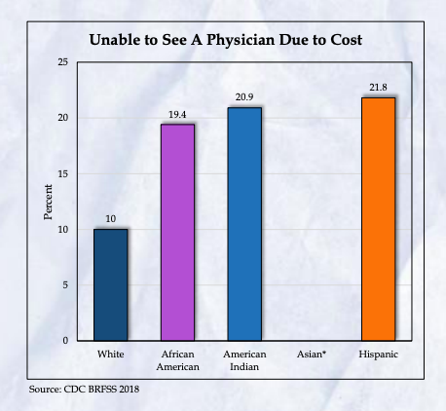 | 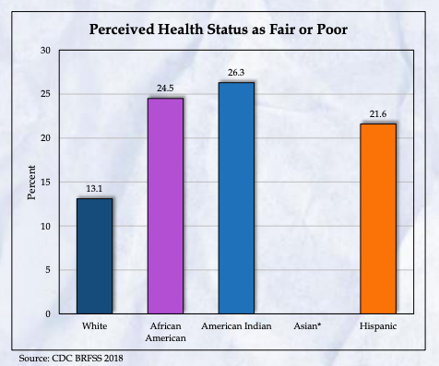
Figure 1.1 – Unable to See a Physician Due to Cost (Division of Public Health, 2020) | Figure 1.2 – Perceived Health Status as Fair or Poor (Division of Public Health, 2020)
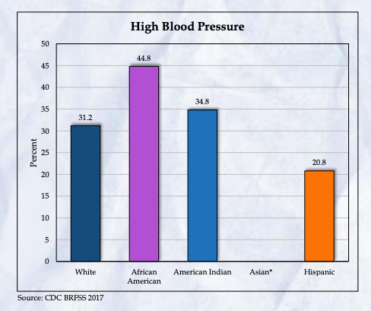 | 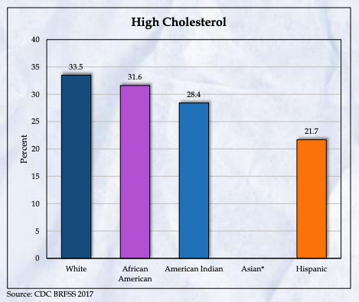
Figure 1.3 – High Blood Pressure (Division of Public Health, 2020) | Figure 1.4 – High Cholesterol (Division of Public Health, 2020)
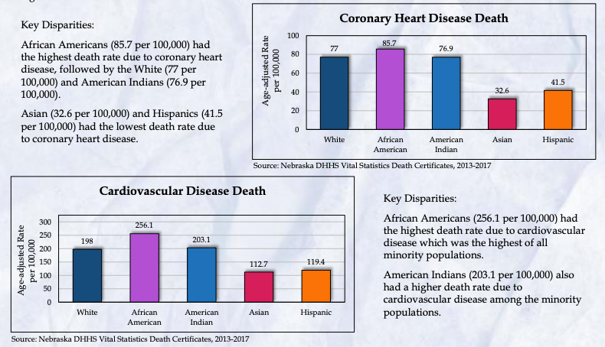
Figure 1.5 Coronary Heart Disease Death and Cardiovascular Disease Death (Division of Public Health, 2020)
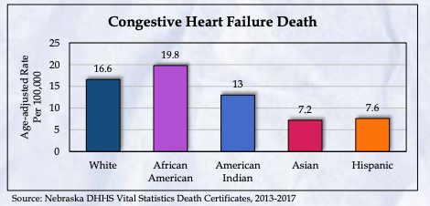
Figure 1.6 – Congestive Heart Failure Death (Division of Public Health, 2020)
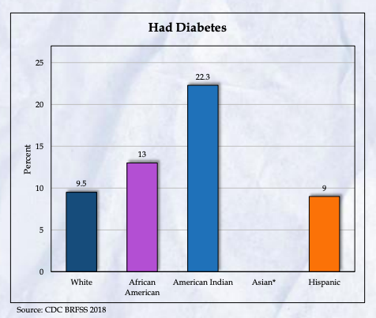
Figure 1.7 – Had Diabetes (Division of Public Health, 2020)
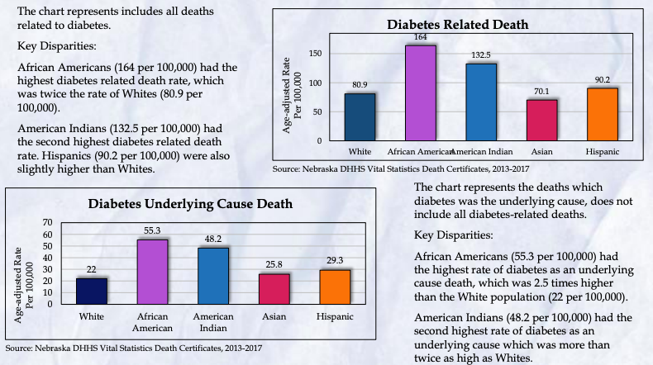
Figure 1.8 Diabetes Related Death and Diabetes Underlying Cause Death (Division of Public Health, 2020)

Genetics
A longitudinal study of the Pima Indians consisted of a physical examination every two years of those above the age of five within the study area. Over the last three decades, the prevalence of diabetes has increased in this population (29% in men and 35% in women) (Narayan, 1996). Compared to Rochester, Minnesota, the Pima Indians (located in Arizona) have diabetes at 19 times the rate. It has also been shown that the Pima people see earlier onsets of diabetes. Although the research surrounding diabetes (NIDDM) is still rudimentary, it is known that diabetes in the Pima Indians is associated with the HLA-A2 phenotype and genetic markers on chromosome 4q and 7q (Narayan, 1996). It is also known that early onset is genetically related. The obesity factor among the Pima Indians is still being researched as their average weight and BMI is still higher than their counterparts but the reason behind this is not understood. A diet shift from local foods high in fiber and low in fat to a more traditional American diet may contribute to this weight change.
One study showed that Native American Myopathy (NAM) is more prevalent in southern tribes than in northern tribes. However, NAM is passed down as a recessive gene within the Stac3 gene. This was first discovered within zebrafish, and there is hope for the development of a drug to reverse this (Raade & Mandal, 2018).
Last CNA
The last CNA showed that Native Americans had higher rates of diabetes and heart disease.
District Health Data
Data taken from County Health Rankings & Roadmaps, a product of University of Wisconsin Population Health Institutes, shows health outcomes ranking, health factors ranking, Native American percentage of a county, Physical Inactivity percentage, Uninsured percentage, Limited Access to Healthy Foods percentage, Diabetes percentage, those in physical distress percentage, and the obesity percentage (County Health, 2021). This data can be seen within the following table. It should be noted that the Native American population for Nebraska is estimated to be 0.8-1.5% (County Health, 2021). This data should also be prefaced with that the data source mentioned that the data on Keya Paha was scarce.
This data shows a small trend of higher Native American population in a county with higher percentages in the different categories. This trend is not true for all counties and not true for all categories (County Health, 2021). One example is both Boyd and Cherry County having lower middle health outcome rankings along over doubled Native American population percentages than the top three counties in the chart. Both Boyd and Cherry County have 12% and 15% uninsured rates, respectively. As for limited access to healthy foods, both counties have a percentage of 41 and 15, respectively, which is much higher than their counterparts (County Health, 2021). However, while Boyd Country has an average percentage of diabetes (11%) and obesity (36%), Cherry County has a lower than average percentage of diabetes (8%) and obesity (30%).
This table also shows that the top three healthiest counties out of the North Central District also have the lowest Native American population (County Health, 2021). These counties also have lower than average percentages in all categories listed. The only outlier of this being Pierce county’s Limited Access to Healthy Food percentage (17%).
Table 3.1 – County Health Rankings & Roadmaps County Data (County Health, 2021)
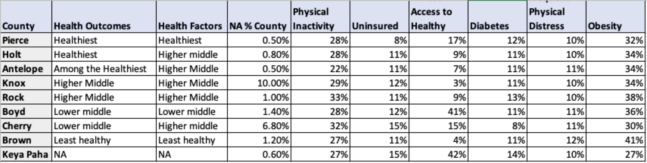
Figure 3.1 – Minority Population by County (Division of Public Health, 2020)
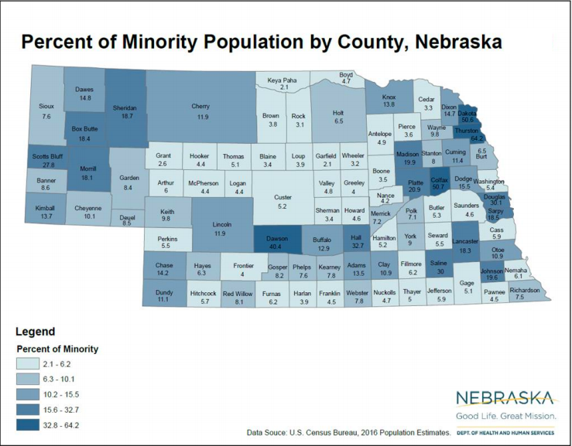
Note that this does use 2016 data while Figure 2.1 uses 2019.
District Health Dialogues
Two contacts within the district had dialogue collected. This dialogue’s purpose is to explain the data trends shown above and assist the NCDHD in pursuing goals and projects to limit the heart disease and diabetes prevalence within the Native American community.
Knox County
The first contact was Kristin Hemes, a dietician within the Santee Clinic, Knox County. During our discussion, Ms. Hemes covered education courses, gaps in care, prevalence of disease, programs that benefit the community, and personal opinions of the current health state of the county.
It was first made clear by Ms. Hemes that the Santee Clinic was not affected by the COVID-19 pandemic in terms of remaining open. The clinic ensured to remain open throughout the pandemic using a “use at your own risk” format.
The Santee clinic currently hosts a diabetes education course, taught by Ms. Hemes. This course primarily sees Type 2 diabetes cases and used to run twice a week for approximately two years. Currently, the course runs once a week and uses a curriculum through the Diabetes Association. Ms. Hemes stated that attendance was a problem due to the time of day conflicting with work schedules. However, to counteract that problem, the clinic would provide meals, gifts, and sometimes gift cards as an incentive. A more recent program allows those with Type 2 diabetes to receive a glucose monitor, subsidized through a grant. Ms. Hemes stated that the program has been effective as the monitor allows patients to see what a high carb diet can do for their blood sugar.
The clinic also has education programs regarding health and exercise benefits. One education program that Ms. Hemes participates in is working with the local school to help with fitness activities and school curriculums. In regard to fitness, Ms. Hemes works with the school and physical education classes to show different workouts to promote a healthy lifestyle for students.
As for cardiac programs, there is not a formal cardiac rehab or education program at the clinic. Cardiac patients are sent to Sioux Falls (a two-hour drive) or Yankton (a one-hour drive). However, Ms. Hemes does ensure to mention cardiac education within her diabetes programs.
The course attendance problems mentioned prior is a problem Ms. Hemes is still trying to solve. She stated that perhaps if they could find a way to improve attendance in classes and diabetes prevention, people may be more inclined to act. These courses had great attendance prior to flood in 2018 which closed to clinic.
However, it is not only attendance problems that create these problems that the Knox County community is seeing. As Ms. Hemes sees, the prevalence of heart disease and diabetes within the community may be genetics but also personal addictions. “It can be hard to change eating habits. People have addictions to alcohol, drugs, and food,” Ms. Hemes recalled. Therefore, although the information is available, it may be lifestyles and genetics creating these prevalence rates.
When discussing possible roadblocks community members maybe experiencing regarding access to care, Ms. Hemes boasted of Santee’s programs to improve access to healthcare. The community has a wellness center and grocery store that is well stocked. She reflected that the grocery store is average in contents and price but creates access to food with the next store being twenty miles away. Regarding transportation, prescriptions can be picked up at the clinic or delivered to a patient. There are also transportation programs to help community members get to appointments.
The conversation with Ms. Hemes showcased a community that is aware of its health problems and is actively pursuing programs to help citizens reverse them. As shown in table 1.1, Knox County has the highest population percentage of Native Americans (10%) in the North Central District. Out of the nine counties, Knox is one of the healthier counties is either average or below average data ranges.
With having the highest percentage of Native American population within the North Central District, it is important the community is taking actions to educate the community about heart disease and diabetes, and their risk factors, to the populations most affected by them. The Santee Clinic models great programs that model affective change within healthcare.
Cherry County
The second contact was that of Shirley Knudson and Kris Betner of Cherry County Hospital. Shirley Knudson is the COVID-19 Specialist and Kris Betner is in charge of community outreach.
Ms. Knudson was contacted shortly about the effect that COVID-19 and the community’s access to gyms. Ms. Knudson said that during the COVID-19 pandemic, gyms remained open with a “enter at your own risk” policy. Accessibility was not affected, however, those who were at higher risk may not have participated.
Speaking with Ms. Betner, it was made clear that currently the hospital only sees one Native American patient with heart disease regularly. As a whole, the hospital does not see many heart disease diagnoses. However, the hospital does have a cardiac rehab program. This program often sees patients from Rosebud Clinic which is approximately 30 miles away from the Cherry County Hospital.
The hospital currently does not have education programs. The only education the hospital currently does is discharge education or cardiac rehab education. They are currently weighing a formal education coordinator position but are not sure if there is enough volume. Ms. Betner included that the Rosebud Reservation has its own education programs that Native American community members attend.
Although noting that heart disease and diabetes are prevalent within the Native American community, Ms. Betner stated that the problem is not prevalent enough within the Valentine community. Therefore, the hospital does not have the necessary programs for these patients.
As mentioned prior, the Cherry County Hospital often sees patients from the Rosebud Clinic which is approximately 30 miles away. Ms. Betner states that transportation is a common problem within the community, especially patients from the Rosebud clinic. Unstable transportation methods can create problems with appointment attendance and to stay on programs. Transportation can also be an issue for those who reside in Cherry County but have their medication paid for by IHS, requiring them to drive to Rosebud Clinic to receive their prescriptions. Ms. Betner stated that the emergency room has seen patients with diabetes come with high as they cannot make the drive to Rosebud to pick up their prescription. Ms. Betner also stated Medicaid could alleviate this problem, but many patients do not have that. It was also included that there are travel vouchers for gas available from Rosebud, but the patient must have been referred by IHS. Also, if the Rosebud Tribe is the payer, the patient must be referred down to Cherry County Hospital. Ms. Betner stated that payment can be intimidating for many patients.
This dialogue shows a community that is recognizing that there is a higher prevalence of diabetes and heart disease within the Native American population but currently does not believe there is enough volume to warrant specialized programs. However, looking at table 1.1, Cherry County has a Native American population of 6.80% which is the second highest percentage behind Knox County. Cherry county is also on the least healthy side of the spectrum as it comes to data ranges.
Comparisons and Takeaways
Comparing the two dialogues of the two counties, both dialogues present different stances for the prevalence of diabetes and heart disease within the Native American Population. Knox County boasts several programs that acknowledge the problem and aim at educating and motivating community members to prevent it. Cherry County aims to someday have these programs and acknowledges the problems without actively fixing them.
It can be seen from these two dialogues, there are a few programs that could be enacted to promote healthy living and prevent heart disease and diabetes within the Native American community within the North Central District. There should be both preventative care and heart disease and diabetes education courses for the communities. There should also be a form of transportation aide. Whether this be funding to reimburse for transportation, medication drop off, or providing transportation, trying to solve this gap of transportation would allow for more people to attend education courses, receive access to healthcare, and maintain healthcare plans.
Potential Model Programs
There are many programs that can be implemented within the North Central District that can either prevent or help maintain heart disease and diabetes within the community. These models can be in a variety of settings with different goals.
Returning to culture was presented by the American College of Cardiology as a potential method of improving cardiovascular health (Beck, 2020). The method would require returning to one’s culture in an effort to return to more holistic methods with improved mental health. By accessing culture knowledge and practice, health interventions can be culturally based. This would strengthen both tribal identities and traditions. A current program in use is the Talking Circle. This program is used to allow community members to communicate their emotions with one another with the aim of empowering community members to manage their diabetes. This method has been used in both rural and urban areas.
The Center for Indigenous Cancer Research (CICR) at Roswell Park has created a podcast called the “Talking Circle.” This podcast features discussions about indigenous knowledge, science, and research from both those at Roswell Park and those within the communities (Rosewell Park, 2021).
Movement programs and events could be utilized to encourage citizens to become active and join social groups. These could include walking groups, fun runs (5ks), exercise classes, or weight loss challenges. These would create environments for those within the community to become active and take control of their health. Also, by creating these environments, members of community in similar situations can meet and provide crucial social interactions to one another. Antelope county’s Antelope Memorial Hospital has a wellness center that showcases this (Antelope Memorial Hospital, 2021). The hospital also has a program for uncompensated care and shares price transparency. The Faith Regional Health Services provides free vein screenings every month.
The Ponca Tribe, in Norfolk, has several health information programs and resources listed on their website. They list several annual events such as walks/runs, lunch and learns, a November Month of diabetes activities, specific youth activities, and promoted exercised facilities (Ponca Tribe, 2021). The Ponca Tribe also boasts a diabetes program with monthly self-management courses. They also have nutrition therapy listed at two of their centers along with a bi-weekly/monthly foot care clinic depending on the center, annual eye exams, direct care, and case management services. The program also offers glucose testing strips and orthopedic shoes (Ponca Tribe, 2021). There is also a resource regarding Native foods and how they should be included in one’s diet. This mainly focuses on buffalo, dandelion greens, squash, sunchokes, and turnips.
As discussed in the Santee Clinic dialogue, there are many programs that are already active with the North Central District. As transportation is a common issue, there has been a transportation program that will help patients either get to appointments or have prescriptions delivered to them. Also, in the same county, the Santee Clinic has partnered with their local public school to ensure preventative lifestyles are taught.
Currently, Macey, in Thurston County, is working with the University of Nebraska-Lincoln and Well Connected Communities (Moster, 2021). Well Connected Communities is a program that aims as implementing cardiovascular disease prevention methods within minority communities. Lincoln is also participating in this program. This program is funded by both the National 4-H Council and the Robert Wood Johnson Foundation and provides a curriculum and 40 hours of training for all volunteers (Moser, 2021). During this program, participants learn about the social determinants of health, nutrition, and how to become involved in one’s community and volunteering. Currently, Lincoln and Macey are focusing on their Native American populations using this program in an attempt to move their population to a more traditional, holistic lifestyle (Moser, 2021). This grant program could be implemented within the North Central District, providing an opportunity of structure towards preventative education towards heart disease and diabetes. The Well Connected Community has a plethora of helpful resources for interested communities.
The town of Macey is also focusing on food sustainability in an effort to support accessibility. Specifically, the Umonhon Nation Public School within Macey has created a K-12 food sustainability program using a farm-school approach utilizing greenhouse (Moser, 201). There is also a focus on creating more accessible medicinal plants for the Omaha tribe. This supports the move to a more traditional and holistic lifestyle. A local tribal leader mentioned the goal of wanting to create local food producers within the Omaha tribe (Moser, 2021). These ideas could be put into a program within the North Central District in an effort to preserve tribal history and also prevent disease by returning to a more natural and holistic diet.
A similar program to Well Connected Communities is the Good Health and Wellness in Indian Country (GHWIC). This program focuses on a holistic effort for healthy living in regards to chronic disease (Good Health, 2021). Their goal is to help efforts that are already in place within Native communities by supporting cultural projects in a public health manner. They also work on extending the reach of these program’s efforts. Their long-term goals include reducing type 2 diabetes, tobacco usage, high blood pressure, and high blood cholesterol while increasing a diet of healthy foods, physical activity, and breastfeeding (Good Health, 2021).
The GHWIC does have funding that is split into three components. One component is the funding to prevent chronic diseases. Component two funds tribal organizations so they may then allocate those funds to extend efforts in four different tribes (GHWIC Funding, 2021). The last component is focused on one tribal organization to act as the coordinating head for evaluation, communication, and peer education. Currently, the only nearby tribe benefiting from this program is the Great Plains Tribal Chairmen’s Health Board that is a component 2 and 3 recipient (GHWIC Funding, 2021).
Lastly, the IHS has a list of resources that those within distance of a reservation can attend. On the IHS website, there is a list of groups within the Great Plains Area that service substance abuse and suicide prevention.

Special Populations: Elderly Population
Though many older individuals are in relatively good health and lead active and robust lives, aging increases the likelihood of compound clinical conditions; increased use of multiple medications; and a variety of mobility, sensory, and cognitive impairments (National Research Council, 1996). These types of health outcomes are considered community and national drivers of illness, disability, death, and in turn rising health care costs (CDC, 2022a).
The percentage of estimated residents who are 65 and older in NCDHD (25.6%) is significantly higher than that the national (16.5%; t(8) = 6.427, p < .05) and the Nebraska (16.2%; t(8) = 6.638, p < .05) estimates (US Census, 2019). The NCDHD CHA (2021) asked respondents if they were 60 years or older (n = 216; 30.6%), with a subset of follow-up questions directed at this group. The majority of NCDHD residents who answered these questions reported being in good or better health (88.9%), eating at least two meals a day (92.2%), and said they had enough money to buy the food they needed (95.3%). Only one-fifth of respondents (20.0%) reported having firm plans for long-term care, however. When asked about public services, most of them reported using or planning to use home health (83.3%), retirement planning (77.4%), and legal assistance (73.7%). Roughly half reported using or planning to use volunteer programs (56.9%) and case management (48.2%), and less than half said telephone services (42.2%) or adult day services (42.1%). Additionally, several other questions were explored from the perspectives of 65 years and older NCDHD residents. Their top three health concerns were heart disease (70.4%), cancer (66.7%), and diabetes (51.9%). Most of them reported doing physical activity at least twice a week (95.0%), eating nutritious and balanced meals (88.9%), and reading (70.4%) to maintain their physical and mental health, but almost one third of them reported not feeling lonely or disconnected from others (30.4%).
There is limited availability of publicly available county-level data on elderly health in rural parts of Nebraska. In these circumstances, national-level data on health outcomes may be instructive. It is well documented that older adults disproportionately experience chronic diseases, and oftentimes multiple chronic conditions (National Council on Aging, 2021). Population studies suggest that approximately half of adults with chronic diseases have multiple conditions simultaneously, which increase with age, and often require costly hospitalization or long-term care costs (Boersma et al., 2021).
Table 12 provides leading causes of death from national 2018 data (NVSS, 2021) for adults aged 65 and older, and aged 85 and older.

Table 12. Top 10 leading causes of death among older adults: United States, 2018
Aged 65+ |  | Aged 85+
Heart disease | 25.1% | Heart disease | 28.6%
Other | 24.6% | Other | 27.1%
Chronic Lower Respiratory Disease | 6.5% | Cancer | 11.7%
Stroke | 6.1% | Stroke | 7.3%
Alzheimer disease | 5.7% | Chronic Lower Respiratory Disease | 5.1%
Diabetes | 2.9% | Influenza and pneumonia | 2.8%
Unintentional injuries | 2.7% | Unintentional injuries | 2.7%
Influenza and pneumonia | 2.3% | Diabetes | 1.9%
Kidney disease | 2.0% | Kidney disease | 1.9%
Parkinson disease | 1.6% | Hypertension | 1.7%

It should be noted that patterns in causes of death are unlikely to shift dramatically unless a high impact acute event occurs. One such event was COVID-19, which disproportionately affected and continues to impact older persons. Table 13 provides national mortality rate data (Woolf, Chapman & Lee, 2021) for leading causes of death among adults over 65 during the period of the initial COVID-19 surge.
Table 13. Top five leading causes of death among older adults: United States, March-October 2020
65-74 years |  | 75-84 years |  | 85 years+
Cancer | 3702.0 | Cancer | 6845.7 | Heart disease | 24530.2
Heart disease | 2516.9 | Heart disease | 6478.5 | COVID-19 | 10699.7
COVID-19 | 1574.6 | COVID-19 | 3832.4 | Cancer | 10442.4
Chronic Lower Respiratory Disease | 809.9 | Chronic Lower Respiratory Disease | 2117.3 | Chronic Lower Respiratory Disease | 4278.4
Suicide* | 114.1 | Transport accidents | 99.2 | Transport accidents | 139.1
Notes. *Intentional injuries are divided into suicide and homicide. During this time frame, the homicide mortality rate for this age group was 15.7.
During this eight-month period, COVID-19 was a top three leading cause of death among older adults, with mortality rates increasing with age. As of March 2022, the most frequently co-occurring conditions listed on death certificates for COVID-19 have been influenza/pneumonia (53.4%), hypertension (16.7%), diabetes (14.5%), Alzheimer disease and other dementias (7.2%), and sepsis (10.3%), also suggesting clear overlap with conditions likely to be experienced among older adults (CDC, 2022b). As COVID-19 variants continue to circulate, it is highly likely that elderly individuals will remain an especially vulnerable population due to already existing chronic conditions. According to 2019 NBRFSS data, 79.7% of Nebraskans over the age of 65 indicated their health was good, very good, or excellent; however, 20.3% reported fair or poor health, and 40.5% reported having a disability stemming from a physical, mental, or emotional condition (CDC, 2022c).
Attention should also be focused on Alzheimer’s disease, which is almost exclusively experienced by older individuals. Alzheimer’s is a neurological disease-causing progressive brain damage and deterioration beyond what is normally expected from aging. Alzheimer’s accounts for approximately 60-80% of dementias, which are a range of symptoms reflecting impaired memory, language, cognitive and physical abilities, and overall functioning, which ultimately leads to death (Alzheimer’s Association, 2022). According to data from 2015, Nebraska was projected to have an estimated 35 thousand individuals with Alzheimer’s dementia by 2020, and a 14.5% increase to 40 thousand Nebraskans with Alzheimer’s dementia by 2025 (Alzheimer’s Association, 2022). Additionally, it is believed that there are clear differences in prevalence by gender and race, with women and racial/ethnic minorities being significantly more likely to experience Alzheimer’s than males, and whites, respectively (NDHHS, 2016). It is estimated that women may be twice as likely as men to be at risk for developing Alzheimer’s dementia (Alzheimer’s Association, 2022).
It should be noted that population estimates of Alzheimer’s disease should be treated with caution because of complications related to reporting methods, and difficulties discerning causes of death among individuals with multiple chronic conditions. From 2000 to 2019, reported causes of death across the United States for Alzheimer’s increased 145%, much of which may be due to changes in documentation and/or reporting approaches.
Aside from identifiable death rate data for Alzheimer’s disease, the nature of the disease drives two other important considerations. First is overall diminished quality of life, both for the individual with dementia, as well as for caregivers and family members. The course of Alzheimer’s progressively diminishes almost all aspects of autonomy, and has well documented symptoms (Lyketsos et al., 2011; Mendez et al., 1990; Wragg & Jeste, 1989). Because of the heavy emotional and physical burden of providing care for individuals with Alzheimer’s, it is probable that the quality of care provided and degree of caregiver burden may be connected (Barbe et al., 2018; Coen et al., 1999; Vellone et al., 2008). Secondly are the overall financial costs related to caring for persons with Alzheimer’s dementia, and those impacts at a community level. Studies show that both formal and informal costs of healthcare increase as the disease progresses (Jönsson et al., 2006; Rapp et al., 2012). Hospitalization costs also increase due to inpatient services rendered for pneumonia, infections, and hip fractures from falls (Zhao et al., 2012). Researchers have estimated that the total direct costs of healthcare for Alzheimer’s related dementias was $109 billion dollars in 2010, and may increase to $259 billion per year as the population continues to age (Deb et al., 2017). Because there is limited evidence on causation and the effectiveness of treatment approaches for Alzheimer’s, it is recommended that early screening and detection be employed so therapy can mitigate or delay the disease (Alzheimer’s Association, 2022).

Conclusion
This report summarized health inequities for certain indicators throughout the North Central District Health Department service area. We focused on American Indians & Hispanics, the elderly and low-income residents. These populations are distributed throughout the entire health district, although the American Indian population is largely focused in the Santee Sioux Nation in the northeastern portion of the district. Heart disease is clearly of great concern with the Native American population and special attention ought to be rendered. The highest percentage of low-income residents are located in Antelope, Brown, and Knox Counties, while the city of O’Neill and northern Antelope County have the highest percentage of Hispanic residents. Considering the inequities for the indicators included here alongside the geographic distribution of these priority populations allows us to have more informed interventions.

References
Agency for Healthcare Research and Quality (AHRQ). 2019 National Healthcare Quality and Disparities Report. (2021). Agency for Healthcare Research and Quality, Rockville, MD. https://www.ahrq.gov/research/findings/nhqrdr/nhqdr19/index.html
Alford, S. (2009). Science and Success: Science-Based Programs that Work to Prevent Teen Pregnancy, HIV & Sexually Transmitted Infections among Hispanics/Latinos. Advocates for Youth.
Alzheimer's Association. (2022). 2022 Alzheimer’s Disease Facts and Figures: Tbl 4. Projections of Total Numbers of Americans Age 65 and Older with Alzheimer’s Dementia by State. https://www.alz.org/media/documents/alzheimers-facts-and-figures.pdf
Andrus, M., & Roth, M. (2002). Health literacy: A review. Pharmacotherapy, 22(3), 282-302.
Ansari, Z., Laditka, J. N., & Laditka, S. B. (2006). Access to health care and hospitalization for ambulatory care sensitive conditions. Medical Care Research and Review, 63(6), 719-741.
Balistreri, S. (2018). Family structure and child food insecurity: Evidence from the current population survey. Social Indicators Research, 138(3), 1171-1185.
Bailey, Z., Krieger, N., Agenor, M., Graves, J., Linos, N., & Bassett, M. (2017). Structural racism and health inequities in the USA: Evidence and interventions. The Lancet, 389, 1453-1463.
Barbe, C., Jolly, D., Morrone, I., Wolak-Thierry, A., Dramé, M., Novella, J. L., & Mahmoudi, R. (2018). Factors associated with quality of life in patients with Alzheimer’s disease. BMC Geriatrics, 18(1), 1-9.
Basch, C. E. (2011). Teen pregnancy and the achievement gap among urban minority youth. Journal of School Health, 81(10), 614-618.
Bassett, D. R., John, D., Conger, S. A., Fitzhugh, E. C., & Coe, D. P. (2015). Trends in physical activity and sedentary behaviors of United States youth. Journal of Physical Activity and Health, 12(8), 1102-1111.
Berrigan, D., Dodd, K., Troiano, R. P., Krebs-Smith, S. M., & Barbash, R. B. (2003). Patterns of health behavior in US adults. Preventive Medicine, 36(5), 615-623.
Black, A. Y., Fleming, N. A., & Rome, E. S. (2012). Pregnancy in adolescents. Adolescent Medicine: State of the Art Reviews, 23(1), 123-38.
Boersma, P., Cohen, R. A., Zelaya, C. E., & Moy, E. (2021). Multiple Chronic Conditions Among Veterans and Nonveterans: United States, 2015-2018. National Health Statistics Reports, (153), 1-13.
Bornstein, E., Wasden, S. W., Eliner, Y., Gulersen, M., Lenchner, E., Grunebaum, A., … & Chervenak, F. (2021). 1026 Teen pregnancy: better definition of the unique sociodemographic and adverse outcomes in this vulnerable population. American Journal of Obstetrics & Gynecology, 224(2), S635.
Boser, U. (2014). Teacher diversity revisited: A new state-by-state analysis. Center for American Progress.
Braveman, P., Dekker, M., Egerter, S., & Grossman-Kahn, R. (2011). Work, workplaces and health. Princeton: Robert Wood Johnson Foundation. Exploring the Social Determinants of Health Issue Brief No. 4.
Braveman, P., Egerter, S., & Barclay, C. (2011). Income, wealth and health. Princeton: Robert Wood Johnson Foundation. Exploring the Social Determinants of Health Issue Brief No. 4.
Braveman, P., Dekker, M., Egerter, S., & Sadegh-Nobari, T. (2011). Housing and health. Princeton: Robert Wood Johnson Foundation. Exploring the Social Determinants of Health Issue Brief No. 7.
Braveman, P., & Gottlieb, L. (2014). The social determinants of health: it's time to consider the causes of the causes. Public health reports (Washington, D.C.: 1974), 129 Suppl 2(Suppl 2), 19–31. https://doi.org/10.1177/00333549141291S206
Card, J. J. (1999). Teen pregnancy prevention: do any programs work? Annual Review of Public Health, 20(1), 257-285.
Carralta, S., & Maxwell, C. (2020). Health disparities by race and ethnicity [Fact Sheet]. Center for American Progress. https://www.americanprogress.org/article/health-disparities-race-ethnicity/
Centers for Disease Control and Prevention. (2021, May 19). Disease & SWS impact. https://www.cdc.gov/safewater/disease.html
Centers for Disease Control and Prevention. (2022a). Health equity considerations and racial and ethnic minority groups. https://www.cdc.gov/coronavirus/2019-ncov/community/health-equity/race-ethnicity.html
Centers for Disease Control and Prevention. (2022b). COVID-19 mortality overview: Most frequently listed comorbidities with COVID-19 deaths. https://www.cdc.gov/nchs/covid19/mortality-overview.htm
Centers for Disease Control and Prevention. (2022c). Healthy Aging Data: Nebraska, 2019 – Self-rated health; Disability status, including sensory or mobility limitations. https://nccd.cdc.gov/aging_data
Centers for Medicare & Medicaid Services Office of Minority Health’s Mapping Medicare Disparities (MMD) (2018). Mapping Medicare Disparities Tool [Data set]. Baltimore, MD.
Chikritzhs, T., & Livingston, M. (2021). Alcohol and the Risk of Injury. Nutrients, 13(8), 2777. https://doi.org/10.3390/nu13082777
Coen, R. F., O'boyle, C. A., Swanwick, G. R., & Coakley, D. (1999). Measuring the impact on relatives of caring for people with Alzheimer's disease: quality of life, burden and well-being. Psychology and Health, 14(2), 253-261.
Colditz, G. A., Manson, J. E., Stampfer, M. J., Rosner, B., Willett, W. C., & Speizer, F. E. (1992). Diet and risk of clinical diabetes in women. The American Journal of Clinical Nutrition, 55(5), 1018-1023.
Conroy, T., Delle,r S., Kures, M., Low, S., Glazer, J., Huyke, G., & Stark, C. (2021). Broadband and the Wisconsin Economy. The Wisconsin Economy Series 7. University of Wisconsin-Madison, Division of Extension.
Cook, B. L., Trinh, N. H., Li, Z., Hou, S. S. Y., & Progovac, A. M. (2017). Trends in racial-ethnic disparities in access to mental health care, 2004–2012. Psychiatric Services, 68(1), 9-16.
Cooksey-Stowers, K., Schwartz, M. B., & Brownell, K. D. (2017). Food swamps predict obesity rates better than food deserts in the United States. International Journal of Environmental Research and Public Health, 14(11), 1366.
County Health Rankings. (2021). County Health Rankings National Data. (2021) [Data set]. https://www.countyhealthrankings.org/explore-health-rankings/rankings-data-documentation
Craun, G., Brunkard, J., Yoder, J., Roberts, V., Carpenter, J., Wade, T., Calderon, R., Roberts, J., Beach, M., & Roy, S. (2010). Causes of Outbreaks Associated with Drinking Water in the United States from 1971 to 2006. Clinical Microbiology Reviews, 23(3), 507-528. https://doi.org/10.1128/CMR.00077-09
Croft, M., Hayes, S., & Moore, R. (2020). Supporting the mental health well-being of high school students. ACT Center for Equity in Learning. https://www.act.org/content/dam/act/unsecured/documents /R1798-mental-health-2020-01.pdf
Dai, H., & Leventhal, A. M. (2019). Prevalence of e-cigarette use among adults in the United States, 2014-2018. JAMA, 322(18), 1824-1827.
Dai, H., Saccardo, S., Han, M. A., et al. Behavioural nudges increase COVID-19 vaccinations. Nature 597, 404–409 (2021). https://doi.org/10.1038/s41586-021-03843-2
Deb, A., Thornton, J. D., Sambamoorthi, U., & Innes, K. (2017). Direct and indirect cost of managing Alzheimer’s disease and related dementias in the United States. Expert Review of Pharmacoeconomics & Outcomes Research, 17(2), 189-202.
Di, Q., Wang, Y., Zanobetti, A., Wang, Y., Koutrakis, P., Choirat, C., Dominici, F., & Schwartz, J. (2017). Air pollution and mortality in the Medicare population. New England Journal of Medicine, 376, 2513-2522. doi: 10.1056/NEJMoa1702747.
Drope, J., Liber, A. C., Cahn, Z., Stoklosa, M., Kennedy, R., Douglas, C. E., ... & Drope, J. (2018). Who's still smoking? Disparities in adult cigarette smoking prevalence in the United States. CA: A Cancer Journal for Clinicians, 68(2), 106-115.
Dunn, J. R. (2000). Housing and health inequalities: Review and prospects for research. Housing Studies, 15(3), 341-366.
Egerter, S., Braveman, P., & Barclay, C. (2011). Exploring the social determinants of health (Issue Brief No. 3). Princeton: Robert Wood Johnson Foundation.
Egerter, S., Braveman, P., Sadegh-Nobari, T., & Grossman-Kahn, R. (2011). Exploring the social determinants of health (Issue Brief No. 5). Princeton: Robert Wood Johnson Foundation.
Fenton, M. C., Keyes, K., Geier, T., Greenstein, E., Skodol, A., Krueger, B., ... & Hasin, D. S. (2012). Psychiatric comorbidity and the persistence of drug use disorders in the United States. Addiction, 107(3), 599-609.
Foran, H. M., & O'Leary, K. D. (2008). Alcohol and intimate partner violence: A meta-analytic review. Clinical Psychology Review, 28(7), 1222-1234.
Freund, T., Campbell, S. M., Geissler, S., Kunz, C. U., Mahler, C., Peters-Klimm, F., & Szecsenyi, J. (2013). Strategies for reducing potentially avoidable hospitalizations for ambulatory care–sensitive conditions. The Annals of Family Medicine, 11(4), 363-370.
Fry, C. E., & Sommers, B. D. (2018). Effect of Medicaid expansion on health insurance coverage and access to care among adults with depression. Psychiatric Services, 69(11), 1146-1152.
Gallaway, M. S., Henley, S. J., Steele, C. B., Momin, B., Thomas, C. C., Jamal, A., ... & Stewart, S. L. (2018). Surveillance for cancers associated with tobacco use—United States, 2010–2014. MMWR Surveillance Summaries, 67(12), 1.
Gaziano, J. M. (2010). Fifth phase of the epidemiologic transition: The age of obesity and inactivity. JAMA, 303(3), 275-276.
Gill, S. K., Broussard, C., Devine, O., Green, R. F., Rasmussen, S. A., Reefhuis, J., & National Birth Defects Prevention Study. (2012). Association between maternal age and birth defects of unknown etiology―United States, 1997–2007. Birth Defects Research Part A: Clinical and Molecular Teratology, 94(12), 1010-1018.
Glasmeier, A. (2020). Living wage calculator. Living Wage Calculator - Living Wage Calculation for Nebraska. Retrieved March 11, 2022, from https://livingwage.mit.edu/states/31
Hall, H. I., Song, R., Tang, T., An, Q., Prejean, J., Dietz, P., ... & Mermin, J. (2017). HIV trends in the United States: diagnoses and estimated incidence. JMIR Public Health and Surveillance, 3(1), e7051.
Hanson, M. D., & Chen, E. (2007). Socioeconomic status and health behaviors in adolescence: a review of the literature. Journal of Behavioral Medicine, 30(3), 263-285.
Health Resources and Services Administration (HRSA). (n.d.). Find shortage areas, HRSA find. Retrieved Feb. 18, 2021 from https://data.hrsa.gov/tools/shortage-area
Hilbrecht, M., Smale, B., & Mock, S. E., (2014). Highway to health? Commute times and well-being among Canadian adults. World Leisure Journal, 56(2), 151-163. https://doi.org/10.1080/16078055.2014.903723
Hiscock, R., Kearns, A., MacIntyre, S., & Ellaway, A. (2001). Ontological security and psycho-social benefits from the home: Qualitative evidence on issues of tenure. Housing, Theory and Society, 18(1-2), 50-66.
Hood, C. M., Gennuso, K. P., Swain, G. R., & Catlin, B. B. (2016). County health rankings: relationships between determinant factors and health outcomes. American Journal of Preventive Medicine, 50(2), 129-135.
Hodgson, K., Deeny, S. R., & Steventon, A. (2019). Ambulatory care-sensitive conditions: Their potential uses and limitations. BMJ Quality & Safety, 28(6), 429-433.
Hu, F. B. (2003). Overweight and obesity in women: health risks and consequences. Journal of Women's Health, 12(2), 163-172.
Johns Hopkins University School of Medicine, Coronavirus Resource Center (JHU) (2021). Nebraska. Retrieved Feb. 15, 2022 at https://coronavirus.jhu.edu/region/us/nebraska
Johns, M. J., Moncloa, F., & Gong, E. J. (2000). Teen pregnancy prevention programs: Linking research and practice. Journal of Extension, 38(4), 1-9.
Jones, C. M., & McCance-Katz, E. F. (2019). Co-occurring substance use and mental disorders among adults with opioid use disorder. Drug and Alcohol Dependence, 197, 78-82.
Kawachi, I., Bruce, P., & Glass, R. (1999). Social capital and self-rated health: A contextual analysis. American Journal of Public Health, 89, 1187-1193.
Keys, A. (1957). Diet and the epidemiology of coronary heart disease. Journal of the American Medical Association, 164(17), 1912-1919.
Key, J. D., Gebregziabher, M. G., Marsh, L. D., & O’Rourke, K. M. (2008). Effectiveness of an intensive, school-based intervention for teen mothers. Journal of Adolescent Health, 42(4), 394-400.
Kim, D. D., & Basu, A. (2016). Estimating the medical care costs of obesity in the United States: systematic review, meta-analysis, and empirical analysis. Value in Health, 19(5), 602-613.
King, B. A., Dube, S. R., & Tynan, M. A. (2012). Current tobacco use among adults in the United States: findings from the National Adult Tobacco Survey. American Journal of Public Health, 102(11), e93-e100.
Kirby, D. (2001). Emerging answers: Research findings on programs to reduce teen pregnancy (summary). American Journal of Health Education, 32(6), 348-355.
Koniak‐Griffin, D., Lesser, J., Uman, G., & Nyamathi, A. (2003). Teen pregnancy, motherhood, and unprotected sexual activity. Research in Nursing & Health, 26(1), 4-19.
Kramer, M., & Hogue, C. (2009). Is segregation bad for your health? Epidemiology, 31, 178-194.
Krause, T. M., Schaefer, C., & Highfield, L. (2021). The association of social determinants of health with health outcomes. American Journal of Managed Care, 27(3), e89-e96.
Künn-Nelen, A. (2016). Does commuting affect health? Health Economics, 25(8), 984–1004. https://doi.org/10.1002/hec.3199
Kushel, M. B., Gupta, R., Gee, L., & Haas, J. S. (2006). Housing instability and food insecurity as barriers to health care among low-income Americans. Journal of General Internal Medicine, 21(1), 71-77.
Lambert, D., Gale, J. A., & Hartley, D. (2008). Substance abuse by youth and young adults in rural America. Journal of Rural Health, 2008 Summer, 24(3):221-8. doi: 10.1111/j.1748-0361.2008.00162.x. PMID: 18643798.
LaVeist, T. A., & Pierre, G. (2014). Integrating the 3Ds—social determinants, health disparities, and health-care workforce diversity. Public Health Reports, 129 (1_suppl2), 9-14.
Lavin, C., & Cox, J. E. (2012). Teen pregnancy prevention: current perspectives. Current Opinion in Pediatrics, 24(4), 462-469.
Lazar, M., & Davenport, L. (2018). Barriers to health care access for low income families: a review of literature. Journal of Community Health Nursing, 35(1), 28-37.
Leonard, K. E. (2005). Alcohol and intimate partner violence: when can we say that heavy drinking is a contributing cause of violence? Addiction, 100, 422-425.
Lee, H. (2011). Inequality as an explanation for obesity in the United States. Sociology Compass, 5(3), 215-232.
Leve, L. D., Kerr, D. C., & Harold, G. T. (2013). Young adult outcomes associated with teen pregnancy among high-risk girls in a randomized controlled trial of multidimensional treatment foster care. Journal of Child & Adolescent Substance Abuse, 22(5), 421-434.
Levy, H., & DeLeire, T. (2003). What do people buy when they don't buy health insurance and what does that say about why they are uninsured? National Bureau of Economic Research.
Lim, J. K., Earlywine, J. J., Bagley, S. M., Marshall, B. D., & Hadland, S. E. (2021). Polysubstance involvement in opioid overdose deaths in adolescents and young adults, 1999-2018. JAMA Pediatrics, 175(2), 194-196.
Lippold, K. M., Jones, C. M., Olsen, E. O. M., & Giroir, B. P. (2019). Racial/ethnic and age group differences in opioid and synthetic opioid–involved overdose deaths among adults aged≥ 18 years in metropolitan areas—United States, 2015–2017. Morbidity and Mortality Weekly Report, 68(43), 967-973.
Loehrer, A. P., Chang, D. C., Scott, J. W., Hutter, M. M., Patel, V. I., Lee, J. E., & Sommers, B. D. (2018). Association of the Affordable Care Act Medicaid expansion with access to and quality of care for surgical conditions. JAMA Surgery, 153(3), e175568-e175568.
Long, S. K. (2003). Hardship among the uninsured: choosing among food, housing, and health insurance.
Lyketsos, C. G., Carrillo, M. C., Ryan, J. M., Khachaturian, A. S., Trzepacz, P., Amatniek, J., ... & Miller, D. S. (2011). Neuropsychiatric symptoms in Alzheimer’s disease. Alzheimer's & Dementia, 7(5), 532-539.
Ma, C. T., Gee, L., & Kushel, M. B. (2008). Associations between housing instability and food insecurity with health care access in low-income children. Ambulatory Pediatrics, 8(1), 50-57.
Mayberry, R. M., Mili, F., & Ofili, E. (2000). Racial and ethnic differences in access to medical care. Medical Care Research and Review, 57(1_suppl), 108-145.
Manning, W. (2015). Cohabitation and child wellbeing. The Future of Children, 25(2).
Maulsby, C., Millett, G., Lindsey, K., Kelley, R., Johnson, K., Montoya, D., & Holtgrave, D. (2014). HIV among black men who have sex with men (MSM) in the United States: A review of the literature. AIDS and Behavior, 18(1), 10-25.
Mendez, M. F., Martin, R. J., Smyth, K. A., & Whitehouse, P. J. (1990). Psychiatric symptoms associated with Alzheimer's disease. Journal of Neuropsychiatry and Clinical Neurosciences, 2(1), 28–33. https://doi.org/10.1176/jnp.2.1.28
National Association of County and City Health Officials (NACCHO). (2020). MAPP evolution blueprint executive summary. https://www.naccho.org/uploads/downloadable-resources/MAPP-Evolution-Blueprint-Executive-Summary-V3-FINAL.pdf
National Council on Aging. (2021). Get the facts on health aging. https://www.ncoa.org/article/get-the-facts-on-healthy-aging
National Research Council (US) Committee to Develop an Agenda for Health Outcomes Research for Elderly People. (1996). Health outcomes for older people: Questions for the coming decade. Feasley, J. (Ed.), National Academy Press, Washington D.C.
National Vital Statistics System (NVSS). (2021). Deaths: Leading causes for 2018. National Vital Statistics Reports – May 17, 2021, 70(4).
Nebraska Department of Health and Human Services (NDHHS). (2016). The Nebraska state plan for Alzheimer’s disease and related dementias. Available at https://dhhs.ne.gov/Medicaid%20SUA/ADRD%20State%20Plan.pdf
Nebraska Department of Health and Human Services (NDHHS). (2021). BRFSS detailed summary for North Central District Health Department adults 18 and older, 2011-2020. Available at https://dhhs.ne.gov/Pages/BRFSS.aspx
Nejat, E. J., Polotsky, A. J., & Pal, L. (2010). Predictors of chronic disease at midlife and beyond-the health risks of obesity. Maturitas, 65(2), 106-111.
North Central District Health Department (NCDHD). (2022). North Central District Health Department COVID-19 dashboard. Available at https://www.ncdhd.com/covid-19
Obisesan, O. H., Osei, A. D., Uddin, S. I., Dzaye, O., Mirbolouk, M., Stokes, A., & Blaha, M. J. (2020). Trends in e-cigarette use in adults in the United States, 2016-2018. JAMA Internal Medicine, 180(10), 1394-1398.
Oster, A. M., Wiegand, R. E., Sionean, C., Miles, I. J., Thomas, P. E., Melendez-Morales, L., ... & Millett, G. A. (2011). Understanding disparities in HIV infection between black and white MSM in the United States. AIDS, 25(8), 1103-1112.
Owusu-Edusei, K., Chesson, H. W., Gift, T. L., Tao, G., Mahajan, R., Ocfemia, M. C. B., & Kent, C. K. (2013). The estimated direct medical cost of selected sexually transmitted infections in the United States, 2008. Sexually Transmitted Diseases, 40(3), 197-201.
Paradies, Y. (2006). A systematic review of empirical research on self-reported racism and health. International Journal of Epidemiology, 35(4), 888-901.
https://doi.org/10.1093/ije/dyl056external icon
Pope, C., Dockery, D., & Schwartz, J. (1995). Review of epidemiological evidence of health effects of particulate air pollution. Inhalation Toxicology, 7(1), 1-18. https://doi.org/10.3109/08958379509014267
Prejean, J., Song, R., Hernandez, A., Ziebell, R., Green, T., Walker, F., ... & HIV Incidence Surveillance Group. (2011). Estimated HIV incidence in the United States, 2006–2009. PloS one, 6(8), e17502.
Rangel, M. C., Gavin, L., Reed, C., Fowler, M. G., & Lee, L. M. (2006). Epidemiology of HIV and AIDS among adolescents and young adults in the United States. Journal of Adolescent Health, 39(2), 156-163.
Rapp, T., Andrieu, S., Molinier, L., Grand, A., Cantet, C., Mullins, C. D., & Vellas, B. (2012). Exploring the relationship between Alzheimer's disease severity and longitudinal costs. Value in Health, 15(3), 412-419.
Rehm, J. (2011). The risks associated with alcohol use and alcoholism. Alcohol Research & Health, 34(2), 135-143.
Rehm, J., & Shield, K. D. (2010). Alcohol and mortality. Global alcohol-attributable deaths from cancer, liver cirrhosis, and injury in, 174-183.
Remington, P. L., Catlin, B. B. & Gennuso, K. P. The County Health Rankings: Rationale and methods. Population Health Metrics, 13, 11 (2015). https://doi.org/10.1186/s12963-015-0044-2
Riley, W. J. (2012). Health disparities: Gaps in access, quality and affordability of medical care. Transactions of the American Clinical and Climatological Association, 123, 167-174.
Robert Wood Johnson Foundation. (2012). How does transportation impact health? Health Policy Snapshot Public Health and Prevention Issue Brief.
Robert Wood Johnson Foundation. (2013). How does employment – or unemployment – affect health? Health Policy Snapshot Public Health and Prevention Issue Brief.
Room, R., Babor, T., & Rehm, J. (2005). Alcohol and public health. The Lancet, 365(9458), 519-530.
Rossen, L. M. (2014). Neighbourhood economic deprivation explains racial/ethnic disparities in overweight and obesity among children and adolescents in the USA. Journal of Epidemiology and Community Health, 68(2), 123-129.
Sasco, A. J., Secretan, M. B., & Straif, K. (2004). Tobacco smoking and cancer: a brief review of recent epidemiological evidence. Lung Cancer, 45, S3-S9.
Schwarzer, R. (2008). Modeling health behavior change: How to predict and modify the adoption and maintenance of health behaviors. Applied Psychology, 57(1), 1-29.
Shaw M. (2004). Housing and public health. Annual Review of Public Health, 25, 397–418. https://doi.org/10.1146/annurev.publhealth.25.101802.123036
Shield, K. D., Gmel, G., Patra, J., & Rehm, J. (2012). Global burden of injuries attributable to alcohol consumption in 2004: a novel way of calculating the burden of injuries attributable to alcohol consumption. Population Health Metrics, 10(1), 1-14.
Substance Abuse and Mental Health Services Administration (SAMHSA). (2021). Key substance use and mental health indicators in the United States: Results from the 2020 National Survey on Drug Use and Health (HHS Publication No. PEP21-07-01-003, NSDUH Series H-56). Rockville, MD: Center for Behavioral Health Statistics and Quality, Substance Abuse and Mental Health Services Administration. Retrieved from https://www.samhsa.gov/data/
Substance Abuse and Mental Health Services Administration (SAMHSA). (2020). Behavioral Health Barometer: Nebraska, Volume 6: Indicators as measured through the 2019 National Survey on Drug Use and Health and the National Survey of Substance Abuse Treatment Services. HHS Publication No. SMA–20–Baro–19–NE. Rockville, MD: Substance Abuse and Mental Health Services Administration, 2020.
Tembo, C., Burns, S., & Kalembo, F. (2017). The association between levels of alcohol consumption and mental health problems and academic performance among young university students. PLoS One, 12(6), e0178142.
Tortolero, S. R., Hernandez, B. F., Cuccaro, P. M., Peskin, M. F., Markham, C. M., & Shegog, R. (2010). Latino Teen Pregnancy in Texas: Prevalence, Prevention, and Policy. Journal of Applied Research on Children, 1(1), 5.
U.S. Census Bureau (2019). QuickFacts for Antelope County, Boyd County, Brown County, Cherry County, Holt County, Keya Paha County, Knox County, Pierce County, & Rock County, Nebraska. Retrieved from https://www.census.gov/quickfacts.
U.S. Centers for Disease Control and Prevention (CDC). (2012). Current cigarette smoking among adults-United States, 2011. MMWR. Morbidity and mortality weekly report, 61(44), 889-894.
U.S. Centers for Disease Control (CDC) (2020). Mortality in the United States, 2020: What are the death rates for the 10 leading causes of death? (NCHS Data Brief No. 427, December 2021). https://www.cdc.gov/nchs/products/databriefs/db427.htm#section_4
U.S. Centers for Disease Control (CDC) (2021). Prevalence of both diagnosed and undiagnosed diabetes. https://www.cdc.gov/diabetes/data/statistics-report/diagnosed-undiagnosed-diabetes.html
U.S. Department of Education. (2016). The state of racial diversity in the educator workforce. Office of Planning, Evaluation, and Policy Development. Washington, D.C.
U.S. Department of Transportation, Federal Highway Administration, (2011). Summary of Travel Trends: 2009 National Household Travel Survey.
Vellone, E., Piras, G., Talucci, C., & Cohen, M. Z. (2008). Quality of life for caregivers of people with Alzheimer’s disease. Journal of Advanced Nursing, 61(2), 222-231.
Viner, R. M., Ozer, E. M., Denny, S., Marmot, M., Resnick, M., Fatusi, A., & Currie, C. (2012). Adolescence and the social determinants of health. The Lancet, 379(9826), 1641-1652.
Walker, R. E., Keane, C. R., & Burke, J. G. (2010). Disparities and access to healthy food in the United States: A review of food deserts literature. Health & Place, 16(5), 876-884.
Walker, K. Z., O’Dea, K., Gomez, M., Girgis, S., & Colagiuri, R. (2010). Diet and exercise in the prevention of diabetes. Journal of Human Nutrition and Dietetics, 23(4), 344-352.
Wehbi, N., Mosalpuria, K., Deras, M., Palm, D., Wilson, F., and Carritt, N. (2020). The status of the Nebraska healthcare workforce: 2020 update. Omaha, NE: UNMC Center for Health Policy. https://www.unmc.edu/publichealth/chp/_documents/Workforce_2020.pdf
Weitzman, E. R. (2004). Poor mental health, depression, and associations with alcohol consumption, harm, and abuse in a national sample of young adults in college. The Journal of Nervous and Mental Disease, 192(4), 269-277.
Wilson, C. M., Wright, P. F., Safrit, J. T., & Rudy, B. (2010). Epidemiology of HIV infection and risk in adolescents and youth. Journal of Acquired Immune Deficiency Syndromes, 54(Suppl 1). doi:10.1097/QAI.0b013e3181e243a1
Windels, K. (2011). What’s in a number? Minority status and implications for creative professionals. Creative Research Journal, 23(4), 231-329. doi: 10.1080/10400419.2011.621820
Wohl, A. R., Galvan, F. H., Carlos, J. A., Myers, H. F., Garland, W., Witt, M. D., ... & George, S. (2013). A comparison of MSM stigma, HIV stigma and depression in HIV-positive Latino and African American men who have sex with men (MSM). AIDS and Behavior, 17(4), 1454-1464.
Woolf, S., Chapman, D., & Lee, J. (2021). COVID-19 as the leading cause of death in the United States. Journal of the American Medical Association, 325(2),123–124. doi:10.1001/jama.2020.24865
Wragg, R. E., & Jeste, D. V. (1989). Overview of depression and psychosis in Alzheimer's disease. American Journal of Psychiatry, 146(5), 577–587. https://doi.org/10.1176/ajp.146.5.577
Xanthos, C., Treadwell, H. M., & Holden, K. B. (2010). Social determinants of health among African–American men. Journal of Men's Health, 7(1), 11-19.
Zhao, G., Okoro, C. A., Li, J., & Town, M. (2018). Health insurance status and clinical cancer screenings among US adults. American Journal of Preventive Medicine, 54(1), e11-e19.
Zhao, Y., Kuo, TC., Weir, S. et al. Healthcare costs and utilization for Medicare beneficiaries with Alzheimer's. BMC Health Serv Res, 8, 108 (2008). https://doi.org/10.1186/1472-6963-8-108
Works Cited for Native American Heart Health Special Populations Assessment
Anthone, G., Medinger, and S., Rodriguez, J. (2021). Nebraska Minorities Disparity Facts Chart Book. Office of Health Disparities and Health Equity. https://dhhs.ne.gov/Reports/Nebraska%20Disparities%20Chartbook%202021.pdf
Antelope Memorial Hospital. (2021). AMH Wellness Center. https://www.amhne.org/getpage.php?name=wellness
Beck, D. (2020, October 07). Caught Between Two Worlds: Cardiovascular Care in American Indians and Alaska Natives. American College of Cardiology. https://www.acc.org/latest-in-cardiology/articles/2020/10/01/01/42/cover-story-caught-between-two-worlds-cardiovascular-care-in-american-indians-and-alaska-natives
Division of Public Health Department of Health and Human Services. (2020). Nebraskan Health Disparity Report. https://dhhs.ne.gov/Reports/Health%20Disparities%20Report%202020.pdf
GHWIC Funding. (2021). Centers for Disease Control and Prevention. https://www.cdc.gov/healthytribes/ghwic-funding.htm
Healthy Tribes. (2021). Centers for Disease Control and Prevention. https://www.cdc.gov/healthytribes/ghwic.htm
Heart Disease Facts. (2021). Centers for Disease Control and Prevention. https://www.cdc.gov/heartdisease/facts.htm
Indian Health Service. (2021). Meta Data Information Resource. https://www.ihs.gov/metadata/
Indian Health Service. (2021). Substance Abuse and Suicide Prevention (SASP). https://www.ihs.gov/sasp/fundedprojects/greatplains/
Moser, D. (2021, June 10). University works with Native Americans to improve nutrition, fight disease. Nebraska Today. https://news.unl.edu/newsrooms/today/article/university-works-with-native-americans-to-improve-nutrition-fight-disease/
Narayan, K.M. (1996). 12, Diabetes Mellitus in Native Americans: The Problem and Its Implications. https://www.ncbi.nlm.nih.gov/books/NBK233089/
NCDHD. (2019). North Central District Community Health Needs Assessment.
Nebraska Dental Association. (2021). Public Health Departments. https://www.nedental.org/for-the-public/public-health-departments
Nebraska Department of Health and Human Services. (2021). Community Health Dashboard. https://dhhs.ne.gov/Pages/Community-Health-Dashboard.aspx
Ponca Tribe of Nebraska. (2021). Diabetes Program. https://www.poncatribe-ne.org/services/health-services/diabetes-program/
Raade JE, Mandal PK. Major health issues of American Indians. J Appl Biotechnol Bioeng. 2018;5(3):184‒187. DOI: 10.15406/jabb.2018.05.00136
Roswell Park. (2021). Native Circle. https://www.roswellpark.org/screening-prevention/indigenous-communities/native-circle
Santee Community Schools. Santee Community School Wellness Policy. https://www.santeeschools.org/vimages/shared/vnews/stories/57b3866b3dbba/Santee%20Wellness%20Policy.pdf
United States Census Bureau. (2021). My Tribal Area. https://www.census.gov/tribal/?st=31&aianihh=3565

Appendix A. NCDHD Community Health Needs Assessment Survey
Table A 1. Top Community Health Concerns - Other
Accidental injury
Affordable healthcare coverage and affordable doctors/procedure charges.
Ambulances. Not enough EMT available . Transfers from hospital to another facility.
Arthritis
Availability of affordable treatment for health issues.
Covid
Covid
COVID
COVIDs current impact and it future impact
Dementia
Developing Alzheimer's from COVID
GI
Hydrocephalus
Joint replacement
Loss of ambulance services
Migraines
MS
Obesity
Osteoporosis
Preventable deaths
Strokes
Unaffordable health insurance

Table A 2. NCDHD Client Reported 3 Top Health Concerns
In your experience, what are the top 3 health concerns? | Top | Second | Third | Overall
Alcohol, Drugs and Tobacco Use | 24 | 15 | 26 | 65
Asthma | 7 | 8 | 19 | 34
Cancer | 79 | 48 | 31 | 158
Challenges getting healthy and affordable food | 27 | 13 | 21 | 61
Chronic Lung Disease (like asthma, COPD) | 11 | 17 | 18 | 46
Diabetes | 27 | 30 | 31 | 88
Getting around town safely (driving, walking and riding) | 8 | 8 | 19 | 35
Getting enough exercise | 22 | 33 | 34 | 89
Heart Disease (for example: high blood pressure and stroke, etc.) | 58 | 55 | 31 | 144
Mental Health (for example: Depression, anxiety, post-traumatic stress, suicide, etc.) | 55 | 44 | 43 | 142
Something else (please write in your answer) | 10 | 6 | 8 | 24
Something else (please write in your answer) - Text
Accidental Injury
Affordable healthcare coverage and affordable doctors/procedure charges.
Ambulances. Not enough EMT available . Transfers from hospital to another facility.
Arthritis
Availability of affordable treatment for health issues.
Cccx [sic]
Covid
Covid
COVID
COVIDs current impact and it future impact
Dementia
Developing Alzheimer's from COVID
GI
Hydrocephalus
Joint replacement
Loss of ambulance services
Migraines
MS
Na
Obesity
Osteoporosis
Preventable deaths
Strokes
Unaffordable health insurance

Table A 3. NCDHD Client Reported highest degree of education.
Your highest level of education is...? | n | %
Less than a High School diploma | 1 | 0.5
High Schools diploma or GED | 26 | 12.7
Some College | 42 | 20.6
College Degree | 102 | 50.0
Graduate or Professional Degree | 33 | 16.2
Total | 204 | 100.0

Table A 4. NCDHD Client Reported Employment Status.
Which of the following best describes your employment status? | n | %
Employed/self-employed | 176 | 89.3
I do not work outside of the home | 1 | 0.5
Retired | 20 | 10.2
Total | 197 | 100.0

Table A 5. NCDHD Client Reported Household Income last year from all sources.
What is your household income last year from all sources? | n | %
Less than $10,000 | 1 | 0.5
$10,000 - $14,999 | 1 | 0.5
$15,000 - $24,999 | 5 | 2.7
$25,000 - $34,999 | 13 | 7.0
$35,000 - $49,999 | 25 | 13.5
$50,000 - $74,999 | 45 | 24.3
$75,000 - $99,999 | 41 | 22.2
$100,000 - $149,999 | 38 | 20.5
$150,000 or more | 16 | 8.6
Total | 185 | 100.0

Table A 6. NCDHD Client Reported Assistance Program Participation
Are you participating in, or receiving, the following assistance? | n | %
SNAP (Supplemental Nutritional Assistance Program) | 2 | 0.9
Cash assistance from community agencies | 0 | 0.0
Disability payments | 1 | 0.4
Help with paying rent | 0 | 0.0
Unemployment | 0 | 0.0
Medicaid/Kids Connection | 9 | 3.9
Medication assistance | 2 | 0.9
Every Woman Matters Program | 1 | 0.4
Respite Care | 1 | 0.4
Heating and electric bills | 0 | 0.0
WIC (Women, Infants and Children) | 1 | 0.4
Commodity Supplemental Food Program (CSFP) | 0 | 0.0
Food pantry | 5 | 1.9
Home Delivered Meals | 1 | 0.4
Senior Center Meals | 3 | 1.3
Child Care Assistance | 0 | 0.0
Free and reduced school meal program | 12 | 5.2
Backpack Meals | 0 | 0.0
Other | 1 | 0.4
None | 205 | 88.7
No Response | 28 | 10.8
Note. Participants were asked to select all responses that applied, therefore percentages may add to greater than 100%.

Table A 7. NCDHD Client Reported Total Number of Individuals Living in their Home.
What is the total number of individuals living in your home? | Count | Valid Percent
1 | 23 | 11.5
2 | 87 | 43.5
3 | 28 | 14
4 | 23 | 11.5
5 | 22 | 11
6 or more | 17 | 8.5
Total | 200 | 100

Table A 8. NCDHD Client Reported
 | Response | n | %
Do you transport children in your vehicles? | Yes | 111 | 49.3
 | No | 114 | 50.7
 | Total | 225 | 100.0
If you have a child under the age of 3, have you had a certified technician check the car seat in the past year? | No | 30 | 63.8
 | Yes | 17 | 36.2
 | Total | 47 | 100.0
When riding in a vehicle, my infants/toddlers use an infant carrier or convertible car seat in the rear-facing position until they reached the highest weight or height allowed by the car seat's manufacturer? | Sometimes | 2 | 4.9
 | Often | 1 | 2.4
 | Always | 38 | 92.7
 | Total | 41 | 100.0
When riding in a vehicle, do your preschool-aged children (age 3 and up that have outgrown the rear-facing weight and height limit for a convertible car seat) use a car seat with a harness in the forward-facing position for as long as possible up to the highest weight or height allowed by the car seat manufacturer? | Sometimes | 4 | 7.8
 | Often | 4 | 7.8
 | Always | 43 | 84.3
 | Total | 51 | 100.0
When riding in a vehicle, do your school-aged children use a booster seat until reaching a height of 4 ft. 9 in.? | Rarely or never | 8 | 15.7
 | Sometimes | 7 | 13.7
 | Often | 7 | 13.7
 | Always | 29 | 56.9
 | Total | 51 | 100
When riding in a vehicle, how often do your child/ren ages 13 and above use a seat belt? | Sometimes | 8 | 11.4
 | Often | 11 | 15.7
 | Always | 51 | 72.9
 | Total | 70 | 100.0
Do you have a fire extinguisher in your vehicle? | No | 206 | 93.6
 | Yes | 14 | 6.4
 | Total | 220 | 100.0
Do you use a helmet? | No | 189 | 85.9
 | Yes | 31 | 14.1
 | Total | 220 | 100.0
Do you supervise riders that are under 16 years of age? | No | 60 | 57.7
 | Yes | 44 | 42.3
 | Total | 104 | 100.0
Have drivers under the age of 16 completed an ATV Safety class? | No | 53 | 93.0
 | Yes | 4 | 7.0
 | Total | 57 | 100.0
Have you ever taken a safe driving class? | No | 105 | 47.7
 | Yes | 115 | 52.3
 | Total | 220 | 100.0
Does your family have a plan on how to communicate and what actions to take during an emergency? | No | 70 | 35.0
 | Yes | 130 | 65.0
 | Total | 200 | 100.0
Do you maintain an emergency preparedness kit at home that includes items such as: non-perishable foods, batteries, bottle water, and flashlights? | No | 119 | 55.9
 | Yes | 94 | 44.1
 | Total | 213 | 100.0
Does your place of work (or school) have a written emergency action plan? | No | 14 | 8
 | Yes | 162 | 92
 | Total | 176 | 100.0
Do employees (or students) receive training at least yearly on the emergency action plan? | No | 21 | 87.5
 | Yes | 3 | 12.5
 | Total | 24 | 100.0

Table A 9. NCDHD Client Reported Worries Most Their Health or Health of Family
What worries you about your health or the health of your family?
1) Our bedrooms are in the basement of our Inn, so I wonder if my family of five is at risk of lung cancer caused by RADON. I’ve tested multiple times through the years and we have concerning radon #s. However we’ve never been able to afford mitigation for radon. 2) Another heart attack (husband) 3) I am in excellent health
80 years old parents
A serious accident or medial condition
Access and cost of meds
Access to care
Access to care in rural communities especially specializations
Access to mental health services
Access to quality healthcare
Access to specialist care.
Access to specialized care.
Accessibility of quality healthcare.
Accessible primary care and preventive health resources
Accessing care
Accidental injuries
Adequate local care
Adequate medical staffing.
Affordable health care
Affordable Health Care
AFFORDABLE HEALTH CARE
Affording dental care and medications
Affording our insurance
Age related illnesses
Age; COVID
Aging
Aging
Aging and ability
Alcoholism
Another cardiac event.
As our age gets older I am concerned about our heart health and diabetes issues getting worse.
Availability
Availability of quality health care
Being able to access health care when needed
Being able to afford our $30k health insurance
Being the cause of a community or extended family members illness or suffering
Broken bones, cancer, dementia, covid
Cancer
Cancer
Cancer or heart attack runs in the family
Cancer statistics
Cancer.
Care for Medicare age patients
Chronic conditions of family members
Cost
Cost
Cost of care
Cost of health care
Cost of healthcare
Cost of healthcare, if insurance will cover, if we can afford the max out-of-pocket costs. We have no dental or vision insurance.
Cost of medications
Cost of treatment
Covid
Covid
COVID
COVID 19 PANDEMIC
Covid and cancers
COVID and the rural clinics and hospitals capability to handle a surge
Covid vaccine mandate
Covid-19 and Influenza
Covid.
Death
Diabetes
Difficulty losing weight
Distance from hospitals
Distances to health care centers
Dying
Environmental concerns
Eventual lack of funds for Medicare/Social Security in future due to mismanagement by government
Finding someone knowledgeable to treat them when needed
Forced vaccine for a proteins that are 2 years old and demonstrates lack of immunity against the current delta virus.
Future cost
genetics
GET ILL
Getting covid
Getting the proper treatment in time
Getting the right medical treatment when needed and/or being referred for treatment.
Handling stress
hart disease
Have had cancer in my extended family history, that is always a concern for my family!
Having money to pay for it
Having to travel to go to routine appointments
HAVING TO WORK AND NOT BEING HOME TO TAKE CARE OF HIM
Health and aging
healthcare workers will be fired for not getting the covid shot and thus a shortage of workers
Heart and lung issues
Heart disease
Heart Disease
Heart/cancer
History of diabetes in family
History of diabetics in the family. I had asthma as a kid and lungs collapsed....worry that it might come back at some point or maybe daughter will develop it.
I am worried most that my family does not appropriately take care of themselves. They do not have a balanced diet, exercise routine, or mental health practices.
I have genetic heart disease with two stents.
I wish we put the same effort into curing cancer or obesity that we do toward COVID
I’d hate to give something to my elderly parents or inlaws; or for my kids to get them sick.
If we get sick are we going to be cared for
Immediately help needed
Insurance
Insurance after retiring
Insurance cost/having care close to home/for COVID to go away
Insurance coverage
Just trying to control weight issues
Lack of empathy from the tribe
Lack of exercise
Lack of healthcare transportation and availability.
Lack of medical services in our area for the large issue and the outrageous costs for health care
Lack of sufficient communication around vaccinations and covid 19
Longevity and maintaining independence without taking a bunch of pills
Losing my grandma
Losing my job
Maintaining a healthy diet and being active
Mandated vaccines
Medical Care Costs and getting timely specialized health care when needed.
Mental health
Mental health care and telemedicine are not readily available.
Mental health issues such as depression and anxiety
Mental health, heart disease, drug/alcohol abuse
Mobility
My autoimmune disease
My grandmother catching something and not being able to recover from it.
My husbands weight and blood pressure.
My knees and back
My son having access to be flown out quickly if needed
N/A
Na
Na
Nitrates in water & cancer
none
None
NONE
Not being able to beat an illness.
Not consuming enough fruits and veggies and eating a lot of processed food.
Not eating correctly or exercising enough
Not having access to any health care providers till 8 am and only till 430pm Monday thru Friday
Not having available beds in hospitals when needed for level of care
Not having the freedom to make one’s own health choices.
Nothing
Nothing
Nothing at this time
Nothing right now
Nothing we are healthy
NOTHING, LIVE EVERY DAY TO THE FULLEST
Now its my husband getting the virus beings he does have health issues
Old age
Old age
One person in the household in diabetic
Ongoing variation in the covid virus. Continued need for increasing vaccinations
Osteoporosis, COPD, asthma, Covid.
Others unwillingness to get vaccinated.
Partners health. Taking the necessary steps to prevent health emergencies.
Paying for the care.
Paying for the health care and getting the health care locally(not having to drive to Omaha)
People not being vaccinated to help protect the ones that can’t be vaccinated! Example-too young to get certain vaccines.
Possible death of a child
Possible unavailability of rooms to be transferred to a facility that can better meet needs
Preventative care, and paying for unexpected medical costs.
Price of medical insurance and pre-existing conditions
Promptness of care
Public schools need more funding and education- stop feeding kids processed foods get kids who need help the help they need. This would decrease health and mental health issues.
Recruiting and retaining MD’s and APP’s in our community
Safety concerns with my husband farming
Salt usage on foods
Shortages and supply chain issues.
Skin cancer treatment
Something goes untreated because a provider fails to care for patients
Something happening to one of them resulting in death
Something incurable
Spreading covid 19
Staying healthy for grandkids
Stress; diet and exercise
That I have something wrong I don’t know about
That I will be able to handle the complications that usually go with a health issue.
That we can access excellent services for our care.
That we have the capability to receive care in our community.
The ability to pay since we have a high deductible
The bills
The cost
The cost of healthcare.
The expense of actual care.
The future and the ability for enough staff to be able to run the health care facilities
The health of myself and my family; being there for my family
The lack of specialty providers that I am allowed to see near where I live due to medical insurance covered under my plan.
The possibility of cancer, hear or lung issues.
The price of health care that keeps rising and rising.
The spread of infections that could land us in the hospital.
The unknown
The unknowns about the disease and vaccinations
To make sure I’m not a burden on my spouse or family
Tobacco use Alcohol use
Too much work, not enough time to care for self
Unvaccinated people
Viruses and pollutants
We don’t catch Covid severe like.
Weight
Well, we’re getting older. Not much we can do about that!
What worries me most is family that lives a distance and not being able to be with them since I have the power of medical decisions.
What’s available in our community
Which one of my family members will need stitches or a cast next

Table A 10. NCDHD Client Report
 | Response | n | %
Is transportation a barrier to receiving health screenings or other health care services? Barriers would include: no car, can't afford gas, no driver's license, no public transportation, no one available to take me, etc. | No | 222 | 94.9
 | Yes | 12 | 5.1
 | Total | 234 | 100.0
Are you limited in any way in any activities because of physical, mental or emotional problems and/or disability? | No | 205 | 87.6
 | Yes | 29 | 12.4
 | Total | 234 | 100.0
At your current place of employment, is there a wellness program to encourage you to be healthy? | No | 63 | 31.7
 | Yes | 136 | 68.3
 | Total | 199 | 100.0
Are members of your household covered by health insurance? | None have insurance | 1 | 0.5
 | Some have insurance | 10 | 4.7
 | All have insurance | 204 | 94.9
 | Total | 215 | 100.0
In the past two years, did you sign up for health insurance coverage, find that you were unable to afford the premiums, and let your coverage lapse? | No | 171 | 92.4
 | Yes | 14 | 7.6
 | Total | 185 | 100.0
Do you have dental insurance? | No | 41 | 19.1
 | Yes | 174 | 80.9
 | Total | 215 | 100.0

Table A 11. NCDHD Client Reported problems which have stopped them from getting a health screening or other health care services, including prescription drugs
Which of the following problems have stopped you from getting a health screening or other health care services, including prescription drugs? (Please check all that apply) | n | %
I don't know what kind of screening I need or when to get a screening | 26 | 11.4
I don't know where to go for a health screening/service | 10 | 4.4
I don't have time to get health screenings/ services | 25 | 11.0
My doctor hasn't recommended I get a health screening | 26 | 11.4
I can't pay for health screenings/services | 19 | 8.3
My health insurance doesn't cover health screenings/services | 19 | 8.3
My deductible or co-payment is too high | 35 | 15.4
Hospitals or Doctor won't take my insurance or medical assistance | 1 | 0.4
I couldn't get an appointment | 3 | 1.3
Health care provider has limited office hours | 8 | 3.5
Health care services aren't close to where I live | 6 | 2.6
Language/ interpretive services not provided | 0 | 0.0
Other Reason | 11 | 4.8
None | 113 | 49.6

Table A 12. NCDHD Client Reported health plans are utilized in their household
Which of the following health plans are utilized in your household? (Please check all that apply) | n | %
Employer Provided | 166 | 77.2
Medicaid/ Medical Assistance | 17 | 7.9
Long Term Care Insurance | 12 | 5.6
Private Plan | 34 | 15.8
Indian Health Services | 6 | 2.8
VA Insurance | 5 | 2.3
Medicare | 39 | 18.1
Medicare Part D (Prescription drug plan) | 28 | 13.0
Table A 13. NCDHD Client Reported miles they travel for health professionals/services.
About how far in miles, one way, do you travel for the following health professionals/services? |  | n | %
Primary Care Health Professional | 0-30 miles | 160 | 83.3
 | 31-45 miles | 20 | 10.4
 | 46-75 miles | 8 | 4.2
 | over 75 miles | 4 | 2.1
 | Total | 192 | 100.0
Cardiology/Heart | 0-30 miles | 66 | 55.9
 | 31-45 miles | 16 | 13.6
 | 46-75 miles | 13 | 11.0
 | over 75 miles | 23 | 19.5
 | Total | 118 | 100.0
Orthopedics/Orthopedic surgeon | 0-30 miles | 46 | 41.4
 | 31-45 miles | 19 | 17.1
 | 46-75 miles | 13 | 11.7
 | over 75 miles | 33 | 29.7
 | Total | 111 | 100.0
Urology | 0-30 miles | 41 | 45.1
 | 31-45 miles | 15 | 16.5
 | 46-75 miles | 13 | 14.3
 | over 75 miles | 22 | 24.2
 | Total | 91 | 100.0
Obstetrics/Gynecology | 0-30 miles | 36 | 39.1
 | 31-45 miles | 19 | 20.7
 | 46-75 miles | 16 | 17.4
 | over 75 miles | 21 | 22.8
 | Total | 92 | 100.0
Pediatrician | 0-30 miles | 25 | 33.8
 | 31-45 miles | 17 | 23.0
 | 46-75 miles | 11 | 14.9
 | over 75 miles | 21 | 28.4
 | Total | 74 | 100.0
General Surgery | 0-30 miles | 46 | 49.5
 | 31-45 miles | 16 | 17.2
 | 46-75 miles | 14 | 15.1
 | over 75 miles | 17 | 18.3
 | Total | 93 | 100.0
Oncology/Cancer | 0-30 miles | 22 | 27.5
 | 31-45 miles | 18 | 22.5
 | 46-75 miles | 13 | 16.3
 | over 75 miles | 27 | 33.8
 | Total | 80 | 100.0
Mental Health | 0-30 miles | 39 | 50.6
 | 31-45 miles | 13 | 16.9
 | 46-75 miles | 9 | 11.7
 | over 75 miles | 16 | 20.8
 | Total | 77 | 100.0
Dental Health | 0-30 miles | 105 | 66.0
 | 31-45 miles | 31 | 19.5
 | 46-75 miles | 14 | 8.8
 | over 75 miles | 9 | 5.7
 | Total | 159 | 100.0
Prescriptions/Pharmacy | 0-30 miles | 127 | 81.4
 | 31-45 miles | 18 | 11.5
 | 46-75 miles | 6 | 3.8
 | over 75 miles | 5 | 3.2
 | Total | 156 | 100.0
Other | 0-30 miles | 20 | 52.6
 | 31-45 miles | 3 | 7.9
 | 46-75 miles | 2 | 5.3
 | over 75 miles | 13 | 34.2
 | Total | 38 | 100.0

Table A 14. NCDHD Client Reported who they get most of their medical care from.
Who do you get most of your medical care from? | n | %
Primary care provider (medical doctor) | 152 | 64.7
Other Medical doctor (OB/GYN, Pulmonologist, Cardiologist, Internal Medicine, etc.) | 14 | 6.0
Non-medical doctor (Chiropractor) | 8 | 3.4
Other medical practitioner (physician assistant (P.A.), nurse practitioner) | 57 | 24.3
I do not seek medical care | 4 | 1.7
Total | 235 | 100.0

Table A 15. NCDHD Client Reported where they get most of their medical care from.
Where do you get most of your medical care? (Please select one option) | n | %
Hospital/Emergency room | 2 | 0.9
Urgent Care | 1 | 0.4
Medical Clinic | 220 | 95.7
Sliding-fee or reduced fee-based clinic | 2 | 0.9
Tribal Health Clinic | 3 | 1.3
I do not seek medical care | 2 | 0.9
Total | 230 | 100.0

Table A 16. NCDHD Client Reported Desired Hospital Services
Are there any services that are not currently offered at your hospital that you would like to see added? | n
Dermatology | 14
Mental Health | 6
Endocrinology | 5
None | 5
Pediatrics | 4
Rheumatology | 4
Urology | 4
Lifestyle/nutrition | 3
Neurology | 3
OB/GYN | 2
Weight loss | 2
Allergy | 1
Audiology | 1
Breast Surgeon | 1
Cardiology | 1
Counseling | 1
Diabetic doctor | 1
Gastoenterology | 1
Gastroenterologist | 1
Health Education | 1
Massage therapy | 1
Nursery | 1
Orthopedics | 1
Permenant MRI | 1
Podiatrist | 1
Pulmonology | 1
Thyroid specialist, ultra sound guided biopsy | 1
Transitional care assistance | 1
Urgent care facility rather than er | 1
Vision 45miles | 1

Table A 17. NCDHD Client Reported ER Services
Have you, or someone in your household, used the emergency room, been admitted to, or used outpatient services at a hospital in the past 24 months? | n | %
No | 86 | 41.7
Yes | 120 | 58.3
Total | 206 | 100.0

Table A 18. NCDHD Client Reported health how satisfied they were with the services they received.
How satisfied were you (or someone in your household) with the services you received | n | Min | Max | Mean | SD
Avera St. Anthony's Hospital | 83 | 1 | 4 | 3.60 | 0.60
Antelope Memorial Hospital | 7 | 3 | 4 | 3.57 | 0.54
West Holt Memorial Hospital | 15 | 3 | 4 | 3.80 | 0.41
Rock County Hospital | 3 | 3 | 4 | 3.67 | 0.58
Cherry County Hospital | 6 | 3 | 4 | 3.67 | 0.52
Avera Creighton Hospital | 21 | 2 | 4 | 3.67 | 0.58
Niobrara Valley Hospital | 6 | 3 | 4 | 3.83 | 0.41
CHI Plainview Hospital | 16 | 3 | 4 | 3.69 | 0.48
Osmond General Hospital | 10 | 3 | 4 | 3.80 | 0.42
Brown County Hospital | 12 | 2 | 4 | 3.42 | 0.67
Other | 29 | 2 | 4 | 3.52 | 0.57
Was the staff helpful? | 110 | 0 | 1 | 0.97 | 0.16
I was happy with my overall experience. | 112 | 0 | 1 | 0.95 | 0.23
My questions were answered. | 113 | 0 | 1 | 0.97 | 0.16
I am likely to return to the Health Department for services. | 101 | 0 | 1 | 0.92 | 0.27
I am likely to recommend the Health Department to family and friends. | 106 | 0 | 1 | 0.91 | 0.29
Do you find the information on our webpage to be helpful? (www.ncdhd.ne.gov) | 118 | 0 | 1 | 0.93 | 0.25
Do you find the information on our social media pages to be helpful? (Facebook, Twitter, Instagram) | 109 | 0 | 1 | 0.91 | 0.29
Do you find our press releases and other printed materials to be helpful? | 118 | 0 | 1 | 0.95 | 0.22

Table A 19. NCDHD Client Reported Experiences with Local Public Health Department
 |  | n | %
Have you ever used a program, service or activity sponsored by your local Health Department? | No | 65 | 41.9
 | Yes | 90 | 58.1
 | Total | 155 | 100.0
Do you know what your local public health department does? | No | 25 | 15.1
 | Yes | 141 | 84.9
 | Total | 166 | 100.0
Were interpreter services available? | No | 4 | 19.0
 | Yes | 17 | 81.0
 | Total | 21 | 100.0
Our main office hours are Monday- Friday, 8:00 A.M. to 4:30 P.M. Do these hours meet your needs? | No | 28 | 20.0
 | Yes | 112 | 80.0
 | Total | 140 | 100.0
Did you utilize the Health Department services (information/ vaccines/ testing/ etc.) during the COVID-19 pandemic? | No | 31 | 19.5
 | Yes | 128 | 80.5
 | Total | 159 | 100.0

Table A 20. NCDHD Client Reported Healthcare Frequency
How often do you have a regular visit at the...? |  | n | %
Primary care provider | Never | 1 | 0.4
 | 5 or more years ago | 8 | 3.4
 | Within past 2- 5 years | 8 | 3.4
 | Within past 1- 2 years | 29 | 12.4
 | Within past year (anytime less than 12 months ago) | 188 | 80.3
 | Total | 234 | 100
Eye Doctor | Never | 5 | 2.2
 | 5 or more years ago | 12 | 5.2
 | Within past 2- 5 years | 20 | 8.7
 | Within past 1- 2 years | 48 | 21.0
 | Within past year (anytime less than 12 months ago) | 144 | 62.9
 | Total | 229 | 100.0
Dentist | Never | 4 | 1.7
 | 5 or more years ago | 15 | 6.5
 | Within past 2- 5 years | 14 | 6.1
 | Within past 1- 2 years | 33 | 14.3
 | Within past year (anytime less than 12 months ago) | 165 | 71.4
 | Total | 231 | 100.0
Chronic Disease Educator | Never | 177 | 84.7
 | 5 or more years ago | 7 | 3.3
 | Within past 2- 5 years | 2 | 1.0
 | Within past 1- 2 years | 7 | 3.3
 | Within past year (anytime less than 12 months ago) | 16 | 7.7
 | Total | 209 | 100.0

Table A 21. NCDHD Client Reported Personal Health Responses
 |  | n | %
When was your most recent cholesterol screening? | Never | 17 | 7.7
 | More than 6 years ago | 6 | 2.7
 | Within past 4-6 years | 197 | 89.5
 | Total | 220 | 100.0
How many times in the past 3 months has an adult in your household been injured and required medical care as the result of a fall? | 0 times | 211 | 92.5
 | 1 time | 16 | 7.0
 | 2 times | 1 | 0.4
 | Total | 228 | 100.0
During your most recent time dialing 911, how long did it take for emergency personnel to respond? | Within 10 minutes | 8 | 42.1
 | 11 to 20 minutes | 7 | 36.8
 | 21 to 30 minutes | 4 | 21.1
 | Total | 19 | 100.0
How often do you use a tanning bed? | Seasonal | 11 | 57.9
 | Just before vacation | 7 | 36.8
 | Weekly | 1 | 5.3
 | Total | 19 | 100.0
How many hours per day do you spend looking at your cell phone, tablet, computer, television, video games or other electronic devices outside of school and/or work? | 1- 2 Hours | 83 | 36.9
 | 3 - 4 Hours | 83 | 36.9
 | 5 or more hours | 46 | 20.4
 | Total | 225 | 100.0
Do you use a seat belt? | Rarely or never | 6 | 2.7
 | Sometimes | 24 | 10.6
 | Often or always | 196 | 86.7
 | Total | 226 | 100.0

Table A 22. NCDHD Client Reported Health Testing
When were you most recently tested for any of the following? |  | n | %
Blood pressure | Never Tested | 5 | 2.2
 | Over 2 years ago | 4 | 1.7
 | Within past 1- 2 years | 6 | 2.6
 | Within past year (anytime less than 12 months ago) | 217 | 93.5
 | Total | 232 | 100.0
Diseases of the eye | Never Tested | 12 | 5.5
 | Over 2 years ago | 22 | 10
 | Within past 1- 2 years | 37 | 16.8
 | Within past year (anytime less than 12 months ago) | 149 | 67.7
 | Total | 220 | 100.0
Osteoporosis | Never Tested | 107 | 55.7
 | Over 2 years ago | 28 | 14.6
 | Within past 1- 2 years | 16 | 8.3
 | Within past year (anytime less than 12 months ago) | 41 | 21.4
 | Total | 192 | 100.0
Diabetes | Never Tested | 34 | 16.4
 | Over 2 years ago | 17 | 8.2
 | Within past 1- 2 years | 18 | 8.7
 | Within past year (anytime less than 12 months ago) | 138 | 66.7
 | Total | 207 | 100.0
HIV / AIDS | Never Tested | 133 | 68.9
 | Over 2 years ago | 38 | 19.7
 | Within past 1- 2 years | 6 | 3.1
 | Within past year (anytime less than 12 months ago) | 16 | 8.3
 | Total | 193 | 100.0
Sexually transmitted diseases/ infections | Never Tested | 119 | 61.7
 | Over 2 years ago | 41 | 21.2
 | Within past 1- 2 years | 12 | 6.2
 | Within past year (anytime less than 12 months ago) | 21 | 10.9
 | Total | 193 | 100.0

Table A 23. NCDHD Client Reported Tobacco Use Type
What type of tobacco/nicotine products do you currently use? (check all that apply) | n | %
Cigarettes | 14 | 6.1
Chewing Tobacco | 2 | 0.9
E-Cigarettes/ Vapors | 1 | 0.4
None | 214 | 92.6
Total | 231 | 100

Table A 24. NCDHD Client Reported Age of First Tobacco Use
How old were you when you started using tobacco/nicotine products routinely? | n | %
13 | 1 | 0.4
14 | 3 | 1.1
16 | 1 | 0.4
17 | 1 | 0.4
18 | 6 | 2.3
19 | 1 | 0.4
20 | 1 | 0.4
23 | 1 | 0.4
27 | 1 | 0.4
30 | 1 | 0.4

Table A 25. NCDHD Client Tobacco Use & Habits
 |  | n | %
Would you like to quit using tobacco/nicotine products? | No | 6 | 35.3
 | Yes | 11 | 64.7
 | Total | 17 | 100
During the past 12 months, have you or someone in your home stopped using tobacco/nicotine products for one day or longer because you/they were trying to quit using these products? | No | 203 | 91.9
 | Yes | 18 | 8.1
 | Total | 221 | 100.0
Which statement best describes the rules about smoking inside your home? | Smoking is not allowed anywhere inside my home | 213 | 94.2
 | Smoking is allowed in some places or at sometimes | 4 | 1.8
 | Smoking is allowed anywhere inside the home | 9 | 4.0
 | Total | 226 | 100.0
Which statement best describes the rules about smoking inside your vehicles? | Smoking is not allowed anywhere inside my vehicle | 200 | 88.9
 | Smoking is allowed in sometimes or in some vehicles | 19 | 8.4
 | Smoking is allowed inside the vehicle | 6 | 2.7
 | Total | 225 | 100.0
At your place of employment, are outside areas tobacco/smoke free? | No | 35 | 19.2
 | Yes | 147 | 80.8
 | Total | 182 | 100.0
If you live in an apartment, is your apartment building smoke free? | No | 0 | 0.0
 | Yes | 3 | 100.0
 | Total | 3 | 100.0

Table A 26. NCDHD Client Reported General Health
Would you say that in general, your health is...? | n | %
Poor | 2 | 0.9
Fair | 23 | 9.8
Good | 101 | 43.0
Very Good | 93 | 39.6
Excellent | 16 | 6.8
Total | 235 | 100.0

Table A 27. NCDHD Client Reported Healthy Activities
What is something you do to be healthy? | n | %
Exercise | 153 | 65.9
Eat nutritious and balanced meal | 163 | 70.3
Yoga/ Stretch | 36 | 15.5

Table A 28. NCDHD Client Reported Days of Physical Activity
How many days a week do you do at least 20-30 minutes of physical activity without stopping, in which you breathe heavier and your heart beats faster? | n | %
Never | 5 | 3.4
1 day a week | 18 | 12.1
2-3 days a week | 62 | 41.6
4-5 days a week | 47 | 31.5
6-7 days a week | 17 | 11.4
Total | 149 | 100

Table A 29. NCDHD Client Reported Weight
Please enter your weight in pounds | n | %
99 | 1 | 0.4
105 | 1 | 0.4
106 | 1 | 0.4
112 | 1 | 0.4
115 | 2 | 0.9
120 | 2 | 0.9
125 | 5 | 2.2
127 | 1 | 0.4
129 | 1 | 0.4
130 | 4 | 1.8
132 | 1 | 0.4
134 | 1 | 0.4
135 | 5 | 2.2
137 | 1 | 0.4
138 | 2 | 0.9
140 | 6 | 2.7
142 | 1 | 0.4
144 | 1 | 0.4
146 | 1 | 0.4
149 | 1 | 0.4
150 | 8 | 3.6
152 | 1 | 0.4
153 | 2 | 0.9
155 | 3 | 1.3
155.2 | 1 | 0.4
157 | 3 | 1.3
158 | 2 | 0.9
160 | 11 | 4.9
163 | 1 | 0.4
164 | 1 | 0.4
165 | 7 | 3.1
170 | 13 | 5.8
174 | 2 | 0.9
175 | 9 | 4.0
177 | 1 | 0.4
178 | 1 | 0.4
180 | 7 | 3.1
182 | 1 | 0.4
185 | 4 | 1.8
186 | 1 | 0.4
188 | 2 | 0.9
190 | 10 | 4.5
192 | 2 | 0.9
193 | 1 | 0.4
194 | 1 | 0.4
195 | 6 | 2.7
196 | 1 | 0.4
197 | 2 | 0.9
198 | 3 | 1.3
200 | 6 | 2.7
201 | 1 | 0.4
202 | 2 | 0.9
205 | 3 | 1.3
206 | 1 | 0.4
207 | 1 | 0.4
208 | 1 | 0.4
209 | 1 | 0.4
210 | 5 | 2.2
213 | 1 | 0.4
215 | 3 | 1.3
217 | 1 | 0.4
220 | 5 | 2.2
221 | 1 | 0.4
225 | 4 | 1.8
228 | 1 | 0.4
230 | 2 | 0.9
233 | 1 | 0.4
235 | 5 | 2.2
236 | 1 | 0.4
239 | 1 | 0.4
240 | 6 | 2.7
250 | 4 | 1.8
254 | 1 | 0.4
257 | 2 | 0.9
260 | 3 | 1.3
265 | 1 | 0.4
270 | 1 | 0.4
275 | 1 | 0.4
278 | 1 | 0.4
280 | 2 | 0.9
285 | 1 | 0.4
290 | 1 | 0.4
295 | 1 | 0.4
325 | 1 | 0.4
345 | 1 | 0.4
350 | 1 | 0.4
400 | 2 | 0.9
Total | 223 | 100.0

Table A 30. NCDHD Client Reported height in feet and inches.
Please enter your height in feet and inches | n | %
4'11 | 1 | 0.4
5'0 | 3 | 1.3
5'1 | 9 | 3.9
5'10 | 12 | 5.2
5'11 | 5 | 2.2
5'2 | 12 | 5.2
5'3 | 23 | 9.9
5'4 | 34 | 14.7
5'5 | 22 | 9.5
5'6 | 41 | 17.7
5'7 | 28 | 12.1
5'8 | 14 | 6.0
5'9 | 10 | 4.3
6'0 | 8 | 3.4
6'1 | 2 | 0.9
6'2 | 4 | 1.7
6'3 | 1 | 0.4
6'5 | 1 | 0.4
6'6 | 2 | 0.9
Total | 232 | 100.0
Table A 31. NCDHD Client Reported Days Consumed Alcohol
During an average week, how many days do you consume any drink containing alcohol such as beer, wine, a malt beverage, or liquor? | n | %
0 Days | 71 | 36.8
1 Days | 56 | 29.0
2 Days | 27 | 14.0
3 Days | 13 | 6.7
4 Days | 5 | 2.6
5 Days | 13 | 6.7
6 Days | 4 | 2.1
7 Days | 4 | 2.1
Total | 193 | 100.0

Table A 32. NCDHD Client Reported Frequency of Binge Drinking
Considering all types of alcohol beverages, how many times during the past month did you have five drinks (men) or four drinks (women) or more during less than a five-hour time frame? | n | %
0 Days | 123 | 65.8
1 Days | 27 | 14.4
2 Days | 16 | 8.6
3 Days | 6 | 3.2
4 Days | 6 | 3.2
5 Days | 9 | 4.8
Total | 187 | 100.0

Table A 33. NCDHD Client Reported sex partners.
In the past year, how many sex partners have you had? | n | %
1 | 205 | 99.0
3 | 2 | 1.0
Total | 207 | 100.0

Table A 34. NCDHD Client Reported Type of Disability
What type of disability do you have? | n | %
Emotional | 6 | 2.3
Physical | 13 | 5.0
Mobility | 9 | 3.5
Non-Response | 1 | 0.4

Table A 35. NCDHD Client Reported Last Major Health Issue
What was the last major health issue you or your family experienced?
? Kidney stone
2 adult children in their 20s were diagnosed with serious health issues
2 children under 3 had RSV
2019 flood
2020
3 months ago
A broken ankle with subsequent surgery to repair with internal fixation.
A lot of my family struggles with diabetes so that is always an issue at all times.
Accident injury
ACL/Meniscus tear.
Acute kidney
Adenectomy
Afib
Afib
afib/copd
Allergies
An ovarian cyst
Anaphylaxis
Anxiety
Appendicitis
ARDS
Asthma
Atrial fibrillation
Back injury
Back pain
Back surgery
Back surgery
Bat Bite
Birth
Birth of premature grandchild
Brain tumor diagnosis
Breast cancer
Broken ankle that needed surgical repair
Bronchitis
C-section
Cancer
Cancer
CANCER
Cancer and heart valve replacement
Cancer diagnosis
Car accident of my son.
Cardiac
Cardiac Arrest.
Child needing a surgery
Childbirth
Circulatory issues in my leg
Cold
Colon Cancer
Covid
Covid
COVID
Covid 19
COVID 19 Infection
Covid 19 our 11 year old had it in August of 2021.
Covid infection-husband
Covid positive
Covid-19
Covid-19
COVID-19
COVID-19 in the family
Covid, High Blood Pressure
Dad had prostate cancer and underwent experimental surgery
Death of a loved one. Hospitalization of sibling.
Death of a sister
Death of my mother from copd
Decision for knee replacement.
Dental care needs/ diagnosis leukemia
Depression and anxiety
Dermatologist appointment, sick kid appointment
Diabetes
Diagnosis of my husband’s ventricular tachycardia.
Did not have one.
Domestic partner being diagnosed with High blood pressure, high cholesterol, sleep apnea, and high risk of a heart attack.
End stage congestive heart failure and covid 19
ER visit Referred on to Cardiologist and lung issues.
Family members with Covid-19
Farm accident
Father became ill with Covid and eventually passed.
Flu
fractured leg
Gallbladder removal
Gestational Diabetes
Have been healthy and no health issues.
Having 2 stents placed in my heart
Having a child
Having a cold
Heart
Heart attack
Heart attack
Heart Attack
Heart Attack 2019. Heller myotomy with toupee fundoplication 2020. Two trips to the ER for possible heart attacks 2021.
Heart cath
Heart disease
Heart Disease
Husband had covid last year and is now having issues with chest pains, stomach pains.
Husband’s illness
HUSBANDS ALZHEIMERS ISSUES
I had sinus surgery.
I was diagnosed with cancer.
Impetigo
Infant born with heart defects
Interstitial lung disease
Kid with broken foot
Kidney infection/lump on kidney
Kidney stone
Kidney stones
knee replacement
Knee surgery
Knee surgery
Knee Surgery, Prostate surgery
Luckily my immediate family hasn’t had major health issues, a grandparent had lung cancer, he passed from that.
Major health diagnosis on a young adult child
Members of the family encountered rotavirus last spring.
Mental health
Mental health issue identified
Migraines
My Father had to have a pace maker installed.
My husband had prostrate cancer
My husband has sepsis pneumonia.
My husband was in a pretty bad car accident in 2019, and my daughters father-in-law just died from cancer.
My husbands recent hospitalization in Norfolk and here at Avera St. Anthony.
My son had Guillan Barre’
N/A
N0NE
Na
NA
Neuroinvasive West Nile Virus
No major health issues
NO MAJOR ISSUE
None
None
None in the last year
None really
Nothin major.
Nothing
Orthopedic injury
Osteoporosis minus 7.
Pancreatic Cancer
Parents ill
Pertussis
Pneumonia
Pneumonia
Post Partum Hemmorhage, PPd
Pregnancy
premature grandchild
Psoriatic Arthritis
Rsv
RSV
Serious side effects to a medication that caused a hospitalization
Shunt revision
Sinus surgery
skin cancer
Some members have had covid
Sore knee
Stent
Stomach bleeding from being on low dose aspirin
stroke
Stroke
Stroke, blood clot
Suicide, Diabetes, cancer
Surgery
Surgery
Therapy
Thyroid Hashimoto disease
Torn Ligament in Foot.
Trauma due to fall
Wife has Minears disease which is connected to Migraines and some hearing loss.

Table A 36. NCDHD Client Reported Attitudes Towards COVID-19 vaccines.
Why are you likely, or unlikely, to recommend the COVID-19 vaccine?
We need to develop herd immunity to control the pandemic
Affects from covid likely to be worse than affects from vaccine
All the things dr. Fauci says and then contradicts himself. Also how fast it was approved.
Because even with the vaccine I got extremely sick, I think my outcome would have been much worse!
Because I believe in it
Because I got the vaccine
Because I think it works.
Because it works
because it's their choice, not mine
becoming less ill
Both my parents died of covid 19
community health
Concern for others
Covid spreads easily and people just aren't careful
Doesn't seem to keep working
Don't want to see anyone sick
Due to the job I am in.
Each person choice
Everyone should act according to their own conscience
Feel all should vaccinate.
Freedom of choice
Good
Help decrease the spread and get closer to normalcy
I am not convinced it is safe for all people.
I believe immunization prevents diseases.
I believe in it
I believe in the science that it works and is the right thing to do as a responsible member of society.
I believe in the vaccine and how it can help prevent serious illness.
I believe in the vaccine and its ability to stem the pandemic and return life to normal
I believe in vaccines!!
I believe it is the correct decision to stay healthy
I believe the science
I believe we all should
I do not generally promote people causing self-harm.
I don’t believe in it
I feel if you want to stop the spread, you have to get the vaccine. But I will not ever push it on anyone.
I feel it helped my case of covid to be mild
I feel it is a personal decision
I feel it is a personal decision.
I feel it's everyone’s own choice
I feel it’s a personal decision
I feel that the vaccine is needed to protect myself and others.
I feel this is still experimental and as such, should be checking people for their antibodies and Igg levels. They should also be monitoring people for every symptom they have post vaccine. I really believe this has not been researched properly for a long enough period of time.
I firmly believe it can be dangerous and it contains parts of aborted babies.
I joined the Meridian Research study.
I see the car end of the spectrum of covid routinely
I think as many people as possible need to get the vaccine to improve herd immunity and to lesson the pandemic as quickly as possible.
I think everyone should get the vaccine so we can move on with our lives.
I think it is a personal choice
I think it is only beneficial for health care workers and the elderly and immune compromised
I think it should be a CHOICE by the individual
I think it should be peoples own decision not someone making you get the shot
I think it's one of the best ways to protect people from becoming deathly ill right now.
I THINK IT'S ONE OF THE IMPORTANT STEPS OF STOPPING THIS PANDEMIC
I think its worth it
I think that is how we are going to get the infection rate to nil.
I understand how infectious diseases and vaccinations work
I was sick for days after the vaccination and still got COVID.
I would recommend the vaccine to someone who is at a high risk of severe symptoms related to COVID 19, like someone who is elderly or has underlying health conditions.
I would recommend to overweight people or people with breathing diseases. I would recommend healthy individuals to stay away from the poison.
I'm a health care professional who understands the importance.
It is a choice
It is a personal choice- I encourage education and personal decision to take or not take.
It is personal choice
It is safe and effective
It is the best way to get back to normal
It is the only way to end, or at least control, this disease.
It is the right thing to do for yourself, your family, community and its members
It just makes sense to
It keeps us all safe
It made me extremely sick and I missed over 2 weeks (combined) work because of it.
It prevents serious illness and lung damage
It seems to be working
It's their choice
It’s every person’s decision and I’m tired of people being judged for it.
It’s still too new and not studied enough to push it in people. I don’t feel comfortable recommending it. I have known people with serious side effects from the vaccine.
It’s their personal choice. Not mine to push on them
Its everyone choice
Likely
LIVING A HEALTHY LIFESTYLE CAN MAKE A BIGGER DIFFERANCE THEN A SHOT.
Most responsible thing to do not for yourself but those you love
Need more testing done.
Need them to avoid covid
Not enough long term research. Long term side effects are unknown.
Not going to promote a vaccine with Dr Fauci and Bill Gates involved
Not sure about it
Not sure; so many unknowns and different answers out there
Not tested long enough
Personal choice
Personal choice not mine
Personal choice, if young and healthy
Personal Choices
Personal choice
PREVENTION
Proven to lessen the effects of the disease.
Reduced chance of contracting COVID, reduced severity of disease if contracted.
Religious beliefs
Right thing to do
Safety
Safety of others
Save a life!
Science has proven time and time again it works
Self choice
Sick of masks
Side effects, mandates
So others don't get sick
So we can begin returning to a normal routine and protect our schools and communities
Son now has heart issues after receiving Moderna vaccine
Stop having the government shove a treatment down our throats that only make politicians rich.
The more vaccinated the community is, the healthier the community is
Think it is important
Though the vaccine will not keep them from contracted covid, it may keep them from serious illness due to infection.
To help prevent the spread or becoming severely sick with the virus
To keep me safe and from spreading to others
To prevent the spread of covid 19
To protect myself, my family, and those around me
To protect others
To stay alive
Unknowns
Vaccine has not been available long, do not know the long term side effects
Vaccines WORK! That's why we don't get Tetanus or Polio anymore.
We are vaccinating for a proteins that is two years old. The vaccine has ill side effects. It is recommended to treat the symptoms, stay healthy, stay home when you are sick, early treatment if you do get diagnosed with Covid. Nothing is changing as it is "strongly recommended to isolate yourself and wear masks even if you vaccinated" therefore you have given a false sense of security to the people in our communities.
We know the disease/virus is real and we are going to have to fight it off. We've taken how many other vaccines in our lifetime not knowing what's in them, and we've remained healthy. To me, this is no different.
We owe it to humanity.
We should not be forced to take it
Why not give your body a weapon to fight off the virus.
Why not?
Why risk the chance of getting COVID and if it helps lesson the symptoms if you do get it, Why not.
You don’t know all the facts yet

Table A 37. NCDHD Client Reported Attitudes Towards Information About COVID-19.
Where do you get your most trusted information regarding COVID-19?
All sources of news outlets
Anywhere but the health department
Articles from Drs. etc. that I trust.
At place of employment
At this point, I'll go with the health department/local hospitals and area doctors. I know they've been handed down information, but I trust them and their beliefs over anything through the media anymore.
Avera St.Anthonys
Can't say I trust any of it
Cdc
CDC
CDC and Helath Dept
CDC or health department
CDC,
CDC, NIH, NE DHHS, NCDHD
CDC, workplace
CDC; NCDHD; Workplace
CDC. Hospital emails.
CDC. NOT media.
Church
Clinic
Department of health
DHHS
Do my own research
Doctor
Doctors, news, friends and family
Dr
DR
Dr,
Dr., CDC
E mail sent from my employer
employer
EMPLOYER/COMPANY INFORMATION
Family
Family doctor and health care websites.
From health care provider
From my family physician.
Gf
Health department
Health Department
Health Department and CDC
Health department and internet
Health department and physician
Health Department Facebook page and evening news outlets
Health Department, State of Nebraska
Health dept and primary care.
Health dept, cdc
Health Dept, no -partisan sources if possible/if can be found
Health dept. & CDC website
Health dept/ Avera
Health dept/ cdc
Health officials
Hospital
Hospital where i work
I did not get trusted information
I don't feel like I get trusted information anywhere!
Internet
Internet
IP nurse at CHI Health Plainview
Local health department
Local Health Dept
MAYO CLINIC Dr
Mayo clinic website
Mayo, Cleveland, Harvard, John Hopkins sites
Medical data bases
Medical profession
Medical professionals
Medical providers, the news
Medical research
Multiple sources
My doctor, CDC, Health Dept.
My employer's infection control staff members
My own knowledge and research
My physician
My primary care provider
My workplace
NCDHD
NCDHD and WHMH
NCDHD website or Facebook page
NCDHD, CDC, DHHS
NCDHD, CDC, WHO
NCDHD, UNMC
NE Med Center, Dr Rainer’s you tube videos, NCDHD
News
Newspaper
No where
No where.
North Central Health District
NOT mainstream media or the CDC
Not the media
One for the provider's that I work with.
Online
Online - cdc.gov
Pharmacist
Pharmacy
Physician
Physician and hospital.
Place of employment
Primary care doctor
Primary care physician
Primary Provider
Quit paying attention to much politics involved
Reading
Reputable sources or my physician
Research
Science and trusted non-biased resources
Talking to family

Appendix B. NCDHD NALHD Survey
Table B 1. Reported Last Major Health Issue
What was the last major health issue you or your family experienced?
ACL (knee) Surgery
Aortic aneurysm sugery
Back Surgery - Late husband had ALS
Bleeding from hiatal hernia (cameron lesions)
broken leg
Broken leg
Cancer
Cancer, Covid
cataracts and full thickness macular hole surgeries
Covid
Covid over thanksgiving last year
Covid-19
Covid-19 in november 2020
Covid, diabetes
Diabetes and heart issues
Father moving in a town 48 miles away instead of his/our hometown
Heart
heart bypass
Hernia repair surgery
Husband was diagnosed with bladder cancer
I gave my sister a kidney in 1999. She died of liver infection 12 years later.
I had a back surgery 6/9/21
I had issues with one of my legs. Upon consult with a vascular surgeon and was able to determine no valve issue or no surgery was needed
Internal bleeding- my wife
Kidney stones
Mother's decline due to age+ severe R.A and related issues, living alone, medicine, move to assisted living
My daughter had septea and two kidney stones
My husband's back surgery last Dec 2020
No major issues
none
None
Nothing major except Covid in November 2020
pneumonia several years ago
Skin cancer on face, my husband donating a kidney to his sister in 1999
Super 'cold' virus 2 weeks ago
Surgeries to remove ovarian cysts

Table B 2. Reported Worries about Health.
What worries you the most about your health or the health of your family?
Being somewhat overweight
cancer
Cancer
Cancer and heart diseases
Cancer/ heart issues
cardiac issues
Complications
Covid
Covid-19 and respiratory problems
dealing with age related illnesses or health declines
getting older
Having to travel for care
Healthcare costs
Hospital closure due to vaccine mandate
I have to drive 4-5 hours away for surgeries
infertility and its impacts on relationships and mental health
Insurance coverage/medicare
Just staying healthy such as having a long term effect from getting sick
Just that we are both getting old - nothing you can do about tha
Longevity and maintaining independence without prescribe any medication
no concerns at this time
None
Nothing, God takes care
old age
Past cardiac issues
Small children in the house and also currently pregnant
smiking - going to try to quit 12/1/21
Someone getting hospitalized for covid and dying alone
staying well and mobile
That they will inherit some of the medical issues of their ancestors
The age factor and inability to resist viruses
The services available in a rural community
water quality and the effects of high nitrate and other pesticides and fertilizer on the drinking water

Table B 3. Reported Top 3 Health Concerns.
In your experience, what are the top 3 health concerns? | n
Alcohol, Drugs, and Tobacco Use | 6
Asthma | 1
Cancer | 11
Challenges getting health and affordable food | 2
Chronic Lung Disease (like asthma, COPD) | 2
Diabetes | 6
Getting around town safely (driving, walking, and riding) | 1
Getting enough exercise | 2
Heart Disease (for example: high blood pressure and stroke, etc.) | 9
Mental Health (for example: Depression, anxiety, post-traumatic stress, suicide, etc.) | 3
Something else? care for the elderly (rest home needed) | 1

Table B 4. Reported Healthy Activities
What is something you do to be healthy?
cutting out sugary foods, cooking at home instead of eating out
Diet, Vitamins
Drink milk, exercise, own a pet
exercise, eating nutritious(try)
I still farm
Regular check ups
retired - but work, volunteer, church, family, walk, keep my mind active
run
Try to eat healthy
walk
We have a recumbant and treadmill in house. I use the recumbant
Yoga, walk, watch what i eat

Table B 5. Reported reasons for a healthier Neighborhood.
What would make your neighborhood a healthier place for you or your family?
Alcohol and drugs problems
caregivers in the community that could check on elderly, light housekeeping duties, help with shopping, paying bills, etc.
Indoor swimming
Keeping environment clean and clear
less traffic
Nothing
putting in sidewalks so it would be safer to walk
safe sidewalks
walking and bike paths
we are in a good location
Wish they didn't charge to use the weight room at the highschool
Table B 6. Reported Zip Code.
What is your zip code? | Frequency
Knox | 9
Holt | 1
Knox | 2
Cherry | 1

Table B 7. Reported Gender.
What is your gender? | Frequency | Percent
Male | 4 | 28.6
Female | 10 | 71.4
Total | 14 | 100

Table B 8. Reported Race/Ethnicity.
What is your race/Ethnicity - Selected Choice | n
White | 33
Hispanic or Latino origin | 3

Table B 9. Reported Birth Year.
What year were you born? | n
1935 | 1
1936 | 1
1937 | 1
1939 | 1
1940 | 1
1944 | 1
1947 | 1
1949 | 2
1950 | 3
1952 | 1
1953 | 1
1954 | 2
1955 | 2
1956 | 4
1957 | 1
1958 | 1
1959 | 3
1971 | 2
1974 | 2
1977 | 1
1980 | 1
1981 | 1
1983 | 1
1990 | 1
1991 | 1

Appendix C. NCDHD Forces of Change Assessment
Thirty-six individuals across the NCDHD service area were initially invited to a one-hour Forces of Change Assessment (FoC) focus group meeting at the O'Neill County Services Building on November 12, 2021. However, the meeting was cancelled due to weather conditions and done in an online manner through Qualtrics. This survey was sent to 223 NCDHD contacts. An analysis of responses by the NCDHD resulted in: 1) identified events, factors, and trends that are relevant to community health in several different domains (see Tables C 1 to C 6); 2) perceived threats to community health, and potential opportunities or interventions to improve community health (see Tables C 7 to C 9); and 3) identified priorities, important themes, and community strengths salient to community health and quality of life (see Tables C 10 to C 19).
Additionally, in partnership with Avera St. Anthony’s Hospital (ASAH) in O’Neill, the NCDHD convened a series of interviews with 17 community health stakeholders and consumers in their coverage area. The interviews were intended to provided more in-depth responses about community health priorities and concerns. Themes identified from those interviews are outlined in Tables C 20 to C 28.

Table C 1. Forces of Change Assessment – Events, Factors, and Trends - Social Domain.
Events | Factors | Trends
Town/Community Celebrations | Better contact with elderly | Increased seclusion
County Fairs | More community involvement in clubs and committees | Decrease in time and desire to volunteer
Street dances/parades | More volunteerism | Decrease in time and desire to volunteer
Health fairs | More daycare options | Decreased population (age 18-35) moving elsewhere
Job Fairs | More community food drives | Increasing minority populations
 |  | Aging population

Table C 2. Forces of Change Assessment – Events, Factors, and Trends - Economic Domain.
Events | Factors | Trends
Higher wages | Better jobs and pay needed especially for benefits | Economic issues residual from COVID-19
Need increase in scholarships | More engagement with youth | Fewer young people wanting to stay in rural areas
Medicare/Medicaid education | More people knowledgeable in the approval process of Medicaid/Medicare | Support services are more in need to get approval
Mental health funding | More people accepting that mental health is crucial to physical health | Mental health issues residual from COVID-19
Outside funding (for healthcare funding too) | More resources spent on basic humanism | Financial capital is harder to obtain

Table C 3. Forces of Change Assessment – Events, Factors, and Trends - Political Domain.
Events | Factors | Trends
Local Policy/Advocacy | More local response & management to disasters/pandemics | COVID-19 still large and impacting everyone around us.
Access to local policy makers | Increase visibility and distract those who don’t want policy to work with the public
Appearance of transparent and fair elections

Table C 4. Forces of Change Assessment – Events, Factors, and Trends - Built Environment Domain.
Events | Factors | Trends
Improve streets/sidewalks | More money and labor to fix infrastructure | What happens when internet and electric resources go down?
Better connectivity/speed for wireless | More help for the homeless or those that need immediate shelter
Built demands
Community wellness centers
Update and clean parks
Update businesses
Mental Health clinic

Table C 5. Forces of Change Assessment – Events, Factors, and Trends - Natural Environment Domain.
Events | Factors | Trends
Elimination of chemicals/waste | We have already a large water supply | Focus on water quality
Safe water supply
More recycling

Table C 6. Forces of Change Assessment – Events, Factors, and Trends - Cultural Domain.
Events | Factors | Trends
Support services for all minorities | Focus on how to plan for all stages of life in every community | Decreased church attendance, spiritual, support systems
Literacy | Increase of minority clients
Cultural competency
Translation services

Table C 7. Forces of Change Assessment – Threats and Opportunities – Events.
Forces of Change | Threats Posed | Opportunities Created
Health fairs | Decreased population (age 18-35) moving elsewhere | More health awareness and literacy for the public
Medicare/Medicaid education | Too complex of a process to apply and many are denied | Creation of grants and contracts to get more people knowledgeable in the approval process of Medicaid/Medicare
Mental health funding | Mental health issues residual from COVID-19 | More clients getting the health they deserve
Local Policy/Advocacy | “Still large event and impacting everyone around us” | More local response & management to disasters/pandemics COVID-19
Mental health clinic | Stigma | More help for the homeless or those that need immediate shelter
Improved streets/sidewalks | Disruption in flow of normal traffic | More money and labor to fix infrastructure

Table C 8. Forces of Change Assessment – Threats and Opportunities – Factors.
Forces of Change | Threats Posed | Opportunities Created
Acceptance of mental health issues | Decrease in getting mental health first aid especially with pandemic | Seeing that the mind and body are not separate
More help for the homeless or those that need immediate shelter | Using financial resources in a different way | Ignoring stigma related to poverty and mental illness/substance abuse

Table C 9. Forces of Change Assessment – Threats and Opportunities – Trends.
Increase of minority clients & services | Institutionalized racism and bias | They are willing to do the work that others won’t
Fewer young people wanting to stay in rural areas | Less people to stimulate local economy and take care of elderly | N/A

Table C 10. FoC – Community Themes and Strengths – What is important to our community?
What is important to our community? | Elder care
 | Families
 | Access to medical care
 | Good school system
 | Agriculture
 | Mental Health Care
 | Crops and farming
 | Shopping local
 | Local jobs
 | Low Crime
 | Retaining youth and youth families
 | Creating more housing options

Table C 11. FoC – Community Themes and Strengths – Characteristics of a healthy community
What do you believe are the most important characteristics of a healthy community? | Faith
 | Prescience of Walmart
 | Adequate housing
 | Patience
 | Caring
 | Equal access to all for health care
 | Education
 | Safe place to live
 | Compassion
 | Strong workforce Support
 | Concern
 | Personal Health care
 | Quality childcare opportunities
 | Quality educational opportunities
 | Exercise
 | Healthy water supply

Table C 12. FoC – Community Themes and Strengths – What makes you most proud of our community?
What makes you most proud of our community? | Strong faith
 | Most people giving a helping hand
 | Collaboration among different groups and business
 | Great place to live, the people
 | How they help each other
 | Health care continuum from primary care to hospital to long term care
 | Everyone bands together in their small towns
 | Loyalty of donors

Table C 13. FoC – Community Themes and Strengths – Examples of people working together
What are some specific examples of people or groups working together to improve the health and quality of life in our community? | Local group meeting yearly to set community goals
 | Economic Development
 | Chamber of Commerce
 | scouts FFA at high school
 | North Central Community Care partnership
 | City council

Table C 14. FoC – Community Themes and Strengths – Important health issues
What do you believe are the most important issues that must be addressed to improve the health and quality of life in our community? | Needs of exercise
 | Reliable internet
 | water
 | Volunteerism
 | Housing
 | Rental housing options
 | Capital campaign for renovations of area hospitals
 | Education

Table C 15. FoC – Community Themes and Strengths – Barriers to improving health
What do you believe is keeping our community from doing what needs to be done to improve the health and quality of life? | Finances and volunteers/time
 | Not wanting to change the processes, the idea that “we always have done this way” doesn’t always for as time and technology changes
 | Old Age
 | Time- many of the movers and shakers are the ones who do “everything” in the community already
 | Money
 | Changing the mindset to help students and parents realize a technical degree or certification is a great career move.
 | Stigma of small town gossip

Table C 16. FoC – Community Themes and Strengths – Barriers to improving health
What actions, policy, or funding priorities would you support to build a healthier community? | donation of items/funds for a community fitness center that offered yoga/meditation type services as well
 | More financial help to rural communities with limited tax basis
 | Funds from LB640, capital campaign to renovate the hospital
 | Support groups

Table C 17. FoC – Community Themes and Strengths – Motivations to improve your community
What would excite you enough to become involved (or more involved) in improving our community? | Most parents work full time and have little extra time to offer- unless their kids are old enough to either help or stay home etc. Offer child watch while volunteering ha! Anything that involves instilling kindness and learning in children- supporting elderly and disabled.
 | Having the physical/psychological energy in which to do so
 | Just being asked
 | The pandemic has taken all my time since I work in health care. I am excited to help but can't lead a project at this time.
 | I'm already there! Serving on 6 different boards and affiliated with multiple regional, state, and national programs.

Table C 18. Forces of Change Assessment – Perceptions of Quality of Life
Are you satisfied with the quality of life in our community? | No- But I know it could be better!
 | No
Are you satisfied with the health care system in the community? | No
 | No full time Dr
 | Yes, we have an incredible local hospital, and multiple clinic covering a large need of the community
Is there a broad variety of health services in the community? Are there enough health and social services in the community? | Believe more mental health options would be incredibly valuable for the community.
 | Acceptable
 | Costs can be high due to lack out specialty clinics not associated with hospitals.
 | Very Good
Is this community a good place to raise children? | No (2 responses)
 | Yes (10 responses)
Are there networks of support for individuals and families during times of stress and need? | No
 | Unsure of that
 | I believe we could do more to help those that are dealing with behavioral health issues such as depression, grieving and drug addiction.
Do all individuals and groups have the opportunity to contribute to and participate in the community’s quality of life? | Low-income folks don’t have an option for a food pantry here
 | Don’t know if they have any
 | Mostly yes, those with young families not so much as most parents work full time these days. Farmer’s market is always on a weekday, late enough in the morning that most cannot attend due to work hours.
 | No
Is there an active sense of civic responsibility and engagement, and of civic pride in shared accomplishments? | Need more people volunteering to serve on boards and local government. Too many of the "older" generation are the only ones serving on the boards. There is a need to bring on more younger community members with different visions and not always doing things the way they have always been done. We have to make changes to grow.
 | Unsure
 | There is some but no one wants to step up and lead because there are many vocal people who speak negatively about any attempt to improve anything.

Table C 19. Forces of Change Assessment – Community Assets to Improve Health
Physical/Environmental  Streets are clean/paved  Jazzercise  Good Water (x2)  Clean Park and recreation areas  Nursing home  Community Center  Nice parks (x2)  Swimming pool (x2)  Roads  Hospital  5 school gyms | Community Resources/ Infrastructure  Libraries  Gas station  School system  Volunteerism  Community Foundation  Rotary  Daycare  Ministerial  Nursing homes
Institutions/Businesses  School  Banks  Valley Hope  Healthcare  Mental Health  School  Hospital  Great Pharmacy  Churches  Bomgaars  Golf Course  Dollar General  Facebook pages  Newspaper  Mailings  Several cell towers  KBRX Radio/ local radio stations across district | People  Small community  Dollar Store  City council  Cultural acceptance of all races  Support  More young families again  Need more diversity  Help each other out  Churches  Increase population of 22–40-year-old residents

Table C 20. Forces of Change Assessment Interviews – Health Status of Family Members
How do you describe your current health status  or that of your immediate family members? | n
Good | 16
Fair | 1
Poor | 0

Table C 21. Forces of Change Assessment Interviews – Health Information – How do you access health information and services in your community?
Google.
Refrigerator Magnet.
Phone #s.
AMGO.
Computer.
Phone.
Peers.
Social Media.
Internet.
Family/Co-workers.
Online.
Radio.
Local nurse.
Clinic/Hospital.

Table C 22. Forces of Change Assessment Interviews – Health Information – What is missing?
Pamphlets.
Ads.
Navigation of info.
User-Friendly Websites.
Broader internet services.
Education “Local clinics don’t have the time to educate Moms”.
Diabetic Education and F/U.
English translation.
limited rural internet connectivity.
Access to patient chart portals.
Community Bulletin Board/Chat Room.
Pamphlets.
Ads.

Table C 23. Forces of Change Assessment Interviews – Health Information – What is desired?
More radio and FB announcements.
Ease and quickness.
Better Internet coverage.
Improved resources for Diabetes.
increased presence of Spanish language reading material.
better rural internet access with different sites.
Affordable internet access.
Public access to computer at local Community Center

Table C 24. Forces of Change Assessment Interviews – How does your community support your physical and mental health?
Support groups, “providing parks and recreation and encouraging healthy lifestyle”.
Fitness Center membership x 4, Recycling, Some classes offered.
“Hospital has done a really good job with all of the resources that are available”.
Small town ownership of self.
Local restaurant takes meals to shut-ins.
Physical is well supported.
Church groups provide support.
Has good economic development network.
Avera provides good support.
Avera or next nearest hospital in adjacent county.

Table C 25. Forces of Change Assessment Interviews – How does your community “miss the mark” in supporting your physical and mental health?
Anonymity, “Hard to get privacy in a small town”.
“Needs to be more intentional – make individual contact with check-ins. A wellness check with mental health”.
“Narrow-minded” citizens, Housing, Recruitment of young families.
Mental Health support.
Service awareness - Many do not know what is out there.
Not enough support of vulnerable elderly as services are not there.
In-home daily care for retired, elderly citizens in small town.
Mental Health is not well supported – not enough mental health providers, stigma of seeing a local provider in small town is not ideal.
Community Center not built to accommodate a wellness opportunity such as an indoor walking track.
Lack of involvement due to COVID.
Veterans seem to have a “disconnect” with any local support.
Educational pamphlets for farmers/ranchers at convenience stores/coffee shops.
Anonymity, “Hard to get privacy in a small town”.
“Needs to be more intentional – make individual contact with check-ins. A wellness check with mental health”.

Table C 26. Forces of Change Assessment Interviews – Any experiences of any barriers to you/your family when accessing medical services?
None. Out of network coverage of services.
Elderly rely on local clinic vs travelling to O’Neill.
Elderly parents needing enhanced services/education.
Slower mail delivery for those dependent on medication access through USPS.
Language barrier.
Getting the right person on the phone.

Table C 27. Forces of Change Assessment Interviews – How do you stay healthy and prevent injuries?
Exercise, Eat Healthy, Stay home. Knowing safe boundaries, Quiet time.
Farm Chores, Walk/Bike, Staying Educated.
Eating healthy.
See personal provider, exercise.
Stick to a routine schedule.

Table C 27. Forces of Change Assessment Interviews – How do you stay healthy and prevent injuries?
“24/7 support team”. Continue to strive for excellence.
Shot clinics. Improve outreach with ambulance service, vaccination clinics.
Coordinate Educational opportunities. More Health Fairs.
Accessibility of info – many don’t feel comfortable but many don’t try to access.
Encourage the opportunities for people to “seize” the info.
Heightened awareness of what is offered through NCDHD – they do great on immunizations.
Too many struggle with Mental Health.
More online opportunities with general health education – video sessions.
More marketing.
Table top educational pamphlets.

Appendix D. NCDHD Local Public Health System Assessment
As part of the local public health system assessment, NCDHD queried community members about perceptions of how well components of the Ten Essential Public Health Services were being implemented, on a range from 1 (Very poor) to 5 (Very well). Tables D 1 to D 10.
ESSENTIAL PUBLIC HEALTH SERVICE #1: Assess and monitor population health status, factors that influence health, and community needs and assets. Question: How well does the public health system provide the above essential service #1 in Antelope, Cherry, Boyd, Brown, Holt, Keya Paha, Knox, Pierce, and Rock Counties?

Table D 1. Essential Public Health Service #1
Question Number: | Very Poor (1) | Poor (2) | Acceptable (3) | Good (4) | Very Well (5) | Average
1 | 0 | 0 | 0 | 2 | 3 | 3.6
2 | 0 | 0 | 0 | 2 | 3 | 3.6
3 | 0 | 0 | 0 | 2 | 3 | 3.6
4 | 0 | 0 | 0 | 2 | 3 | 3.6
5 | 0 | 0 | 0 | 2 | 3 | 3.6
6 | 0 | 0 | 0 | 2 | 3 | 3.6
7 | 0 | 0 | 1 | 2 | 2 | 3.2
8 | 0 | 0 | 1 | 2 | 2 | 3.2
- Maintaining an ongoing understanding of health in the jurisdiction by collecting, monitoring, and analyzing data on health and factors that influence health to identify threats, patterns, and emerging issues, with a particular emphasis on disproportionately affected populations.
- Using data and information to determine the root causes of health disparities and inequities.
- Working with the community to understand health status, needs, assets, key influences, and narrative.
- Collaborating and facilitating data sharing with partners, including multisector partners.
- Using innovative technologies, data collection methods, and data sets.
- Utilizing various methods and technology to interpret and communicate data to diverse audiences.
- Analyzing and using disaggregated data (e.g., by race) to track issues and inform equitable action.
- Engaging community members as experts and key partners.

ESSENTIAL PUBLIC HEALTH SERVICE #2 Investigate, diagnose, and address health problems and hazards affecting the population. Question: How well does the public health system provide the above essential service in Antelope, Cherry, Boyd, Brown, Holt, Keya Paha, Knox, Pierce, and Rock Counties?

Table D 2. Essential Public Health Service #2
Question Number: | Very Poor (1) | Poor (2) | Acceptable (3) | Good (4) | Very Well (5) | Average
1 | 0 | 0 | 2 | 2 | 1 | 3.8
2 | 0 | 0 | 2 | 3 | 0 | 3.6
3 | 0 | 0 | 0 | 2 | 3 | 3.6
4 | 0 | 0 | 0 | 2 | 3 | 3.6
5 | 0 | 0 | 0 | 3 | 2 | 3.6
6 | 0 | 0 | 0 | 2 | 3 | 3.4
7 | 0 | 0 | 0 | 2 | 3 | 3.6

- Anticipating, preventing, and mitigating emerging health threats through epidemiologic identification
- Monitoring real-time health status and identifying patterns to develop strategies to address chronic diseases and injuries
- Using real-time data to identify and respond to acute outbreaks, emergencies, and other health hazards
- Using public health laboratory capabilities and modern technology to conduct rapid screening and high-volume testing
- Analyzing and utilizing inputs from multiple sectors and sources to consider social, economic, and environmental root causes of health status
- Identifying, analyzing, and distributing information from new, big, and real-time data sources

ESSENTIAL PUBLIC HEALTH SERVICE #3 Communicate effectively to inform and educate people about health, factors that influence it, and how to improve it. Question: How well does the public health system provide the above essential service in Antelope, Cherry, Boyd, Brown, Holt, Keya Paha, Knox, Pierce, and Rock Counties?

Table D 3. Essential Public Health Service #3
Question Number: | Very Poor (1) | Poor (2) | Acceptable (3) | Good (4) | Very Well (5) | Average
1 | 0 | 0 | 3 | 2 | 0 | 3.4
2 | 0 | 0 | 3 | 2 | 0 | 3.4
3 | 0 | 0 | 5 | 0 | 0 | 3.0
4 | 0 | 0 | 0 | 2 | 3 | 3.4
5 | 0 | 0 | 3 | 2 | 0 | 3.4
6 | 0 | 0 | 3 | 2 | 0 | 3.4
7 | 0 | 0 | 0 | 3 | 2 | 3.2
8 | 0 | 0 | 0 | 3 | 2 | 3.2

- Developing and disseminating accessible health information and resources, including through collaboration with multi-sector partners
- Communicating with accuracy and necessary speed
- Developing and deploying culturally and linguistically appropriate and relevant communications and educational resources, which includes working with stakeholders and influencers in the community to create effective and culturally resonant materials
- Employing the principles of risk communication, health literacy, and health education to inform the public, when appropriate
- Actively engaging in two-way communication to build trust with populations served and ensure accuracy and effectiveness of prevention and health promotion strategies
- Ensuring public health communications and education efforts are asset based when appropriate and do not reinforce narratives that are damaging to disproportionately affected populations

ESSENTIAL PUBLIC HEALTH SERVICE #4 Strengthen, support, and mobilize communities and partnerships to improve health. Question: How well does the public health system provide the above essential service in Antelope, Cherry, Boyd, Brown, Holt, Keya Paha, Knox, Pierce, and Rock Counties?

Table D 4. Essential Public Health Service #4
Question Number: | Very Poor (1) | Poor (2) | Acceptable (3) | Good (4) | Very Well (5) | Average
1 | 0 | 0 | 4 | 1 | 0 | 3.6
2 | 0 | 0 | 0 | 2 | 3 | 3.6
3 | 0 | 0 | 0 | 2 | 3 | 3.6
4 | 0 | 0 | 0 | 2 | 3 | 3.6
5 | 0 | 0 | 0 | 2 | 3 | 3.6
6 | 0 | 0 | 0 | 2 | 3 | 3.6
7 | 0 | 0 | 1 | 2 | 2 | 3.2
8 | 0 | 0 | 1 | 2 | 2 | 3.2

- Convening and facilitating multisector partnerships and coalitions that include sectors that influence health (e.g., planning, transportation, housing, education, etc.)
- Fostering and building genuine, strengths-based relationships with a diverse group of partners that reflect the community and the population
- Authentically engaging with community members and organizations to develop public health solutions
- Learning from, and supporting, existing community partnerships and contributing public health expertise

ESSENTIAL PUBLIC HEALTH SERVICE #5 Create, champion, and implement policies, plans, and laws that impact health How well does the public health system provide the above essential service in Antelope, Cherry, Boyd, Brown, Holt, Keya Paha, Knox, Pierce, and Rock Counties? Question: How well does the public health system provide the above essential service in Antelope, Cherry, Boyd, Brown, Holt, Keya Paha, Knox, Pierce, and Rock Counties?

Table D 5. Essential Public Health Service #5
Question Number: | Very Poor (1) | Poor (2) | Acceptable (3) | Good (4) | Very Well (5) | Average
1 | 0 | 0 | 3 | 2 | 0 | 3.4
2 | 0 | 0 | 3 | 2 | 0 | 3.4
3 | 0 | 0 | 4 | 1 | 0 | 3.2
4 | 0 | 0 | 5 | 0 | 0 | 3.0
5 | 0 | 0 | 4 | 1 | 0 | 3.2
6 | 0 | 0 | 4 | 1 | 0 | 3.2
7 | 0 | 0 | 0 | 0 | 0 | 0
8 | 0 | 0 | 0 | 0 | 0 | 0

- Developing and championing policies, plans, and laws that guide the practice of public health
- Examining and improving existing policies, plans, and laws to correct historical injustices
- Ensuring that policies, plans, and laws provide a fair and just opportunity for all to achieve optimal health
- Providing input into policies, plans, and laws to ensure that health impact is considered
- Continuously monitoring and developing policies, plans, and laws that improve public health and preparedness and strengthen community resilience
- Collaborating with all partners, including multi-sector partners, to develop and support policies, plans, and laws
- Working across partners and with the community to systematically and continuously develop and implement health improvement strategies and plans, and evaluate and improve those plans

ESSENTIAL PUBLIC HEALTH SERVICE #6 Utilize legal and regulatory actions designed to improve and protect the public’s health. Question: How well does the public health system provide the above essential service in Antelope, Cherry, Boyd, Brown, Holt, Keya Paha, Knox, Pierce, and Rock Counties?

Table D 6. Essential Public Health Service #6
Question Number: | Very Poor (1) | Poor (2) | Acceptable (3) | Good (4) | Very Well (5) | Average
1 | 0 | 0 | 0 | 3 | 2 | 3.0
2 | 0 | 0 | 0 | 3 | 2 | 3.0
3 | 0 | 0 | 0 | 4 | 1 | 3.0
4 | 0 | 0 | 0 | 5 | 0 | 3.0
5 | 0 | 0 | 0 | 4 | 1 | 3.2
6 | 0 | 0 | 0 | 4 | 1 | 3.0
7 | 0 | 0 | 0 | 0 | 0 | 0
8 | 0 | 0 | 0 | 0 | 0 | 0

- Ensuring that applicable laws are equitably applied to protect the public’s health
- Conducting enforcement activities that may include, but are not limited to sanitary codes, especially in the food industry; full protection of drinking water supplies; and timely follow-up on hazards, preventable injuries, and exposure related diseases identified in occupational and community settings
- Licensing and monitoring the quality of healthcare services (e.g., laboratory, nursing homes, and home healthcare)
- Reviewing new drug, biologic, and medical device applications
- Licensing and credentialing the healthcare workforce
- Including health considerations in laws from other sectors (e.g., zoning)

ESSENTIAL PUBLIC HEALTH SERVICE #7 Assure an effective system that enables equitable access to the individual services and care needed to be healthy. Question: How well does the public health system provide the above essential service in Antelope, Cherry, Boyd, Brown, Holt, Keya Paha, Knox, Pierce, and Rock Counties?

Table D 7. Essential Public Health Service #7
Question Number: | Very Poor (1) | Poor (2) | Acceptable (3) | Good (4) | Very Well (5) | Average
1 | 0 | 1 | 3 | 1 | 0 | 3.0
2 | 0 | 1 | 3 | 1 | 3 | 3.1
3 | 0 | 1 | 3 | 1 | 0 | 3.2
4 | 0 | 1 | 3 | 1 | 0 | 3.2
5 | 0 | 0 | 0 | 2 | 3 | 3.0
6 | 0 | 0 | 0 | 4 | 1 | 2.8
7 | 0 | 0 | 1 | 3 | 1 | 3.2
8 | 0 | 0 | 0 | 0 | 0 | 0

- Connecting the population to needed health and social services that support the whole person, including preventive services
- Ensuring access to high-quality and cost-effective healthcare and social services, including behavioral and mental health services, that are culturally and linguistically appropriate
- Engaging health delivery systems to assess and address gaps and barriers in accessing needed health services, including behavioral and mental health
- Addressing and removing barriers to care
- Building relationships with payers and healthcare providers, including the sharing of data across partners to foster health and well-being
- Contributing to the development of a competent healthcare workforce

ESSENTIAL PUBLIC HEALTH SERVICE #8 Build and support a diverse and skilled public health workforce. Question: How well does the public health system provide the above essential service in Antelope, Cherry, Boyd, Brown, Holt, Keya Paha, Knox, Pierce, and Rock Counties?

Table D 8. Essential Public Health Service #8
Question Number: | Very Poor (1) | Poor (2) | Acceptable (3) | Good (4) | Very Well (5) | Average
1 | 0 | 0 | 4 | 1 | 0 | 3.6
2 | 0 | 0 | 0 | 2 | 3 | 3.6
3 | 0 | 0 | 0 | 2 | 3 | 3.6
4 | 0 | 0 | 0 | 2 | 3 | 3.6
5 | 0 | 0 | 0 | 2 | 3 | 3.6
6 | 0 | 0 | 0 | 2 | 3 | 3.6
7 | 0 | 0 | 1 | 2 | 2 | 3.2
8 | 0 | 0 | 1 | 2 | 2 | 3.2

- Providing education and training that encompasses a spectrum of public health competencies, including technical, strategic, and leadership skills
- Ensuring that the public health workforce is the appropriate size to meet the public’s needs
- Building a culturally competent public health workforce and leadership that reflects the community and practices cultural humility
- Incorporating public health principles in non-public health curricula
- Cultivating and building active partnerships with academia and other professional training programs and schools to assure community-relevant learning experiences for all learners
- Promoting a culture of lifelong learning in public health
- Building a pipeline of future public health practitioners
- Fostering leadership skills at all levels

ESSENTIAL PUBLIC HEALTH SERVICE #9 Improve and innovate public health functions through ongoing evaluation, research, and continuous quality improvement. Question: How well does the public health system provide the above essential service in Antelope, Cherry, Boyd, Brown, Holt, Keya Paha, Knox, Pierce, and Rock Counties?

Table D 9. Essential Public Health Service #9
Question Number: | Very Poor (1) | Poor (2) | Acceptable (3) | Good (4) | Very Well (5) | Average
1 | 0 | 0 | 1 | 3 | 1 | 3.0
2 | 0 | 0 | 0 | 4 | 1 | 3.4
3 | 0 | 0 | 0 | 4 | 1 | 3.4
4 | 0 | 0 | 0 | 4 | 1 | 3.4
5 | 0 | 0 | 0 | 4 | 1 | 3.2
6 | 0 | 0 | 1 | 3 | 1 | 3.2
7 | 0 | 0 | 2 | 2 | 1 | 3.4

- Building and fostering a culture of quality in public health organizations and activities
- Linking public health research with public health practice
- Using research, evidence, practice-based insights, and other forms of information to inform decision-making
- Contributing to the evidence base of effective public health practice
- Evaluating services, policies, plans, and laws continuously to ensure they are contributing to health and not creating undue harm
- Establishing and using engagement and decision-making structures to work with the community in all stages of research
- Valuing and using qualitative, quantitative, and lived experience as data and information to inform decision making

ESSENTIAL PUBLIC HEALTH SERVICE #10 Build and maintain a strong organizational infrastructure for public health. Question: How well does the public health system provide the above essential service in Antelope, Cherry, Boyd, Brown, Holt, Keya Paha, Knox, Pierce, and Rock Counties?

Table D 10. Essential Public Health Service #10
Question Number: | Very Poor (1) | Poor (2) | Acceptable (3) | Good (4) | Very Well (5) | Average
1 | 0 | 0 | 0 | 4 | 1 | 3.6
2 | 0 | 0 | 0 | 4 | 1 | 3.6
3 | 0 | 0 | 0 | 5 | 0 | 3.6
4 | 0 | 0 | 0 | 3 | 2 | 3.6
5 | 0 | 0 | 0 | 3 | 2 | 3.6
6 | 0 | 0 | 0 | 3 | 2 | 3.6
7 | 0 | 0 | 0 | 3 | 2 | 3.2
8 | 0 | 0 | 0 | 3 | 2 | 3.2

- Developing an understanding of the broader organizational infrastructures and roles that support the entire public health system in a jurisdiction (e.g., government agencies, elected officials, and non-governmental organizations)
- Ensuring that appropriate, needed resources are allocated equitably for the public’s health
- Exhibiting effective and ethical leadership, decision-making, and governance
- Managing financial and human resources effectively
- Employing communications and strategic planning capacities and skills
- Having robust information technology services that are current and meet privacy and security standards
- Being accountable, transparent, and inclusive with all partners and the community in all aspects of practice

Appendix E. Visioning Process
Key Stakeholders presenter were asked, “What does a healthy community mean to you? The responses were:

“Access to care; thriving; varied food markets; job opportunities; clean water; sewer systems; community events and activities; mental health access; business growth; assisted living; elderly support; a feeling of safety and security; sense of closeness/ relationship with neighbors; neighbors helping neighbors; religious organizations; religious school opportunities; clean parks; a place for people to be active; and a low crime rate.”

Stakeholders then listed needs and resources/assets of the community as it related to the below factors:

BUILT CAPITAL | SOCIAL CAPITAL | Human Capital | POLITICAL CALPITAL | FINANCIAL CAPITAL | CULTURAL CAPITAL:
Needs: | Needs: | Needs: | Needs: | Needs: | Needs:
Mental health clinic | Better contact between community and elderly | More volunteers | Local Policy/  Advocacy (management, e.g. local response to floods/COVID-19) | Higher Wages | Support services for Hispanic citizens
Sustain school system
housing | more volunteerism | Healthcare workers |  | Medicare/Medicaid education
updated clean parks | community food drives
What happens when internet & electric resources go down? | More involvement in clubs/committees | Job applicants |  | Mental health funding | Literacy  Translation Services
updated businesses | more daycare options | More youth groups |  | Increase in scholarships
Improved streets/sidewalks |  |  | Access to local policy makers | Outside funding (healthcare funding too)
Community wellness centers
wireless connectivity/speed
Resources: | Resources: | Resources: | Resources: | Resources: | Resources:
Gyms growing in towns | Small town events/ Street dances | Hard working population | People know local politicians | Wealthy landowners/ farmers and ranchers with stake in the community | Long history of farmer/ rancher lifestyle
 | Job fairs | Influx in migrant community eager to work in agriculture | Appearance of fair elections | Grants through Economic Development | Rodeo/Cowboy Culture
 | Health Fairs
 | County Fairs |  |  | Community Funds specific to area

After reviewing the below vision statement and value wheel, the group decided to keep the vision and value selected in previous years to remain.

Vision Statement: “Healthy People in Health Communities”

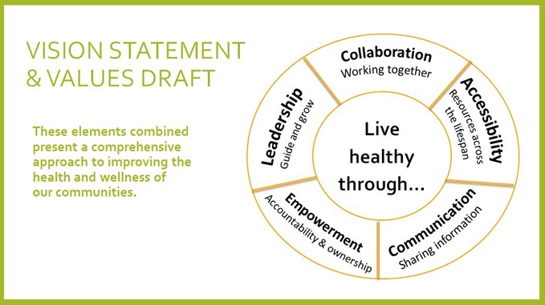

Appendix E. NCDHD Community Themes and Strengths Assessment

2021 COMMUNITY THEMES AND STRENGTHS ASSESSMENT

What is important to our community?
Elder care | Crops and farming
Families | Shopping local
Access to medical care | Local jobs
Good school system | Low Crime
Agriculture | Retaining youth and youth families
Mental Health Care | Creating more housing options

What do you believe are the most important characteristics of a healthy community?
Faith | Compassion
Prescience of Walmart | Strong workforce Support
Adequate housing | Concern
Patience | Personal Health care
Caring | Quality childcare opportunities
Equal access to all for health care | Quality educational opportunities
Education | Exercise
Safe place to live | Healthy water supply

What makes you most proud of our community?
Strong faith | Health care continuum from primary care to hospital to long term care
Most people giving a helping hand | Everyone bands together in their small towns
Collaboration among different groups and business | How they help each other
Great place to live, the people | Loyalty of donors

What are some specific examples of people or groups working together to improve the health and quality of life in our community?
Local group meeting yearly to set community goals | scouts FFA at high school
Economic Development | North Central Community Care partnership
Chamber of Commerce | City council

What do you believe are the most important issues that must be addressed to improve the health and quality of life in our community?
Needs of Exercise | Housing
Reliable internet | Renal housing options
Water | Capital campaign for renovations of area hospitals
Volunteerism | Education

What do you believe is keeping our community from doing what needs to be done to improve the health and quality of life?
Finances and volunteers/time | Money
Not wanting to change the processes, the idea that “we always have done this way” doesn’t always for as time and technology changes | Changing the mindset to help students and parents realize a technical degree or certification is a great career move.
Old Age | Stigma of small town gossip
Time- many of the movers and shakers are the ones who do “everything” in the community already

What actions, policy, or funding priorities would you support to build a healthier community?
donation of items/funds for a community fitness center that offered yoga/meditation type services as well | Funds from LB640, capital campaign to renovate the hospital
More financial help to rural communities with limited tax basis | Support groups

What would excite you enough to become involved (or more involved) in improving our community?
Most parents work full time and have little extra time to offer- unless their kids are old enough to either help or stay home etc. Offer child watch while volunteering ha! Anything that involves instilling kindness and learning in children- supporting elderly and disabled. | The pandemic has taken all my time since I work in health care. I am excited to help but can't lead a project at this time.
 | Just being asked
Having the physical/psychological energy in which to do so | I'm already there! Serving on 6 different boards and affiliated with multiple regional, state, and national programs.

HOW IS QUALITY OF LIFE PERCEIVED IN OUR COMMUNITY?

Are you satisfied with the quality of life in our community?
No- But I know it could be better! | No

Are you satisfied with the health care system in the community?
No | No full time Dr
Yes, we have an incredible local hospital, and multiple clinic covering a large need of the community

Is there a broad variety of health services in the community? Are there enough health and social services in the community?
Believe more mental health options would be incredibly valuable for the community. | Costs can be high due to lack out specialty clinics not associated with hospitals.
Acceptable | Very Good

Is this community a good place to raise children?
No (2 responses) | Yes (10 responses)

Are there networks of support for individuals and families during times of stress and need?
No | Unsure of that
I believe we could do more to help those that are dealing with behavioral health issues such as depression, grieving and drug addiction.

Do all individuals and groups have the opportunity to contribute to and participate in the community’s quality of life?
Low-income folks don’t have an option for a food pantry here | Mostly yes, those with young families not so much as most parents work full time these days. Farmer’s market is always on a weekday, late enough in the morning that most cannot attend due to work hours.
Don’t know if they have any | No

Is there an active sense of civic responsibility and engagement, and of civic pride in shared accomplishments?
Need more people volunteering to serve on boards and local government. Too many of the "older" generation are the only ones serving on the boards. There is a need to bring on more younger community members with different visions and not always doing things the way they have always been done. We have to make changes to grow. | There is some but no one wants to step up and lead because there are many vocal people who speak negatively about any attempt to improve anything.
Unsure

WHAT ASSETS DO WE HAVE THAT CAN BE USED TO IMPROVE COMMUNITY HEALTH?

Physical/Environmental
Streets are clean/paved | Nice parks (x2)
Jazzercise | Swimming pool (x2)
Good Water (x2) | Roads
Clean Park and recreation areas | Hospital
Nursing home | 5 school gyms
Community Center

Community Resources/ Infrastructure
Libraries | Community Foundation
Gas station | Rotary
School system | Daycare
Volunteerism | Ministerial
 | Nursing homes

Institutions/Businesses
School | Hospital
Banks | Great Pharmacy
Valley Hope | Churches
Healthcare | Bomgaars
Mental Health | Golf Course
School | Dollar General

People
Small community | More young families again
Dollar Store | Need more diversity
City council | Help each other out
Cultural acceptance of all races | Churches
Support | Increase population of 22–40-year-old residents

Institutions/Businesses
Facebook pages | Several cell towers
Newspaper | KBRX Radio/ local radio stations across district
Mailings

Appendix E. Disparities and Contributing Factors
Disparities amongst subpopulations or sub-geographic areas in terms of: Health Status* or Health Behavior** | Social determinants of health or built environment contributing to health status/behavior disparity: | Community assets or resources beyond healthcare and the health department that can be mobilized to address health challenges.
Health Status: Cancer Diagnosis  Population: Low socioeconomic residents  Disparity: A lack of health care coverage for lower income populations, more cancer diagnoses, less up-to-date colon cancer screening and higher depression rates were notable inequities identified for low-income people in NCDHD’s service area. (Page 55, 56) | Socioeconomic status  Insurance status | Medicare/ Medicaid access  Local hospitals and clinics  NCDHD community impact coordinator to increase awareness of Medicare
Health Status: Insurability  Population: Low socioeconomic residents  Disparity: A lack of health care coverage for lower income populations, more cancer diagnoses, less up-to-date colon cancer screening and higher depression rates were notable inequities identified for low-income people in NCDHD’s service area. (Page 55, 56) | Socioeconomic status  Insurance status | Medicare/ Medicaid access  DHHS  NCDHD community impact coordinator to increase awareness of Medicare
Health Status: Mental Health  Population: Low socioeconomic residents  Disparity: A lack of health care coverage for lower income populations, more cancer diagnoses, less up-to-date colon cancer screening and higher depression rates were notable inequities identified for low-income people in NCDHD’s service area. (Page 55, 56) | Socioeconomic status  Insurance status | Medicare/ Medicaid access  DHHS  NCDHD community impact coordinator to increase awareness of Medicare
Health Behavior: Alcohol consumption  Population: Youth  Disparity: Among NCDHD youth respondents, 7.2% (n = 996) indicated they had consumed alcohol three or more times in the previous month (6.1% statewide), and 26.7% (n = 997) indicated it was a little or not wrong to drink alcohol frequently (25.3% statewide). (page 46) | Rural Vs. State | TeamMates  School Prevention  ESU’s
Health Behavior: Tobacco Use  Population: Youth  Disparity: Youth responses to the NRPFSS (2018) showed tobacco use that was slightly higher than state averages. For example, among 12th grade respondents 19.6% reported current cigarette or smokeless tobacco use (compared to 15.3% statewide), and 38.9% reported vaping once or more in the past 30 days (compared to 37.3% statewide) (Page 43) | Rural Vs. State | Tobacco prevention funding from health department  Schools provide access to youth  Teammate mentoring program
Health Status: Insurance status  Population: Medicare recipient/ low-income  Disparity: The percentage of female fee-for-service Medicare enrollees who received a mammogram averaged across counties within the NCDHD was 43.9%, compared to an overall Nebraska average of 48% (MMD, 2018). (Page 41) | Insurability  Socioeconomic Status | Area hospitals and clinics
Health Behavior: Healthy Eating  Population: low-income  Disparity: 11.9% of respondents across the NCDHD reported not having access to a reliable source of food the previous year, and 16.5% of the low-income population does not live close to a grocery store. (Page 45) | Socioeconomic Status  Access to healthy food | Community food pantries  Summer lunch programs  Local gardening
*Health Status: Refers to your medical conditions (both physical and mental health), claims experience, receipt of health care, medical history, genetic information, evidence of insurability, and disability.
** Healthy behaviors: Health behaviors are actions individuals take that affect their health. They include actions that lead to improved health, such as eating well and being physically active, and actions that increase one’s risk of disease, such as smoking, excessive
*** Health equity relates to social justice in health; that is, everyone has a fair and just opportunity to be as healthy as possible. The description of factors that contribute to inequities may relate to conditions that vary by population, for example, the availability of affordable housing for low- and middle-income families; availability of culturally and linguistically appropriate services for limited English-speaking populations; or how conditions vary by neighborhood such as school funding or access to health services. Inequities related to the built environment might include vulnerability to climate change, or the availability of grocery stores, parks, sidewalks, or transportation.
As part of identifying factors that contribute to health challenges within the community, the description may also address related policies (e.g., taxation, education, transportation, or insurance status), social or structural determinants of health, or other the unique characteristics of the community that impact health status. Social determinants of health include factors in which people are born, live, and grow that influence health beyond a person’s control. Social determinants may include structural determinants or “root causes” of health inequities. Structural determinants include factors such as the political, economic, or social policies that affect income, education, or housing conditions. The structural determinants affect whether the resources necessary for health are distributed equally in society, or whether they are unjustly distributed according to race, gender, social class, geography, sexual orientation, or other socially defined group of people. The description could include equity indicators, for example, the Social Vulnerability Index or the Index of Concentration at the Extremes.

BRFSS adult health data is not available for specific age groups in rural areas with low populations. Several national surveys relevant to aging and elderly health have been discontinued for over ten years, such as the National Home Health Aide Survey (2007), National Home and Hospice Care Survey (last administered 2007), and National Nursing Home Survey (2004). The U.S. Department of Health and Human Services Administration for Community Living provides its annual Profile of Older Americans results, but data is aggregated to the national or state levels only.

