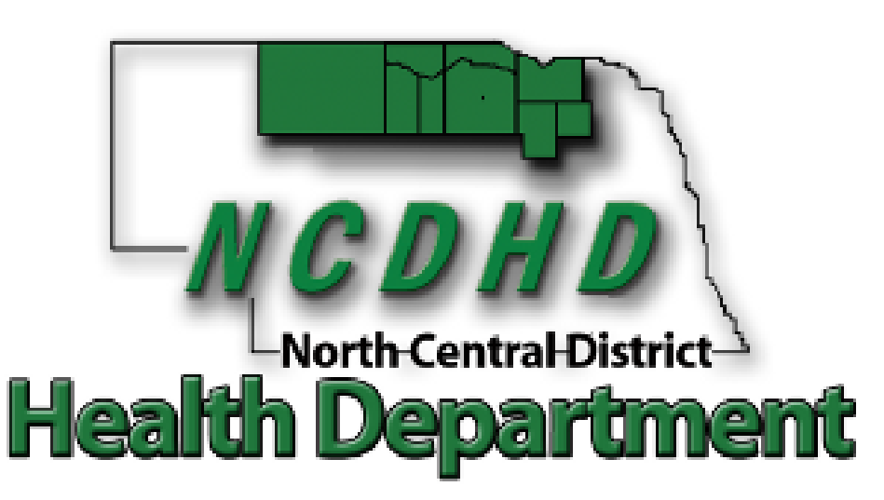
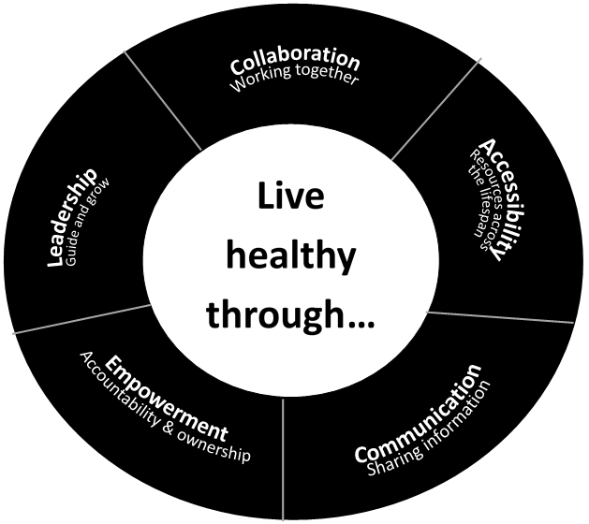

2022-2024

COMMUNITY HEALTH
IMPROVEMENT PLAN

Serving the Counties of: Antelope, Boyd, Brown, Cherry, Holt, Keya Paha, Knox, Pierce, and Rock

CONTENTS
ACKNOWLEDGEMENTS 2
EXECUTIVE SUMMARY 3
DETERMINING HEALTH PRIORITIES 4
PRIORITY 1: CARDIOVASCUALR HEALTH 5
PRIORITY 2: MENTAL HEALTH 7
PARTNERS AND COMMUNITY MEMBERS WHO HAVE AGREED TO SUPPORT CHIP ACTION 8
WORK PLAN 9

ACKNOWLEDGEMENTS

The North Central District Health Department would like to recognize the following organizations for their participation in the planning sessions that led to the development of this report:

North Central District Health Department | Niobrara Valley Hospital
NCDHD Board of Health | Osmond General Hospital
Antelope Memorial Hospital | Rock County Hospital
Avera Creighton Hospital | West Holt Memorial Hospital
Avera St. Anthony’s Hospital-O’Neill | Indian Health Services***
Brown County Hospital | The Evergreen Assisted Living Facility ***
Cherry County Hospital*** | Cottonwood Villa Assisted Living Facility**
CHI Health Plainview Hospital | Calvary Bible Church
Counseling & Enrichment Center | Brown-Rock-Keya Paha County
Building Blocks | O’Neill Public School Board
Region 4 Behavioral Health System | O’Neill Ministerial Association
Central Nebraska Community Action Partnership*** | West Holt Health Ministries
Northeast Nebraska Community Action Partnership | Legal Aid of Nebraska***
Valentine Community School | O’Neill Public Schools
NorthStar Services*** | Santee Sioux Nation***
North Central Community Care Partnership- | University of Nebraska Public Policy Center
Area Substance Abuse Prevention Coalition | O’Neill Chamber of Commerce
Proteus*** | ESU 17/ Ainsworth Schools
Central Nebraska Economic Development | Holt County Economic Development
Good Samaritan Society – Atkinson | Northwest Nebraska Community Action Partnership
***in the 2019-2021 Community Health Assessment, Native Americans, Hispanics, the elderly, and those living in poverty were identified as populations that are disproportionately affected by health risks or poorer health outcomes. NCDHD ensured these populations were represented in the health assessment efforts.

EXECUTIVE SUMMARY
The health of our nation and its people is an especially important topic. Improving and maintaining good health for the entire nation starts with a dedicated public health system that works together at the local level to promote quality of life, health equity, supportive environments, and healthy behaviors across all life stages.

This community health improvement plan was developed through a collaborative process involving a wide variety of local community partners and stakeholders. It serves to describe the priority health issues identified through the community health assessment process and outlines the work plan developed to address those issues.

Individuals and organizations involved in the effort thus far have committed to continue their participation as workgroup members to strategically implement work plan action items. A tracking system will be developed to document activities completed by all participating workgroup partners and periodic progress updates for each priority health issue.

As the public health system serving north-central Nebraska, we are excited to move forward into the implementation phase of our community health improvement efforts, with a focus on building and strengthening the local foundation that will ultimately serve to support good health for our entire nation.

"HEALTH IS A STATE OF COMPLETE PHYSICAL, MENTAL AND SOCIAL WELL-BEING AND NOT MERELY THE ABSENCE OF DISEASE OR INFIRMITY."

-WORLD HEALTH ORGANIZATION, 1948.

DETERMINING HEALTH PRIORITIES

HOW DID WE GET HERE?

The Community Health Assessment and

Community Health Improvement Plan were

developed through a community-driven strategic planning process called Mobilizing for Action

through Planning and Partnership (MAPP). The MAPP process commenced in August 2021 and took approximately eight months to complete.

North Central District Health Department

(NCDHD) guided the processes and incorporated members and representatives of many

organizations throughout the health district.

The Community Health Assessment (CHA) was completed by obtaining and reviewing health

data for the community. The Community Health Improvement Plan details strategic issues noted throughout the assessment process and outlines goals and strategies to address identified health priority areas.

Data related to the health of the North Central District referenced throughout this document can be found on the NCDHD website: www.ncdhd.ne.gov.

PROCESS

Community partners gathered to create a common vision, identify key stakeholders, complete the Forces of Change Assessment, the Community Themes and Strengths Assessment, and the Local Public Health System Assessment. Questions included in the NCDHD resident survey were identified by key stakeholders. The results of all these assessment and surveys were then sent the UNL Public Policy Division to assess. Results of the CHA were then presented to partners at the community prioritization meeting. In groups and individually, participants voted on the health issues of highest concern and impact. The process resulted in two priorities: cardiovascular health and mental health.

On April 21, 2022 partners drafted the CHIP priority goals, objectives, and strategies. Work groups for each priority health issue will meet regularly to implement action plans and ensure progress is being made to obtain goals. NCDHD will assist in convening these meetings and measuring progress with each work plan.

PURPOSE
We recognize that by including members from many
organizations throughout the community, we can accomplish more than what could be done by any one organization alone. The purpose of the Community Health Improvement Plan is not to create a heavier workload for our partners, but rather, to align efforts of these various organizations to move forward in improving the health of the community in a strategic manner. Community partnership also serves to create a broader representation of community perspectives and engender ownership of the efforts aimed at addressing identified priority health issues.

What follows is the result of the community’s collaborated effort and planning to address health concerns in a way that combines resources and energy to make a measurable impact on the health issues of the North Central District community. There are many assets within the North Central District that will aid in the accomplishment of these goals.

CARDIOVASCULAR HEALTH

STRATEGIC ISSUE 1: HOW DO WE OPTIMIZE CARDIOVASCULAR HEALTH WITHIN

THE HEALTH DISTRICT?

CURRENT SITUATION: CARDIOVASCUALR DISEASE

CARDIOVASCULAR DISEASE  When surveyed, NCDHD community member’s health concerns include cancer, heart disease, mental and behavioral health resources, poverty, and quality of life – all issues which have been previously identified as major public health issues. With heart disease being the primary cause of death for NCDHD residents, the workgroup deemed this a worthy cause (see Table at bottom of page).  According to the CDC, heart disease risk factors include high blood pressure, blood cholesterol, diabetes, obesity, lack of exercise, excess alcohol consumption, tobacco use, unhealthy diet, and genetics (Heart Disease Facts, 2021). Per the CDC, diabetes risk factors are family history, age, overweight, lack of physical activity, and history of gestational diabetes.  EMPLOYMENT AND INSURANCE STATUS  Gainful employment can provide income and a sense of purpose and belonging. Employment may often include provision of health care insurance, paid sick leave, and wellness programs that can encourage healthy choices. Employment can have profoundly positive effects on social and emotional well-being and self-efficacy. Unfortunately, those who are unable to find and maintain gainful employment often are more likely to suffer increased stress, high blood pressure, and greater prevalence of heart disease and depression than those with gainful employment (Braveman, Dekker, et al., 2011; RWJF, 2013).  HEALTH BEHAVIORS:  An abundance of research shows that personal health behaviors are strongly linked to chronic disease, mortality, or other outcomes that affect well-being (Berrigan et al., 2003; Hanson & Chen, 2007; Schwarzer, 2008). Cancer, heart disease, diabetes, and other leading causes of death in the United States are strongly associated with unhealthy behaviors that may evolve over a lifetime (Colditz et al., 1992; Keys, 1957; Sasco et al., 2004; Walker et al., 2010). Health professionals play a critical role highlighting behavioral health risks and promoting interventions that encourage communities and individuals to adopt and maintain healthy behaviors across their lifespans. | According to NBRFSS data (2020), 70.5% (n = 749) of NCDHD respondents had a routine checkup in the past year with a healthcare provider, 89.7% (n = 436) had their blood pressure checked in the past year, and among CHA (2021) survey respondents, 92.7% (n = 234) indicated that they had seen a primary care provider once within the previous one to two years, 85.7% (n = 231). Regularly seeing a healthcare provider and screening for common conditions is an important preventative measure.  Maintaining a healthy diet and regular exercise are key predictors of positive health outcomes. An abundance of evidence links obesity with a wide variety of chronic health conditions, including diabetes, heart disease, stroke, hypertension, cancers, and other illnesses (Hu, 2003; Hubbard, 2000; Kelly et al., 2013; Nejat et al., 2010). Obesity and poor exercise habits are major factors causing preventable chronic diseases and deaths among Americans, resulting in substantially increased individual health care costs and social-economic losses. It should be noted that both obesity and lack of exercise are also impacted by environmental conditions (e.g., costs and availability of healthy food) (Cooksey-Stowers et al., 2017; Walker, Keane & Burke, 2010) and workplace or social and community contexts that promote sedentary lifestyles (Bassett et al., 2015; Gaziano, 2010). It is worth highlighting that the prevalence of obesity and its health impacts in the United States is among the highest in the world, and research indicates strong associations between obesity and race, ethnicity, income, and educational status (Kirby et al., 2012; Lee, 2011; Rossen, 2014).  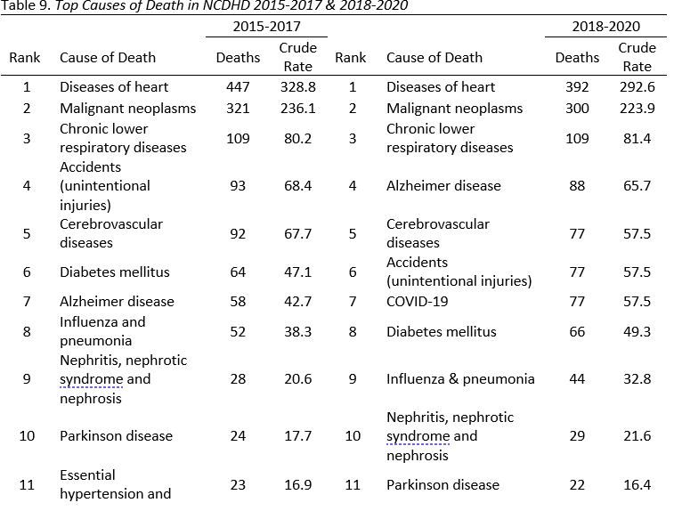

ASSETS AND RESOURCES: Healthcare providers, hospitals, local public health department, schools, community organizations, community gardens, fitness facilities, long-term care facility activity directors, UNMC APEX Partnership, Indian Health Services, Santee Clinic, and senior centers.

PRIORITY 2: MENTAL HEALTH

STRATEGIC ISSUE 2: HOW DO WE OPTIMIZE MENTAL HEALTH IN THE DISTRICT?

CURRENT SITUATION: MENTAL HEALTH

Of the top concerns identified by NCDHD CHA respondents (n = 242), 58.7% reported mental health as a top concern.  Mental health illnesses are very common in the United States, with an estimated 50% of all Americans diagnosed with a mental illness or disorder at some point in their lifetime. Mental illnesses, such as depression, are the third most common cause of hospitalization in the United States for those aged 18-44 years old, and adults living with serious mental illness die on average 25 years earlier than others (CDC, 2019). Depressive illness (including major depression, bipolar disorder, and dysthymia) is the most common mental illness, affecting roughly 21 million Americans each year.  Frequent mental distress is the percentage reporting 14 or more poor mental health days. The averaged values across NCDHD counties was 12.1% for frequent mental distress, compared to overall Nebraska values 11.3%, respectively (NBRFSS, 2018). About one third of elderly residents surveyed reported not feeling lonely or disconnected from others (69.6%).  FAMILY SUPPORT  According to the results of the American Community Survey (2019), 15% of children within the NCDHD live in single-parent households, which is associated with adverse mental health outcomes and unhealthy behaviors for children and adults (Balistreri, 2018; Manning, 2015). However, the percentage of children in single-family households in the NCDHD (15.0%) is significantly lower than the US average (25.5%) and the Nebraska average (21.0%). This result is supported by NCDHD student self-reports, with 14% saying they lived with one parent (NRPFSS, 2018). Students living in the NCDHD also largely agreed that they could ask their parents for help with personal problems (85.4%) and that they had an adult who listens to them at home (86.9%).  HEALTH DISPARITIES  The two primary minority populations in NCDHD are American Indians and Hispanics. General health and physical health are worse for American Indians and Hispanics compared to non-Hispanic Whites, while mental health is better for Hispanics and Whites compared to American Indians. Other notable health disparities are health care coverage, diabetes, cigarette use and depression. Hispanics have higher rates of being uninsured, while American Indians have higher rates of diabetes, tobacco use and depression. | HEALTH BEHAVIORS  Alcohol sale and consumption is a widespread fixture of American life. However, excessive use has been linked to a wide range of preventable chronic conditions and acute issues, including a variety of cancers, cardiovascular disorders, and gastrointestinal conditions (Room et al., 2005). Excessive alcohol use is also associated with unintentional and intentional injuries (Chikritzhs & Livingston, 2021; Shield et al., 2012), co-morbidities in mental health (Tembo et al., 2017; Weitzman, 2004), and domestic or relationship aggression and violence (Foran & O’Leary, 2008; Leonard, 2005). Similarly, illegal drug use and addiction is linked to a variety of physical and mental health co-morbidities (Fenton et al., 2012; Jones & McCance-Katz, 2019) and drug overdose related deaths (Lim et al., 2021; Lippold et al., 2019).  SOCIOECONOMIC STATUS  A household’s income level determines what types of health-related choices are available. Those with lower levels of income often have lower access to healthy foods, preventative health care, and educational opportunities and are also associated with poorer physical and mental health outcomes (Braveman, Egerter, & Barclay, 2011).A lack of financial resources can make engaging in healthy behaviors difficult, often leading to poor health behaviors and outcomes. Poor physical health and mental health are all more common among people making less money in their household. A lack of health care coverage for lower income populations, more cancer diagnoses, less up-to-date colon cancer screening and higher depression rates were notable inequities identified for low-income people in NCDHD’s service area.  ACCESS TO CARE:  The ratio of the population to mental health providers was 1,903 persons per mental health provider, compared to an overall average of 360 people per mental health provider statewide. It should be noted that all counties which compose the NCDHD are designated as health professional shortage areas by the State of Nebraska for at least one if not all primary medical professions; as well as dentistry, pharmacy, and allied health professions (Wehbi et al., 2020). Additionally, every NCDHD county is also a HRSA-designated mental health professional shortage area (HRSA, 2021).

ASSETS AND RESOURCES: Healthcare providers, mental health/behavioral health agencies, hospitals, pharmacies, local public health department, schools, faith/community organizations, law enforcement, and community action agencies.

PARTNERS AND COMMUNITY MEMBERS WHO HAVE AGREED TO SUPPORT CHIP ACTION:

North Central District Health Department | Niobrara Valley Hospital
NCDHD Board of Health | Osmond General Hospital
Antelope Memorial Hospital | Rock County Hospital
Avera Creighton Hospital | West Holt Memorial Hospital
Avera St. Anthony’s Hospital-O’Neill | Indian Health Services***
Brown County Hospital | The Evergreen Assisted Living Facility ***
Cherry County Hospital*** | Cottonwood Villa Assisted Living Facility**
CHI Health Plainview Hospital | Calvary Bible Church
Counseling & Enrichment Center | Brown-Rock-Keya Paha County
Building Blocks | O’Neill Public School Board
Region 4 Behavioral Health System | O’Neill Ministerial Association
Central Nebraska Community Action Partnership*** | West Holt Health Ministries
Northeast Nebraska Community Action Partnership | Legal Aid of Nebraska***
Valentine Community School | O’Neill Public Schools
NorthStar Services*** | Santee Sioux Nation***
North Central Community Care Partnership- | University of Nebraska Public Policy Center
Area Substance Abuse Prevention Coalition | O’Neill Chamber of Commerce
Proteus*** | ESU 17/ Ainsworth Schools
Central Nebraska Economic Development | Holt County Economic Development
Good Samaritan Society – Atkinson | Northwest Nebraska Community Action Partnership

WORK PLAN

The remaining pages in this document outline the work plan for each issue identified by community partners as priority health areas through this planning process.

The work plan contains goals, objectives, strategies, activities, measures, timelines, and partners for each priority health area.

Over the course of the next three years, workgroup members will commit resources and efforts to activities as outlined in the work plan. This section is meant to be a flexible, responsive component of the community health improvement plan. As such, it will periodically be reviewed and updated to ensure the elements reflect workgroup progress and needs of our community.

PRIORITY 1: CARDIOVASCULAR HEALTH

GOAL: Improve cardiovascular health and reduce deaths from heart disease and stroke

OBJECTIVE 1 |  |  | OUTCOME MEASURES
Decrease the mortality rates due to heart disease in NCDHD by 1% by 2024.  ***Crude rate is defined as number of deaths per 100,000 residents. |  |  | Crude rate of deaths due to heart disease.  Note:  2015-2017 Heart Disease Deaths: 447 Crude Rate: 328.8  2018-2022 Heart Disease Deaths: 392 Crude Rate: 292.6
STRATEGY | ACTIVITY |  |  | PROCESS MEASURES | TIMELINE | PARTNERS
1. Increase amount of CPR/AED/first aid certified instructors and trainees | Promote, advertise, and/or schedule CPR/AED/ first aid trainings |  |  | Number of trainers and trainees trained in Basic Life Support | December 2024 | Workgroup members/ Hospitals/ Community Colleges
2. Promote blood pressure screenings with appropriate referrals | Promote blood pressure screening at public events, fairs, etc. |  |  | Number promotions in community | December 2024 | Workgroup member organizations/ UNMC
3. Promote awareness of the risks of abnormal  blood pressure values | Create a media campaign to educate public |  |  | Number of ads/PSAs/ social media posts | December 2024 | NCDHD/ Workgroups members/ media/ UNMC
4. Explore avenues for physical activity in each county | Workgroup will assess physical activity opportunities in each county for all populations |  |  | Number physical activity opportunities per county | December 2024 | All workgroup member
5. Connect minorities and populations with lowest health indicators with Medicaid awareness and access | Workgroup will identify locations and events to provide Medicaid awareness to populations of need |  |  | Number of events/ locations/media releases providing Medicaid education | December 2024 | NCDHD & Partners
6. Explore avenues to reach Native American, Hispanic, elderly, and low-income residents in the above strategies | Workgroup will identify avenues to reach disparate populations regarding CPR, blood pressure education and screening, physical activity, and Medicaid education |  |  | Number of efforts workgroup made to reach disparate populations, i.e. material in language other than English, etc. | December 2024 | All workgroup member organizations
RECOMMENDED POLICY CHANGES
- Encourage providers to include health literacy and cultural competency into their outreach efforts to address language and literacy barriers.
- Encourage providers to include blood pressure screens and health fairs and clinics at no cost to address access to care and socioeconomic health disparities.
- Encourage non-medical partners, i.e. churches, businesses, county court houses, etc., to have blood pressure cuffs and education available for employees and guests.
STATE ALIGNMENT
Pending.
NATIONAL ALIGNMENT
National Prevention Strategy Priorities: Healthy Eating, Active Living
HP2030 PREP-01: Increase the rate of bystander CPR for non-traumatic cardiac arrests
HP2030 PREP-02: Increase the rate of bystander AED for non-traumatic cardiac arrests
HP2030 HDS–1: Improve cardiovascular health in adults
HP2030- HDS-02 Reduce coronary heart disease deaths
HP2030- HDS-04 Reduce the proportion of adults with high blood pressure
HP2030- HDS-05 Increase control of high blood pressure in adults
HP2030 PREP‑01 Increase the rate of bystander CPR for non-traumatic cardiac arrests
HP2030-CKD‑06 Reduce the proportion of adults with chronic kidney disease who have elevated blood pressure
DETERMINANTS OF HEALTH EQUITY CONSIDERATION
Availability of healthy food; Access to Healthcare services; Transportations Options; Language/ Literacy; Socioeconomic Conditions; Gender; Age.

PRIORITY 2: MENTAL HEALTH

GOAL: IMPROVE MENTAL HEALTH

OBJECTIVE 1 |  |  |  | OUTCOME MEASURES
Decrease the number of deaths by suicide in the NCDHD area during the period of 2022- 2024 by 10% from the previous period of 2018-2020, which was 21 deaths. |  |  |  | Number of 2022-2024 deaths by suicide in the NCDHD area as reported by the Nebraska Vitals Record.
STRATEGY | ACTIVITY | PROCESS MEASURES |  |  | TIMELINE | PARTNERS
1 Increase Mental Health First Aid Training (MHFA) providers in NCDHD district | Identify NCDHD residents to attend MHFA training of the trainer. | # of new NCDHD residents/ provider trained as a MHFA trainer |  |  | December 2024 | All workgroup member organizations/ Region 4
2 Provide MHFA trainings in each county | Coordinate one MHFA training in each county | The number of MHFA trainings in each county |  |  | December 2024 | NCDHD/Mental health providers/ Region 4 Behavioral Health Systems/ Hospitals/ ESU’s/ media partners
3 Bring one BCBA (Board Certified Behavior Analyst) to the district | Workgroup will compile a list of requirements for BCBA, identify possibly personnel, funding, and logistics to place BCBA in district | Number of BCBAs in district |  |  | December 2024 | All workgroup member organizations/ schools/ Region 4
4 Provider peer to peer mental health training to local schools (QPR, Teen MHFA, etc.) | Link schools with peer-to-peer mental health trainings | The number of trainings in each school |  |  | December 2024 | All workgroup member organizations/ schools/ Region 4
5 Utilize media outlets to increase the awareness of mental health and suicide | Disperse mental health media campaign advertising the National Suicide Prevention Lifeline’s 3-digit number (988) | Number of outreach attempts, i.e. fliers dispersed, media releases, social media posts, etc. |  |  | December 2024 | All workgroup member organizations
6 Explore avenues to reach Native American, Hispanic, elderly, and low-income, and/or other populations of health inequity in the above strategies. | Workgroup will identify avenues to reach disparate populations regarding MHFA trainers, trainees, and in media/ outreach efforts. | Number of efforts workgroup made to reach disparate populations, i.e. material in language other than English, etc. |  |  | December 2024 | All workgroup member organizations
RECOMMENDED POLICY CHANGES
Encourage policies for providers to implement mental telehealth services to address access to care.
Encourage partner organizations to implement health literacy and cultural competency policies to address language and literacy health inequities.

STATE ALIGNMENT
PENDING

NATIONAL ALIGNMENT
HP2030 MHMD-01: Reduce the suicide rate
HP2030- EMC-DO6: Increase the proportion of children and adolescents who get preventive mental health care in school
HP2030 AH-RO9: Increase the proportion of public schools with a counselor, social worker, and psychologists
DETERMINANTS OF HEALTH EQUITY CONSIDERATION
Gender; Age; Lack of Available Health Care; Insurance Status; Lack of Awareness; Social Norms and Attitudes; Socioeconomic conditions; Language/ Literacy Barriers.

